**Emergency Responder Radio System**

**Coverage Report Test Results**

|  |  |
| --- | --- |
| **Date Prepared:** | Sep 10, 2024 |
| **Test File:** | PRMCE 20240828 |
| **Test Location:** | _PRMCE 463550 |
|  |  |
| **Technician:** | Aaron Keyte |
| **FCC#:** | PG00066071 |

**Building: _PRMCE 463550**

**Result: Fail (Adjacent Area Rule)**

**Test Report Summary**

| **Channel/ Ch Group** | **Freq (MHz)** | **Technology** | **Band** | **Result** | **Area Points**  **passed (%)** | **Critical Points passed (%)** |
| --- | --- | --- | --- | --- | --- | --- |
| 463550 | 463.55000 | P25 | PRMCE | Fail (Adjacent) | 298/537 (55%) | 172/187 (91%) |

|  |  |  |  |
| --- | --- | --- | --- |
| **Test Details** | | | |
| **Number of Floors Tested:** | 22 | **Result Calculation:** | By area per floor |
| **Number of Areas Tested:** | 537 | **Area Pass Criteria:** | 95% |
| **Number of Critical Points Tested:** | 187 | **Critical Points Pass Criteria:** | 99% |
|  |  | **Apply Adjacent Area Rule:** | Yes |

|  |  |  |  |  |
| --- | --- | --- | --- | --- |
| **Equipment Configuration** | | | | |
| **Vendor** | **Application** | **Device** | **Calibration Expires** | **Antenna info** |
| PCTEL | SeeHawk Touch  rel 3.2.0.2 | SeeGull IBflex Device rel 3.10.0.0  SN: 081911044 | 2-13-2026 |  |

**Threshold Settings**

| **Measurement** | **DL Area Point** | **UL Area Point** | **DL Critical Point** | **UL Critical Point** | **Use for grading** |
| --- | --- | --- | --- | --- | --- |
| P25 Power (RSSI) | -95.0 dBm | -95.0 dBm | -150.0 dBm | -95.0 dBm | Yes |
| DAQ | 3.0 |  |  |  | No |

**Floors Result**

| **Floor Plan** | **463550 463.55000** |
| --- | --- |
| A1.0 | **Pass** |
| A1.1 | **Fail (Adjacent)** |
| A1.2 | **Pass** |
| A1.3 | **Pass** |
| A1.4 | **Pass** |
| A1.5 | **Pass** |
| A1.6 | **Pass** |
| A1.7 | **Fail** |
| A1.8 | **Pass** |
| A4.B | **Fail (Adjacent)** |
| A4.G | **Fail (Adjacent)** |
| A4.1 | **Fail (Adjacent)** |
| A4.2 | **Fail (Adjacent)** |
| A4.3 | **Fail (Adjacent)** |
| A4.4 | **Fail (Adjacent)** |
| A4.5 | **Fail (Adjacent)** |
| A4.6 | **Fail (Adjacent)** |
| A4.7 | **Fail (Adjacent)** |
| A4.8 | **Fail (Adjacent)** |
| A4.9 | **Fail (Adjacent)** |
| A4.10 | **Fail (Adjacent)** |
| A.4R | **Pass** |

**Floor: A1.0**

**Channel: 463550**

**Result: Pass**

| **Freq (MHz)** | **Tech** | **Band** | **Ant Gain** | **Cable Loss** | **Ph.** | **Type** | **Mod** | **NAC** | **Area Points passed (%)** | **Critical Points passed (%)** |
| --- | --- | --- | --- | --- | --- | --- | --- | --- | --- | --- |
| 463.55000 | P25 | PRMCE | 0.00 | 0.00 |  |  |  |  | 8/8 (100%) | 4/4 (100%) |

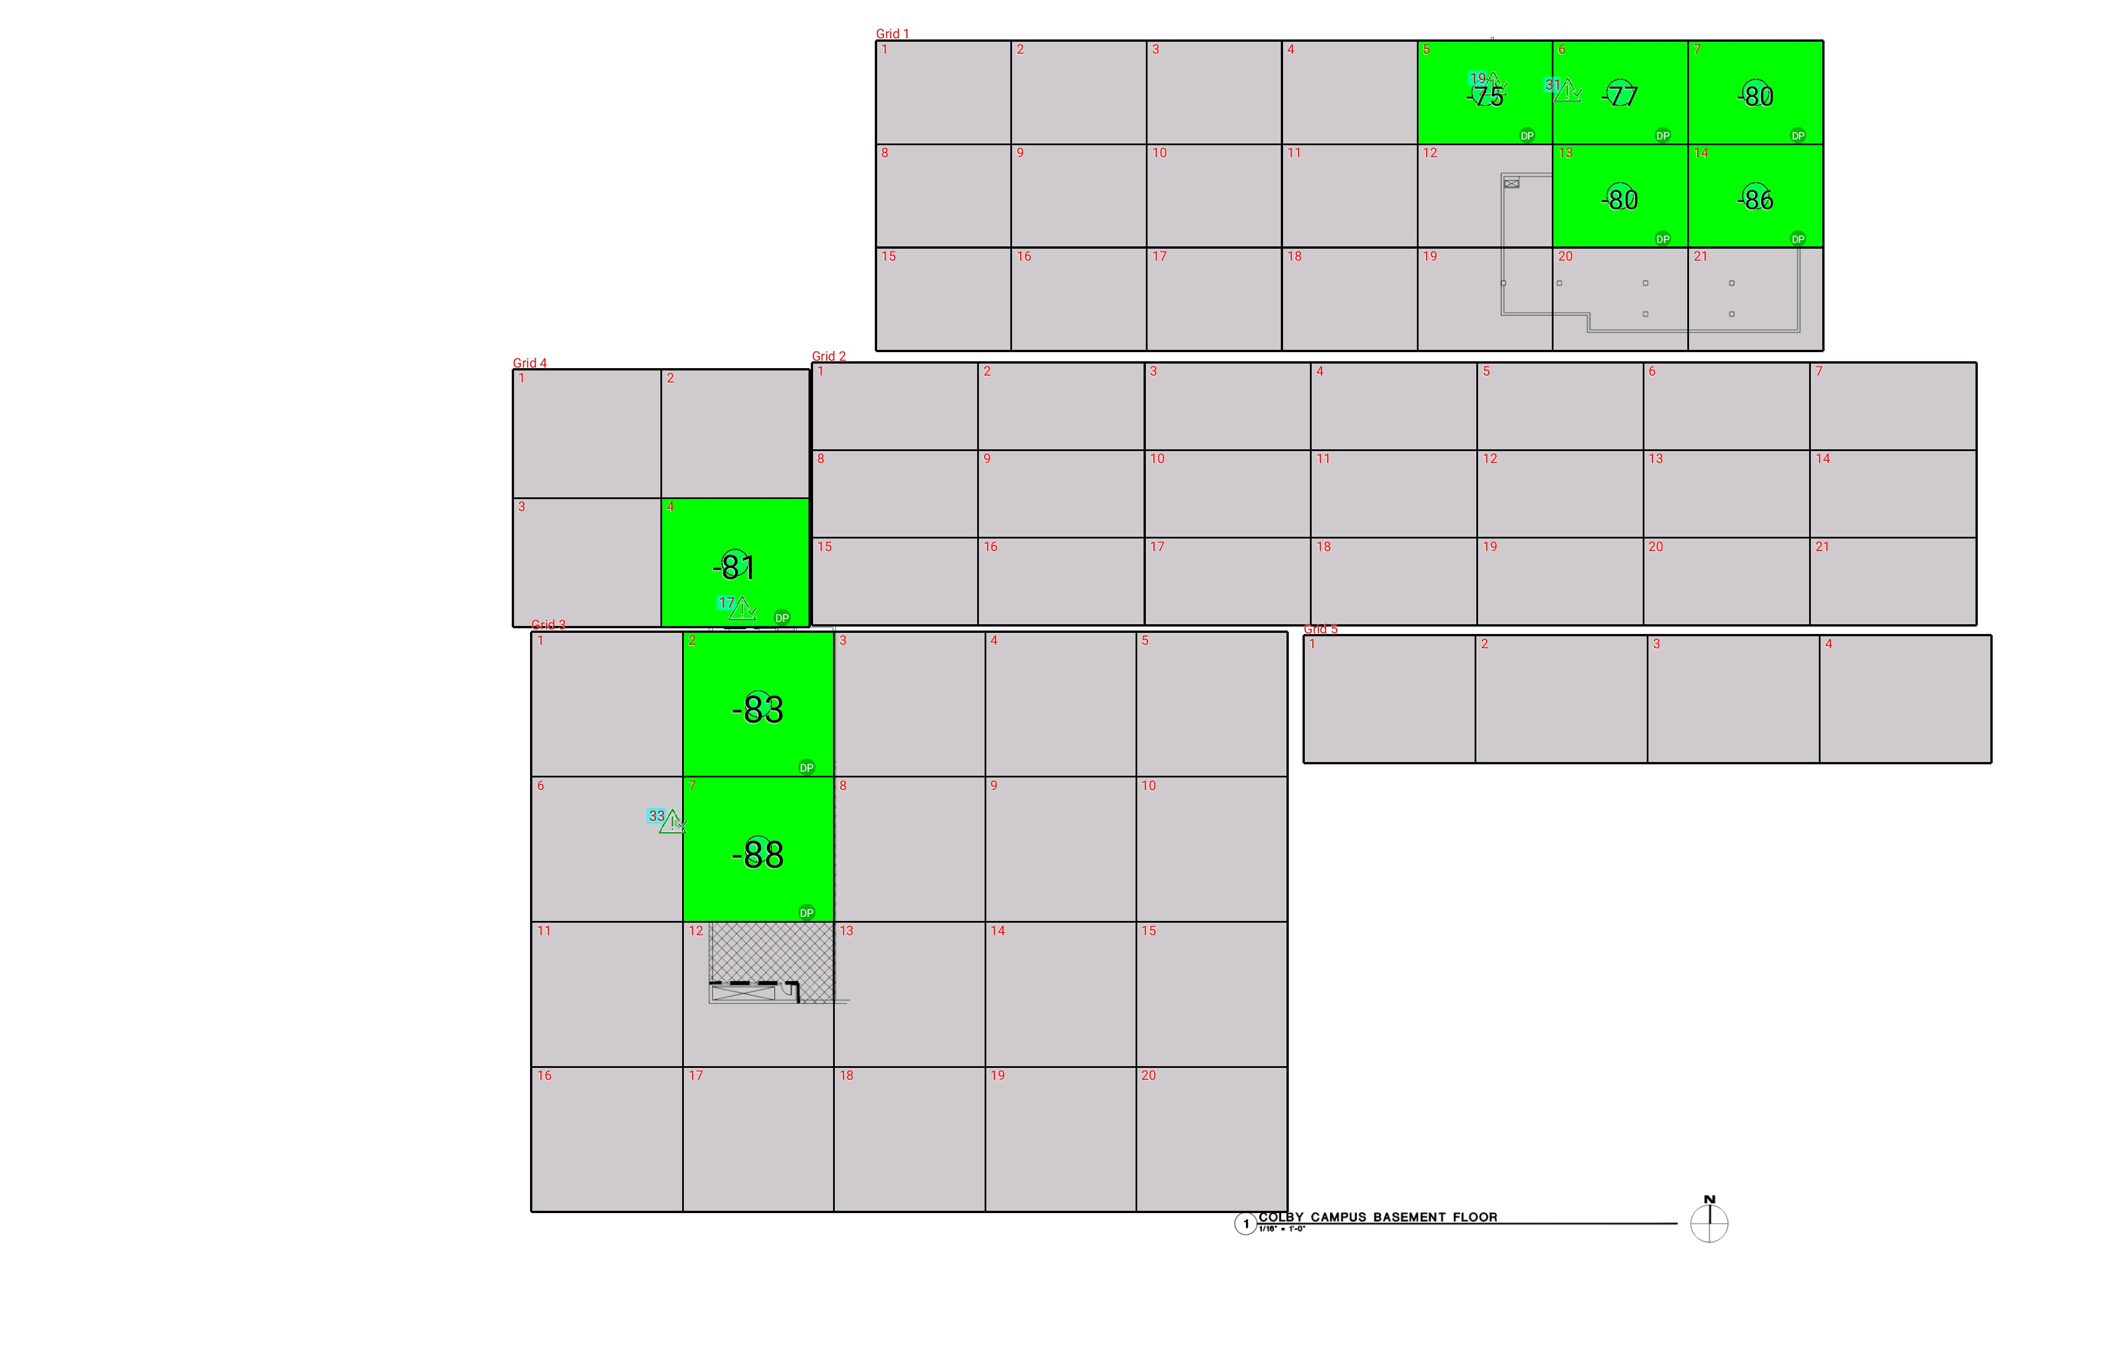

| **Grid** | **# of Areas** | **Area Size (sq. ft)** | **Area Width**  **(ft)** | **Area Height**  **(ft)** | **Ignore Area Color** | **Comments** |
| --- | --- | --- | --- | --- | --- | --- |
| 1 | 21 | 272.91 | 16.54 | 16.50 | Black |  |
| 2 | 21 | 284.23 | 20.34 | 13.98 | Black |  |
| 3 | 20 | 428.00 | 18.49 | 23.15 | Black |  |
| 4 | 4 | 372.29 | 18.13 | 20.54 | Black |  |
| 5 | 4 | 428.33 | 21.03 | 20.37 | Black |  |

**Floor: A1.0**

**Channel: 463550**

| **Critical Point Report** | | | | | | | |
| --- | --- | --- | --- | --- | --- | --- | --- |
| **Critical Point** | **DL**  **Power**  **(dBm)** | **DL**  **DAQ** | **UL**  **Power**  **(dBm)** | **UL**  **DAQ** | **Result** | **DL**  **Loss**  **(dB)** | **Comment** |
| 17 | -80.08 |  |  |  | **Pass** |  |  |
| 19 | -70.64 |  |  |  | **Pass** |  |  |
| 31 | -56.23 |  |  |  | **Pass** |  |  |
| 33 | -79.18 |  |  |  | **Pass** |  |  |

| **Area Report** | | | | | | | | |
| --- | --- | --- | --- | --- | --- | --- | --- | --- |
| **Grid** | **Area** | **DL**  **Power**  **(dBm)** | **DL**  **DAQ** | **UL**  **Power**  **(dBm)** | **UL**  **DAQ** | **Result** | **DL**  **Loss**  **(dB)** | **Comment** |
| 1 | 1 | NT | NT | NT | NT | **NT** |  |  |
| 1 | 2 | NT | NT | NT | NT | **NT** |  |  |
| 1 | 3 | NT | NT | NT | NT | **NT** |  |  |
| 1 | 4 | NT | NT | NT | NT | **NT** |  |  |
| 1 | 5 | -74.28 |  |  |  | **Pass** |  |  |
| 1 | 6 | -76.75 |  |  |  | **Pass** |  |  |
| 1 | 7 | -79.37 |  |  |  | **Pass** |  |  |
| 1 | 8 | NT | NT | NT | NT | **NT** |  |  |
| 1 | 9 | NT | NT | NT | NT | **NT** |  |  |
| 1 | 10 | NT | NT | NT | NT | **NT** |  |  |
| 1 | 11 | NT | NT | NT | NT | **NT** |  |  |
| 1 | 12 | NT | NT | NT | NT | **NT** |  |  |
| 1 | 13 | -79.72 |  |  |  | **Pass** |  |  |
| 1 | 14 | -85.75 |  |  |  | **Pass** |  |  |
| 1 | 15 | NT | NT | NT | NT | **NT** |  |  |
| 1 | 16 | NT | NT | NT | NT | **NT** |  |  |
| 1 | 17 | NT | NT | NT | NT | **NT** |  |  |
| 1 | 18 | NT | NT | NT | NT | **NT** |  |  |
| 1 | 19 | NT | NT | NT | NT | **NT** |  |  |
| 1 | 20 | NT | NT | NT | NT | **NT** |  |  |
| 1 | 21 | NT | NT | NT | NT | **NT** |  |  |
| 2 | 1 | NT | NT | NT | NT | **NT** |  |  |
| 2 | 2 | NT | NT | NT | NT | **NT** |  |  |
| 2 | 3 | NT | NT | NT | NT | **NT** |  |  |
| 2 | 4 | NT | NT | NT | NT | **NT** |  |  |
| 2 | 5 | NT | NT | NT | NT | **NT** |  |  |
| 2 | 6 | NT | NT | NT | NT | **NT** |  |  |
| 2 | 7 | NT | NT | NT | NT | **NT** |  |  |
| 2 | 8 | NT | NT | NT | NT | **NT** |  |  |
| 2 | 9 | NT | NT | NT | NT | **NT** |  |  |
| 2 | 10 | NT | NT | NT | NT | **NT** |  |  |
| 2 | 11 | NT | NT | NT | NT | **NT** |  |  |
| 2 | 12 | NT | NT | NT | NT | **NT** |  |  |
| 2 | 13 | NT | NT | NT | NT | **NT** |  |  |
| 2 | 14 | NT | NT | NT | NT | **NT** |  |  |
| 2 | 15 | NT | NT | NT | NT | **NT** |  |  |
| 2 | 16 | NT | NT | NT | NT | **NT** |  |  |
| 2 | 17 | NT | NT | NT | NT | **NT** |  |  |
| 2 | 18 | NT | NT | NT | NT | **NT** |  |  |
| 2 | 19 | NT | NT | NT | NT | **NT** |  |  |
| 2 | 20 | NT | NT | NT | NT | **NT** |  |  |
| 2 | 21 | NT | NT | NT | NT | **NT** |  |  |
| 3 | 1 | NT | NT | NT | NT | **NT** |  |  |
| 3 | 2 | -82.81 |  |  |  | **Pass** |  |  |
| 3 | 3 | NT | NT | NT | NT | **NT** |  |  |
| 3 | 4 | NT | NT | NT | NT | **NT** |  |  |
| 3 | 5 | NT | NT | NT | NT | **NT** |  |  |
| 3 | 6 | NT | NT | NT | NT | **NT** |  |  |
| 3 | 7 | -87.82 |  |  |  | **Pass** |  |  |
| 3 | 8 | NT | NT | NT | NT | **NT** |  |  |
| 3 | 9 | NT | NT | NT | NT | **NT** |  |  |
| 3 | 10 | NT | NT | NT | NT | **NT** |  |  |
| 3 | 11 | NT | NT | NT | NT | **NT** |  |  |
| 3 | 12 | NT | NT | NT | NT | **NT** |  |  |
| 3 | 13 | NT | NT | NT | NT | **NT** |  |  |
| 3 | 14 | NT | NT | NT | NT | **NT** |  |  |
| 3 | 15 | NT | NT | NT | NT | **NT** |  |  |
| 3 | 16 | NT | NT | NT | NT | **NT** |  |  |
| 3 | 17 | NT | NT | NT | NT | **NT** |  |  |
| 3 | 18 | NT | NT | NT | NT | **NT** |  |  |
| 3 | 19 | NT | NT | NT | NT | **NT** |  |  |
| 3 | 20 | NT | NT | NT | NT | **NT** |  |  |
| 4 | 1 | NT | NT | NT | NT | **NT** |  |  |
| 4 | 2 | NT | NT | NT | NT | **NT** |  |  |
| 4 | 3 | NT | NT | NT | NT | **NT** |  |  |
| 4 | 4 | -80.20 |  |  |  | **Pass** |  |  |
| 5 | 1 | NT | NT | NT | NT | **NT** |  |  |
| 5 | 2 | NT | NT | NT | NT | **NT** |  |  |
| 5 | 3 | NT | NT | NT | NT | **NT** |  |  |
| 5 | 4 | NT | NT | NT | NT | **NT** |  |  |

**Floor: A1.1**

**Channel: 463550**

**Result: Fail (Adjacent)**

| **Freq (MHz)** | **Tech** | **Band** | **Ant Gain** | **Cable Loss** | **Ph.** | **Type** | **Mod** | **NAC** | **Area Points passed (%)** | **Critical Points passed (%)** |
| --- | --- | --- | --- | --- | --- | --- | --- | --- | --- | --- |
| 463.55000 | P25 | PRMCE | 0.00 | 0.00 |  |  |  |  | 52/61 (85%) | 27/27 (100%) |

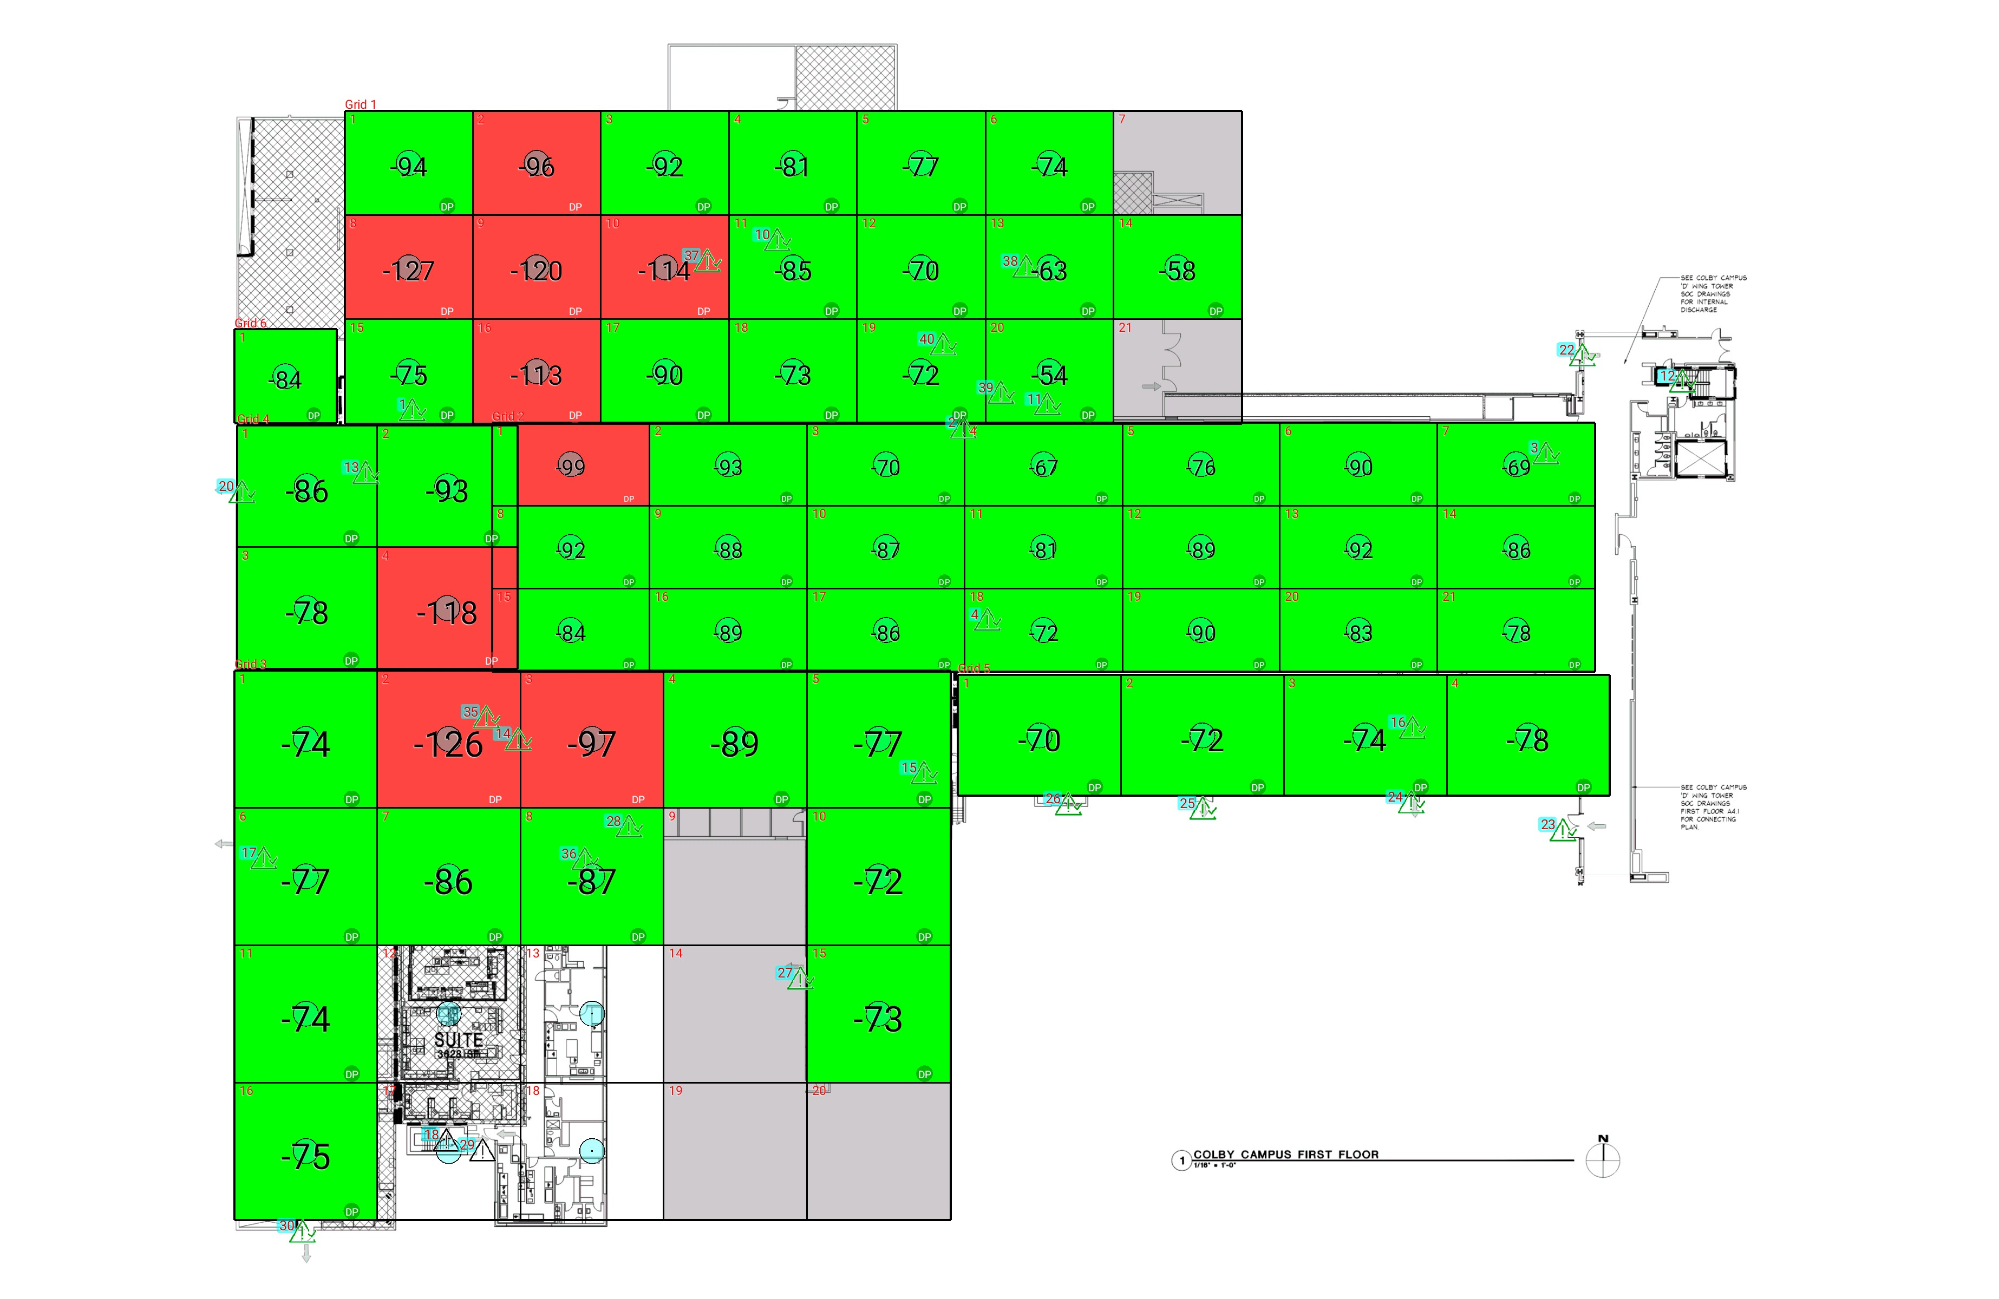

| **Grid** | **# of Areas** | **Area Size (sq. ft)** | **Area Width**  **(ft)** | **Area Height**  **(ft)** | **Ignore Area Color** | **Comments** |
| --- | --- | --- | --- | --- | --- | --- |
| 1 | 21 | 290.55 | 16.54 | 17.57 | Black |  |
| 2 | 21 | 284.23 | 20.34 | 13.98 | Black |  |
| 3 | 20 | 428.00 | 18.49 | 23.15 | Black |  |
| 4 | 4 | 372.29 | 18.13 | 20.54 | Black |  |
| 5 | 4 | 428.33 | 21.03 | 20.37 | Black |  |
| 6 | 1 | 209.75 | 13.25 | 15.83 | Black |  |

**Floor: A1.1**

**Channel: 463550**

| **Critical Point Report** | | | | | | | |
| --- | --- | --- | --- | --- | --- | --- | --- |
| **Critical Point** | **DL**  **Power**  **(dBm)** | **DL**  **DAQ** | **UL**  **Power**  **(dBm)** | **UL**  **DAQ** | **Result** | **DL**  **Loss**  **(dB)** | **Comment** |
| 1 | -81.65 |  |  |  | **Pass** |  |  |
| 2 | -68.20 |  |  |  | **Pass** |  |  |
| 3 | -69.44 |  |  |  | **Pass** |  |  |
| 4 | -73.13 |  |  |  | **Pass** |  |  |
| 10 | -83.37 |  |  |  | **Pass** |  |  |
| 11 | -56.18 |  |  |  | **Pass** |  |  |
| 12 | -78.40 |  |  |  | **Pass** |  |  |
| 13 | -90.54 |  |  |  | **Pass** |  |  |
| 14 | -83.88 |  |  |  | **Pass** |  |  |
| 15 | -84.31 |  |  |  | **Pass** |  |  |
| 16 | -71.74 |  |  |  | **Pass** |  |  |
| 17 | -65.01 |  |  |  | **Pass** |  |  |
| 18 |  |  |  |  |  |  |  |
| 20 | -80.65 |  |  |  | **Pass** |  |  |
| 22 | -61.76 |  |  |  | **Pass** |  |  |
| 23 | -67.69 |  |  |  | **Pass** |  |  |
| 24 | -59.60 |  |  |  | **Pass** |  |  |
| 25 | -73.23 |  |  |  | **Pass** |  |  |
| 26 | -66.13 |  |  |  | **Pass** |  |  |
| 27 | -67.25 |  |  |  | **Pass** |  |  |
| 28 | -67.56 |  |  |  | **Pass** |  |  |
| 29 |  |  |  |  |  |  |  |
| 30 | -72.53 |  |  |  | **Pass** |  |  |
| 35 | -89.72 |  |  |  | **Pass** |  |  |
| 36 | -111.37 |  |  |  | **Pass** |  |  |
| 37 | -82.90 |  |  |  | **Pass** |  |  |
| 38 | -52.49 |  |  |  | **Pass** |  |  |
| 39 | -66.80 |  |  |  | **Pass** |  |  |
| 40 | -64.71 |  |  |  | **Pass** |  |  |

| **Area Report** | | | | | | | | |
| --- | --- | --- | --- | --- | --- | --- | --- | --- |
| **Grid** | **Area** | **DL**  **Power**  **(dBm)** | **DL**  **DAQ** | **UL**  **Power**  **(dBm)** | **UL**  **DAQ** | **Result** | **DL**  **Loss**  **(dB)** | **Comment** |
| 1 | 1 | -93.91 |  |  |  | **Pass** |  |  |
| 1 | 2 | -95.72 |  |  |  | **Fail** |  |  |
| 1 | 3 | -91.88 |  |  |  | **Pass** |  |  |
| 1 | 4 | -80.07 |  |  |  | **Pass** |  |  |
| 1 | 5 | -76.74 |  |  |  | **Pass** |  |  |
| 1 | 6 | -73.23 |  |  |  | **Pass** |  |  |
| 1 | 7 | NT | NT | NT | NT | **NT** |  |  |
| 1 | 8 | -126.24 |  |  |  | **Fail** |  |  |
| 1 | 9 | -119.14 |  |  |  | **Fail** |  |  |
| 1 | 10 | -113.01 |  |  |  | **Fail** |  |  |
| 1 | 11 | -84.49 |  |  |  | **Pass** |  |  |
| 1 | 12 | -69.31 |  |  |  | **Pass** |  |  |
| 1 | 13 | -62.10 |  |  |  | **Pass** |  |  |
| 1 | 14 | -57.74 |  |  |  | **Pass** |  |  |
| 1 | 15 | -74.18 |  |  |  | **Pass** |  |  |
| 1 | 16 | -112.10 |  |  |  | **Fail** |  |  |
| 1 | 17 | -89.90 |  |  |  | **Pass** |  | no ul |
| 1 | 18 | -72.65 |  |  |  | **Pass** |  |  |
| 1 | 19 | -71.31 |  |  |  | **Pass** |  |  |
| 1 | 20 | -53.03 |  |  |  | **Pass** |  |  |
| 1 | 21 | NT | NT | NT | NT | **NT** |  |  |
| 2 | 1 | -98.91 |  |  |  | **Fail** |  |  |
| 2 | 2 | -92.15 |  |  |  | **Pass** |  |  |
| 2 | 3 | -69.09 |  |  |  | **Pass** |  |  |
| 2 | 4 | -66.04 |  |  |  | **Pass** |  |  |
| 2 | 5 | -75.34 |  |  |  | **Pass** |  |  |
| 2 | 6 | -89.40 |  |  |  | **Pass** |  | bad ul |
| 2 | 7 | -68.48 |  |  |  | **Pass** |  |  |
| 2 | 8 | -91.27 |  |  |  | **Pass** |  |  |
| 2 | 9 | -87.71 |  |  |  | **Pass** |  | ul bad |
| 2 | 10 | -86.47 |  |  |  | **Pass** |  | bad ul |
| 2 | 11 | -80.59 |  |  |  | **Pass** |  |  |
| 2 | 12 | -88.39 |  |  |  | **Pass** |  |  |
| 2 | 13 | -91.82 |  |  |  | **Pass** |  |  |
| 2 | 14 | -85.07 |  |  |  | **Pass** |  | bad ul |
| 2 | 15 | -83.36 |  |  |  | **Pass** |  |  |
| 2 | 16 | -88.04 |  |  |  | **Pass** |  |  |
| 2 | 17 | -85.42 |  |  |  | **Pass** |  |  |
| 2 | 18 | -71.41 |  |  |  | **Pass** |  |  |
| 2 | 19 | -90.00 |  |  |  | **Pass** |  |  |
| 2 | 20 | -82.62 |  |  |  | **Pass** |  |  |
| 2 | 21 | -77.59 |  |  |  | **Pass** |  |  |
| 3 | 1 | -73.01 |  |  |  | **Pass** |  |  |
| 3 | 2 | -125.89 |  |  |  | **Fail** |  |  |
| 3 | 3 | -96.60 |  |  |  | **Fail** |  |  |
| 3 | 4 | -88.98 |  |  |  | **Pass** |  | no ul |
| 3 | 5 | -76.68 |  |  |  | **Pass** |  |  |
| 3 | 6 | -76.67 |  |  |  | **Pass** |  |  |
| 3 | 7 | -85.35 |  |  |  | **Pass** |  |  |
| 3 | 8 | -86.68 |  |  |  | **Pass** |  | no ul |
| 3 | 9 | NT | NT | NT | NT | **NT** |  |  |
| 3 | 10 | -71.48 |  |  |  | **Pass** |  |  |
| 3 | 11 | -73.33 |  |  |  | **Pass** |  |  |
| 3 | 14 | NT | NT | NT | NT | **NT** |  |  |
| 3 | 15 | -72.79 |  |  |  | **Pass** |  |  |
| 3 | 16 | -74.48 |  |  |  | **Pass** |  |  |
| 3 | 19 | NT | NT | NT | NT | **NT** |  |  |
| 3 | 20 | NT | NT | NT | NT | **NT** |  |  |
| 4 | 1 | -85.75 |  |  |  | **Pass** |  |  |
| 4 | 2 | -92.02 |  |  |  | **Pass** |  |  |
| 4 | 3 | -77.06 |  |  |  | **Pass** |  |  |
| 4 | 4 | -117.34 |  |  |  | **Fail** |  |  |
| 5 | 1 | -69.32 |  |  |  | **Pass** |  |  |
| 5 | 2 | -71.08 |  |  |  | **Pass** |  |  |
| 5 | 3 | -73.71 |  |  |  | **Pass** |  |  |
| 5 | 4 | -77.09 |  |  |  | **Pass** |  |  |
| 6 | 1 | -83.24 |  |  |  | **Pass** |  |  |

**Floor: A1.2**

**Channel: 463550**

**Result: Pass**

| **Freq (MHz)** | **Tech** | **Band** | **Ant Gain** | **Cable Loss** | **Ph.** | **Type** | **Mod** | **NAC** | **Area Points passed (%)** | **Critical Points passed (%)** |
| --- | --- | --- | --- | --- | --- | --- | --- | --- | --- | --- |
| 463.55000 | P25 | PRMCE | 0.00 | 0.00 |  |  |  |  | 48/48 (100%) | 18/18 (100%) |

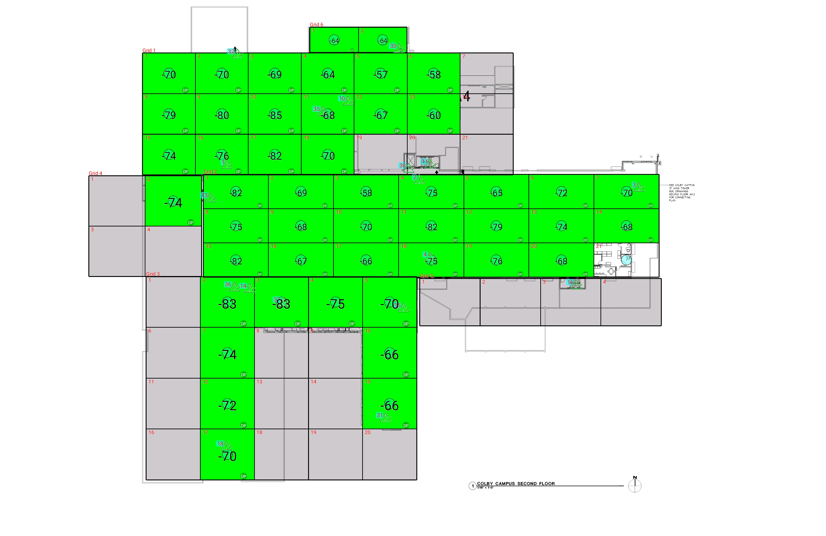

| **Grid** | **# of Areas** | **Area Size (sq. ft)** | **Area Width**  **(ft)** | **Area Height**  **(ft)** | **Ignore Area Color** | **Comments** |
| --- | --- | --- | --- | --- | --- | --- |
| 1 | 21 | 274.29 | 16.54 | 16.58 | Black |  |
| 2 | 21 | 284.23 | 20.34 | 13.98 | Black |  |
| 3 | 20 | 350.68 | 16.90 | 20.75 | Black |  |
| 4 | 4 | 361.71 | 17.61 | 20.54 | Black |  |
| 5 | 4 | 365.23 | 18.87 | 19.36 | Black |  |
| 6 | 2 | 156.85 | 15.14 | 10.36 | Black |  |

**Floor: A1.2**

**Channel: 463550**

| **Critical Point Report** | | | | | | | |
| --- | --- | --- | --- | --- | --- | --- | --- |
| **Critical Point** | **DL**  **Power**  **(dBm)** | **DL**  **DAQ** | **UL**  **Power**  **(dBm)** | **UL**  **DAQ** | **Result** | **DL**  **Loss**  **(dB)** | **Comment** |
| 1 | -77.03 |  |  |  | **Pass** |  |  |
| 2 | -68.39 |  |  |  | **Pass** |  |  |
| 3 | -71.70 |  |  |  | **Pass** |  |  |
| 4 | -68.53 |  |  |  | **Pass** |  |  |
| 10 | -54.53 |  |  |  | **Pass** |  |  |
| 11 | -55.41 |  |  |  | **Pass** |  |  |
| 13 | -78.47 |  |  |  | **Pass** |  |  |
| 14 | -76.84 |  |  |  | **Pass** |  |  |
| 15 | -65.57 |  |  |  | **Pass** |  |  |
| 16 | -55.89 |  |  |  | **Pass** |  |  |
| 18 | -73.08 |  |  |  | **Pass** |  |  |
| 31 | -77.64 |  |  |  | **Pass** |  |  |
| 32 | -68.24 |  |  |  | **Pass** |  |  |
| 33 | -60.72 |  |  |  | **Pass** |  |  |
| 35 | -77.68 |  |  |  | **Pass** |  |  |
| 36 | -87.51 |  |  |  | **Pass** |  |  |
| 37 | -77.12 |  |  |  | **Pass** |  |  |
| 38 | -64.94 |  |  |  | **Pass** |  |  |

| **Area Report** | | | | | | | | |
| --- | --- | --- | --- | --- | --- | --- | --- | --- |
| **Grid** | **Area** | **DL**  **Power**  **(dBm)** | **DL**  **DAQ** | **UL**  **Power**  **(dBm)** | **UL**  **DAQ** | **Result** | **DL**  **Loss**  **(dB)** | **Comment** |
| 1 | 1 | -69.95 |  |  |  | **Pass** |  |  |
| 1 | 2 | -69.12 |  |  |  | **Pass** |  |  |
| 1 | 3 | -68.08 |  |  |  | **Pass** |  |  |
| 1 | 4 | -63.78 |  |  |  | **Pass** |  |  |
| 1 | 5 | -56.36 |  |  |  | **Pass** |  |  |
| 1 | 6 | -57.79 |  |  |  | **Pass** |  |  |
| 1 | 7 | NT | NT | NT | NT | **NT** |  |  |
| 1 | 8 | -78.07 |  |  |  | **Pass** |  |  |
| 1 | 9 | -79.93 |  |  |  | **Pass** |  |  |
| 1 | 10 | -84.32 |  |  |  | **Pass** |  |  |
| 1 | 11 | -67.23 |  |  |  | **Pass** |  |  |
| 1 | 12 | -66.70 |  |  |  | **Pass** |  |  |
| 1 | 13 | -59.51 |  |  |  | **Pass** |  |  |
| 1 | 14 | NT | NT | NT | NT | **NT** |  |  |
| 1 | 15 | -73.41 |  |  |  | **Pass** |  |  |
| 1 | 16 | -75.09 |  |  |  | **Pass** |  |  |
| 1 | 17 | -81.18 |  |  |  | **Pass** |  |  |
| 1 | 18 | -69.21 |  |  |  | **Pass** |  |  |
| 1 | 19 | NT | NT | NT | NT | **NT** |  |  |
| 1 | 20 | NT | NT | NT | NT | **NT** |  |  |
| 1 | 21 | NT | NT | NT | NT | **NT** |  |  |
| 2 | 1 | -81.62 |  |  |  | **Pass** |  |  |
| 2 | 2 | -68.65 |  |  |  | **Pass** |  |  |
| 2 | 3 | -57.60 |  |  |  | **Pass** |  |  |
| 2 | 4 | -74.31 |  |  |  | **Pass** |  |  |
| 2 | 5 | -64.34 |  |  |  | **Pass** |  |  |
| 2 | 6 | -71.47 |  |  |  | **Pass** |  |  |
| 2 | 7 | -69.62 |  |  |  | **Pass** |  |  |
| 2 | 8 | -74.24 |  |  |  | **Pass** |  |  |
| 2 | 9 | -67.50 |  |  |  | **Pass** |  |  |
| 2 | 10 | -69.44 |  |  |  | **Pass** |  |  |
| 2 | 11 | -81.61 |  |  |  | **Pass** |  |  |
| 2 | 12 | -78.88 |  |  |  | **Pass** |  |  |
| 2 | 13 | -73.38 |  |  |  | **Pass** |  |  |
| 2 | 14 | -67.63 |  |  |  | **Pass** |  |  |
| 2 | 15 | -81.28 |  |  |  | **Pass** |  |  |
| 2 | 16 | -66.45 |  |  |  | **Pass** |  |  |
| 2 | 17 | -65.53 |  |  |  | **Pass** |  |  |
| 2 | 18 | -74.42 |  |  |  | **Pass** |  |  |
| 2 | 19 | -75.04 |  |  |  | **Pass** |  |  |
| 2 | 20 | -67.57 |  |  |  | **Pass** |  |  |
| 3 | 1 | NT | NT | NT | NT | **NT** |  |  |
| 3 | 2 | -82.91 |  |  |  | **Pass** |  |  |
| 3 | 3 | -82.14 |  |  |  | **Pass** |  |  |
| 3 | 4 | -74.27 |  |  |  | **Pass** |  |  |
| 3 | 5 | -69.88 |  |  |  | **Pass** |  |  |
| 3 | 6 | NT | NT | NT | NT | **NT** |  |  |
| 3 | 7 | -73.76 |  |  |  | **Pass** |  |  |
| 3 | 8 | NT | NT | NT | NT | **NT** |  |  |
| 3 | 9 | NT | NT | NT | NT | **NT** |  |  |
| 3 | 10 | -65.62 |  |  |  | **Pass** |  |  |
| 3 | 11 | NT | NT | NT | NT | **NT** |  |  |
| 3 | 12 | -71.12 |  |  |  | **Pass** |  |  |
| 3 | 13 | NT | NT | NT | NT | **NT** |  |  |
| 3 | 14 | NT | NT | NT | NT | **NT** |  |  |
| 3 | 15 | -65.78 |  |  |  | **Pass** |  |  |
| 3 | 16 | NT | NT | NT | NT | **NT** |  |  |
| 3 | 17 | -69.27 |  |  |  | **Pass** |  |  |
| 3 | 18 | NT | NT | NT | NT | **NT** |  |  |
| 3 | 19 | NT | NT | NT | NT | **NT** |  |  |
| 3 | 20 | NT | NT | NT | NT | **NT** |  |  |
| 4 | 1 | NT | NT | NT | NT | **NT** |  |  |
| 4 | 2 | -73.50 |  |  |  | **Pass** |  |  |
| 4 | 3 | NT | NT | NT | NT | **NT** |  |  |
| 4 | 4 | NT | NT | NT | NT | **NT** |  |  |
| 5 | 1 | NT | NT | NT | NT | **NT** |  |  |
| 5 | 2 | NT | NT | NT | NT | **NT** |  |  |
| 5 | 3 | NT | NT | NT | NT | **NT** |  |  |
| 5 | 4 | NT | NT | NT | NT | **NT** |  |  |
| 6 | 1 | -63.17 |  |  |  | **Pass** |  |  |
| 6 | 2 | -64.00 |  |  |  | **Pass** |  |  |

**Floor: A1.3**

**Channel: 463550**

**Result: Pass**

| **Freq (MHz)** | **Tech** | **Band** | **Ant Gain** | **Cable Loss** | **Ph.** | **Type** | **Mod** | **NAC** | **Area Points passed (%)** | **Critical Points passed (%)** |
| --- | --- | --- | --- | --- | --- | --- | --- | --- | --- | --- |
| 463.55000 | P25 | PRMCE | 0.00 | 0.00 |  |  |  |  | 38/38 (100%) | 13/13 (100%) |

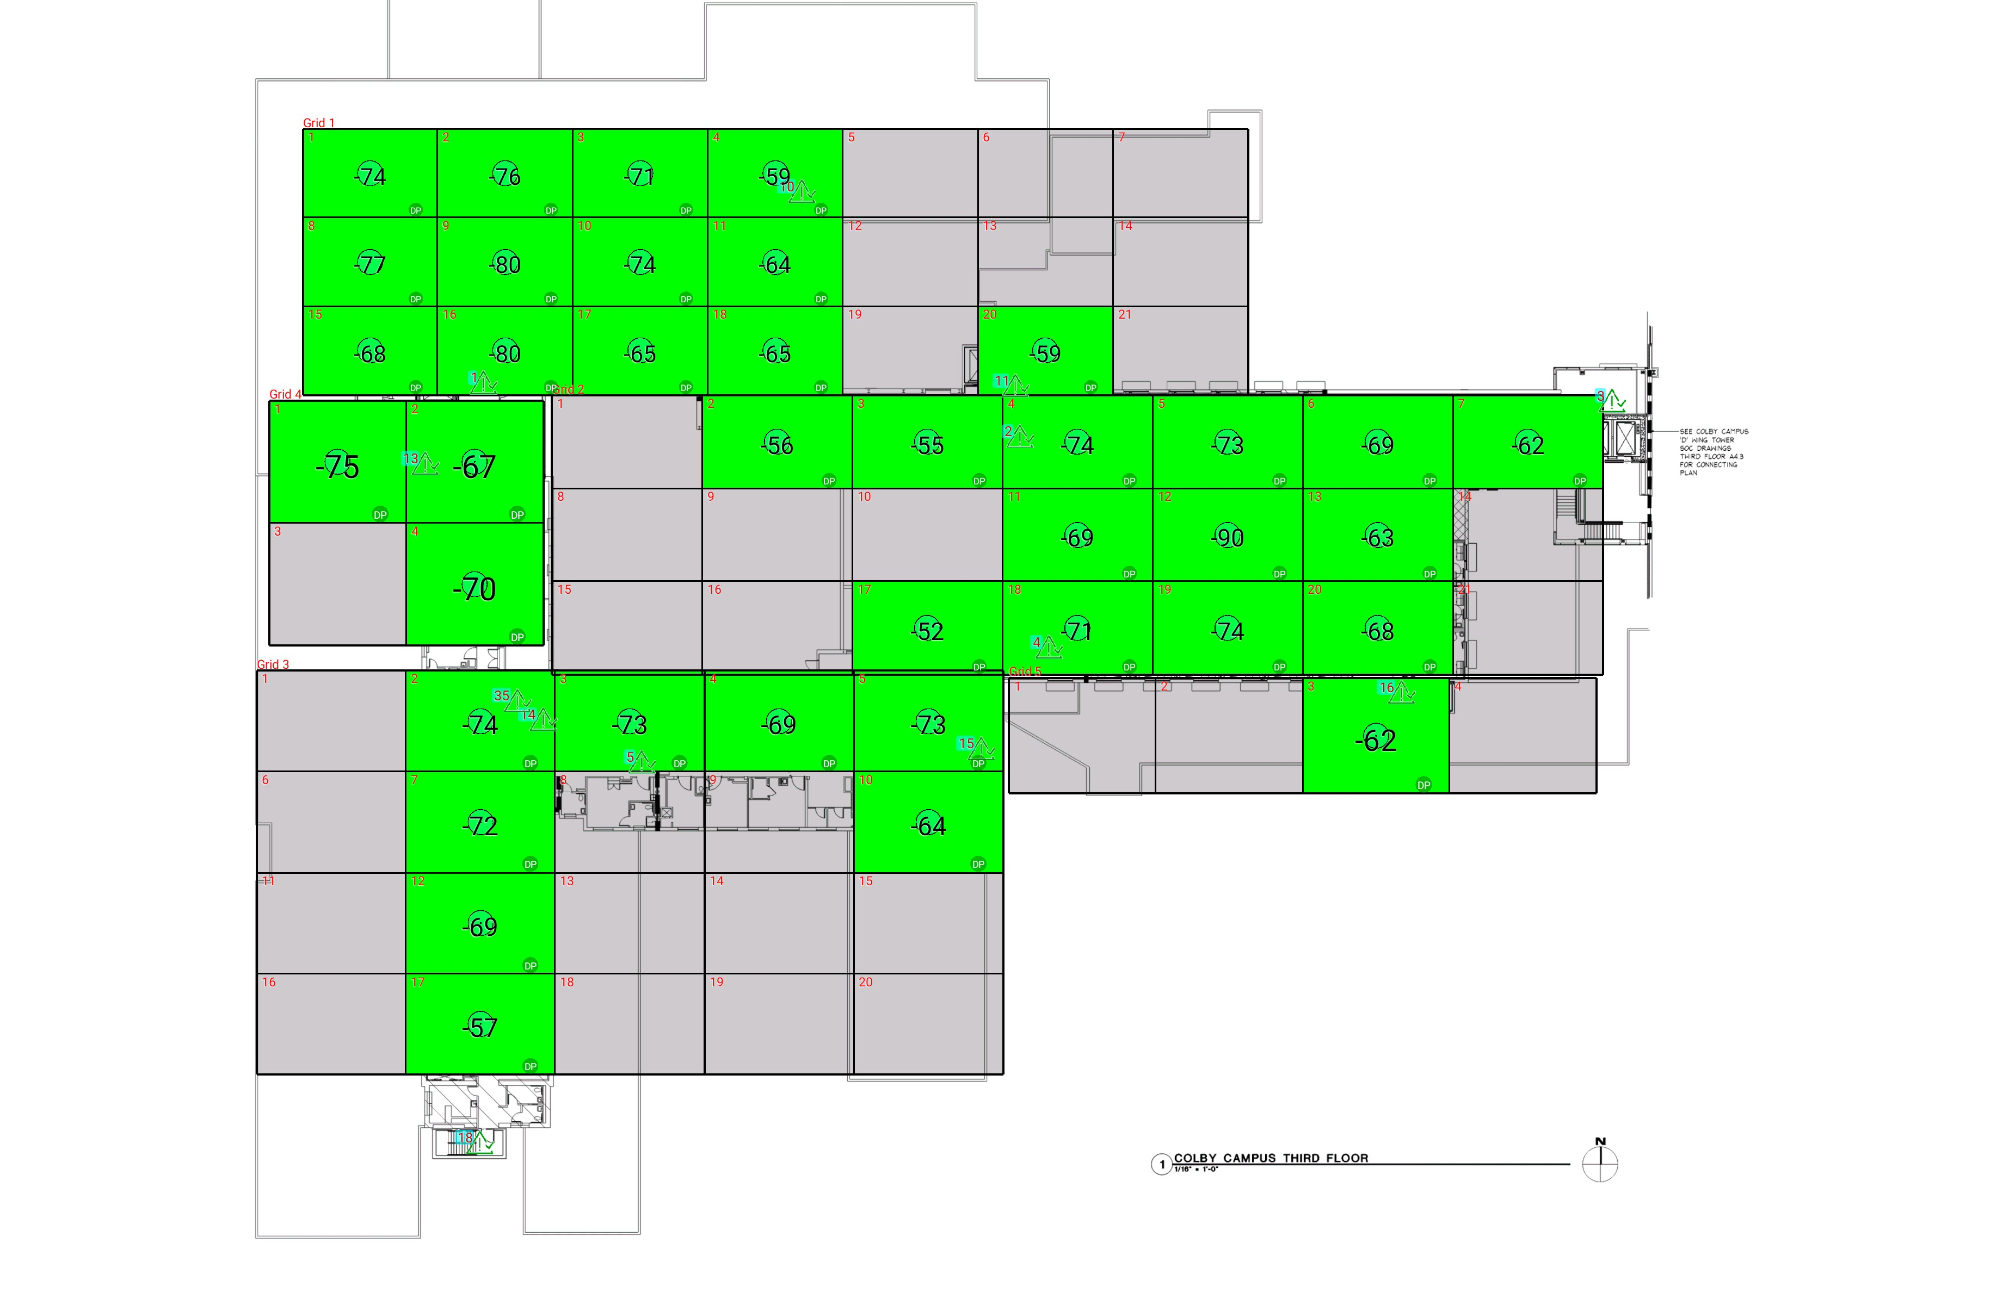

| **Grid** | **# of Areas** | **Area Size (sq. ft)** | **Area Width**  **(ft)** | **Area Height**  **(ft)** | **Ignore Area Color** | **Comments** |
| --- | --- | --- | --- | --- | --- | --- |
| 1 | 21 | 257.92 | 17.34 | 14.87 | Black |  |
| 2 | 21 | 300.92 | 19.29 | 15.60 | Black |  |
| 3 | 20 | 324.99 | 19.18 | 16.94 | Black |  |
| 4 | 4 | 361.71 | 17.61 | 20.54 | Black |  |
| 5 | 4 | 365.23 | 18.87 | 19.36 | Black |  |

**Floor: A1.3**

**Channel: 463550**

| **Critical Point Report** | | | | | | | |
| --- | --- | --- | --- | --- | --- | --- | --- |
| **Critical Point** | **DL**  **Power**  **(dBm)** | **DL**  **DAQ** | **UL**  **Power**  **(dBm)** | **UL**  **DAQ** | **Result** | **DL**  **Loss**  **(dB)** | **Comment** |
| 1 | -75.76 |  |  |  | **Pass** |  |  |
| 2 | -61.47 |  |  |  | **Pass** |  |  |
| 3 | -68.00 |  |  |  | **Pass** |  |  |
| 4 | -59.79 |  |  |  | **Pass** |  |  |
| 5 | -73.72 |  |  |  | **Pass** |  |  |
| 10 | -60.76 |  |  |  | **Pass** |  |  |
| 11 | -64.63 |  |  |  | **Pass** |  |  |
| 13 | -74.90 |  |  |  | **Pass** |  |  |
| 14 | -67.97 |  |  |  | **Pass** |  |  |
| 15 | -54.52 |  |  |  | **Pass** |  |  |
| 16 | -55.83 |  |  |  | **Pass** |  |  |
| 18 | -58.53 |  |  |  | **Pass** |  |  |
| 35 | -76.93 |  |  |  | **Pass** |  |  |

| **Area Report** | | | | | | | | |
| --- | --- | --- | --- | --- | --- | --- | --- | --- |
| **Grid** | **Area** | **DL**  **Power**  **(dBm)** | **DL**  **DAQ** | **UL**  **Power**  **(dBm)** | **UL**  **DAQ** | **Result** | **DL**  **Loss**  **(dB)** | **Comment** |
| 1 | 1 | -73.11 |  |  |  | **Pass** |  |  |
| 1 | 2 | -75.64 |  |  |  | **Pass** |  |  |
| 1 | 3 | -70.04 |  |  |  | **Pass** |  |  |
| 1 | 4 | -58.28 |  |  |  | **Pass** |  |  |
| 1 | 5 | NT | NT | NT | NT | **NT** |  |  |
| 1 | 6 | NT | NT | NT | NT | **NT** |  |  |
| 1 | 7 | NT | NT | NT | NT | **NT** |  |  |
| 1 | 8 | -76.55 |  |  |  | **Pass** |  |  |
| 1 | 9 | -79.42 |  |  |  | **Pass** |  |  |
| 1 | 10 | -73.54 |  |  |  | **Pass** |  |  |
| 1 | 11 | -63.80 |  |  |  | **Pass** |  |  |
| 1 | 12 | NT | NT | NT | NT | **NT** |  |  |
| 1 | 13 | NT | NT | NT | NT | **NT** |  |  |
| 1 | 14 | NT | NT | NT | NT | **NT** |  |  |
| 1 | 15 | -67.57 |  |  |  | **Pass** |  |  |
| 1 | 16 | -79.12 |  |  |  | **Pass** |  |  |
| 1 | 17 | -64.61 |  |  |  | **Pass** |  |  |
| 1 | 18 | -64.55 |  |  |  | **Pass** |  |  |
| 1 | 19 | NT | NT | NT | NT | **NT** |  |  |
| 1 | 20 | -58.84 |  |  |  | **Pass** |  |  |
| 1 | 21 | NT | NT | NT | NT | **NT** |  |  |
| 2 | 1 | NT | NT | NT | NT | **NT** |  |  |
| 2 | 2 | -55.81 |  |  |  | **Pass** |  |  |
| 2 | 3 | -54.98 |  |  |  | **Pass** |  |  |
| 2 | 4 | -73.04 |  |  |  | **Pass** |  |  |
| 2 | 5 | -72.91 |  |  |  | **Pass** |  |  |
| 2 | 6 | -68.57 |  |  |  | **Pass** |  |  |
| 2 | 7 | -61.89 |  |  |  | **Pass** |  |  |
| 2 | 8 | NT | NT | NT | NT | **NT** |  |  |
| 2 | 9 | NT | NT | NT | NT | **NT** |  |  |
| 2 | 10 | NT | NT | NT | NT | **NT** |  |  |
| 2 | 11 | -68.88 |  |  |  | **Pass** |  |  |
| 2 | 12 | -89.42 |  |  |  | **Pass** |  |  |
| 2 | 13 | -62.87 |  |  |  | **Pass** |  |  |
| 2 | 14 | NT | NT | NT | NT | **NT** |  |  |
| 2 | 15 | NT | NT | NT | NT | **NT** |  |  |
| 2 | 16 | NT | NT | NT | NT | **NT** |  |  |
| 2 | 17 | -51.37 |  |  |  | **Pass** |  |  |
| 2 | 18 | -70.54 |  |  |  | **Pass** |  |  |
| 2 | 19 | -73.50 |  |  |  | **Pass** |  |  |
| 2 | 20 | -67.97 |  |  |  | **Pass** |  |  |
| 2 | 21 | NT | NT | NT | NT | **NT** |  |  |
| 3 | 1 | NT | NT | NT | NT | **NT** |  |  |
| 3 | 2 | -73.10 |  |  |  | **Pass** |  |  |
| 3 | 3 | -72.70 |  |  |  | **Pass** |  |  |
| 3 | 4 | -69.00 |  |  |  | **Pass** |  |  |
| 3 | 5 | -72.05 |  |  |  | **Pass** |  |  |
| 3 | 6 | NT | NT | NT | NT | **NT** |  |  |
| 3 | 7 | -71.49 |  |  |  | **Pass** |  |  |
| 3 | 8 | NT | NT | NT | NT | **NT** |  |  |
| 3 | 9 | NT | NT | NT | NT | **NT** |  |  |
| 3 | 10 | -63.44 |  |  |  | **Pass** |  |  |
| 3 | 11 | NT | NT | NT | NT | **NT** |  |  |
| 3 | 12 | -68.13 |  |  |  | **Pass** |  |  |
| 3 | 13 | NT | NT | NT | NT | **NT** |  |  |
| 3 | 14 | NT | NT | NT | NT | **NT** |  |  |
| 3 | 15 | NT | NT | NT | NT | **NT** |  |  |
| 3 | 16 | NT | NT | NT | NT | **NT** |  |  |
| 3 | 17 | -56.53 |  |  |  | **Pass** |  |  |
| 3 | 18 | NT | NT | NT | NT | **NT** |  |  |
| 3 | 19 | NT | NT | NT | NT | **NT** |  |  |
| 3 | 20 | NT | NT | NT | NT | **NT** |  |  |
| 4 | 1 | -74.17 |  |  |  | **Pass** |  |  |
| 4 | 2 | -66.12 |  |  |  | **Pass** |  |  |
| 4 | 3 | NT | NT | NT | NT | **NT** |  |  |
| 4 | 4 | -69.77 |  |  |  | **Pass** |  |  |
| 5 | 1 | NT | NT | NT | NT | **NT** |  |  |
| 5 | 2 | NT | NT | NT | NT | **NT** |  |  |
| 5 | 3 | -61.01 |  |  |  | **Pass** |  |  |
| 5 | 4 | NT | NT | NT | NT | **NT** |  |  |

**Floor: A1.4**

**Channel: 463550**

**Result: Pass**

| **Freq (MHz)** | **Tech** | **Band** | **Ant Gain** | **Cable Loss** | **Ph.** | **Type** | **Mod** | **NAC** | **Area Points passed (%)** | **Critical Points passed (%)** |
| --- | --- | --- | --- | --- | --- | --- | --- | --- | --- | --- |
| 463.55000 | P25 | PRMCE | 0.00 | 0.00 |  |  |  |  | 36/36 (100%) | 12/12 (100%) |

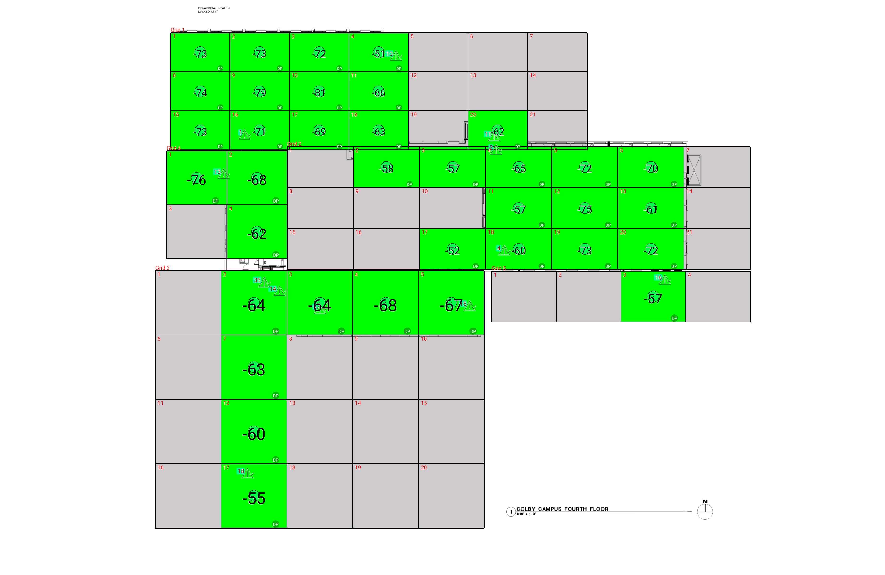

| **Grid** | **# of Areas** | **Area Size (sq. ft)** | **Area Width**  **(ft)** | **Area Height**  **(ft)** | **Ignore Area Color** | **Comments** |
| --- | --- | --- | --- | --- | --- | --- |
| 1 | 21 | 257.46 | 17.34 | 14.85 | Black |  |
| 2 | 21 | 300.92 | 19.29 | 15.60 | Black |  |
| 3 | 20 | 469.72 | 19.18 | 24.49 | Black |  |
| 4 | 4 | 361.71 | 17.61 | 20.54 | Black |  |
| 5 | 4 | 365.23 | 18.87 | 19.36 | Black |  |

**Floor: A1.4**

**Channel: 463550**

| **Critical Point Report** | | | | | | | |
| --- | --- | --- | --- | --- | --- | --- | --- |
| **Critical Point** | **DL**  **Power**  **(dBm)** | **DL**  **DAQ** | **UL**  **Power**  **(dBm)** | **UL**  **DAQ** | **Result** | **DL**  **Loss**  **(dB)** | **Comment** |
| 1 | -64.08 |  |  |  | **Pass** |  |  |
| 2 | -67.68 |  |  |  | **Pass** |  |  |
| 4 | -56.02 |  |  |  | **Pass** |  |  |
| 5 | -66.65 |  |  |  | **Pass** |  |  |
| 10 | -38.53 |  |  |  | **Pass** |  |  |
| 11 | -51.64 |  |  |  | **Pass** |  |  |
| 13 | -73.30 |  |  |  | **Pass** |  |  |
| 14 | -55.63 |  |  |  | **Pass** |  |  |
| 15 | -57.11 |  |  |  | **Pass** |  |  |
| 16 | -55.32 |  |  |  | **Pass** |  |  |
| 18 | -51.85 |  |  |  | **Pass** |  |  |
| 35 | -63.73 |  |  |  | **Pass** |  |  |

| **Area Report** | | | | | | | | |
| --- | --- | --- | --- | --- | --- | --- | --- | --- |
| **Grid** | **Area** | **DL**  **Power**  **(dBm)** | **DL**  **DAQ** | **UL**  **Power**  **(dBm)** | **UL**  **DAQ** | **Result** | **DL**  **Loss**  **(dB)** | **Comment** |
| 1 | 1 | -72.34 |  |  |  | **Pass** |  |  |
| 1 | 2 | -72.45 |  |  |  | **Pass** |  |  |
| 1 | 3 | -71.49 |  |  |  | **Pass** |  |  |
| 1 | 4 | -50.25 |  |  |  | **Pass** |  |  |
| 1 | 5 | NT | NT | NT | NT | **NT** |  |  |
| 1 | 6 | NT | NT | NT | NT | **NT** |  |  |
| 1 | 7 | NT | NT | NT | NT | **NT** |  |  |
| 1 | 8 | -73.23 |  |  |  | **Pass** |  |  |
| 1 | 9 | -78.30 |  |  |  | **Pass** |  |  |
| 1 | 10 | -80.61 |  |  |  | **Pass** |  |  |
| 1 | 11 | -65.11 |  |  |  | **Pass** |  |  |
| 1 | 12 | NT | NT | NT | NT | **NT** |  |  |
| 1 | 13 | NT | NT | NT | NT | **NT** |  |  |
| 1 | 14 | NT | NT | NT | NT | **NT** |  |  |
| 1 | 15 | -72.41 |  |  |  | **Pass** |  |  |
| 1 | 16 | -70.35 |  |  |  | **Pass** |  |  |
| 1 | 17 | -68.86 |  |  |  | **Pass** |  |  |
| 1 | 18 | -62.99 |  |  |  | **Pass** |  |  |
| 1 | 19 | NT | NT | NT | NT | **NT** |  |  |
| 1 | 20 | -61.95 |  |  |  | **Pass** |  |  |
| 1 | 21 | NT | NT | NT | NT | **NT** |  |  |
| 2 | 1 | NT | NT | NT | NT | **NT** |  |  |
| 2 | 2 | -57.17 |  |  |  | **Pass** |  |  |
| 2 | 3 | -56.13 |  |  |  | **Pass** |  |  |
| 2 | 4 | -64.82 |  |  |  | **Pass** |  |  |
| 2 | 5 | -71.06 |  |  |  | **Pass** |  |  |
| 2 | 6 | -69.80 |  |  |  | **Pass** |  |  |
| 2 | 7 | NT | NT | NT | NT | **NT** |  |  |
| 2 | 8 | NT | NT | NT | NT | **NT** |  |  |
| 2 | 9 | NT | NT | NT | NT | **NT** |  |  |
| 2 | 10 | NT | NT | NT | NT | **NT** |  |  |
| 2 | 11 | -56.33 |  |  |  | **Pass** |  |  |
| 2 | 12 | -74.94 |  |  |  | **Pass** |  |  |
| 2 | 13 | -60.91 |  |  |  | **Pass** |  |  |
| 2 | 14 | NT | NT | NT | NT | **NT** |  |  |
| 2 | 15 | NT | NT | NT | NT | **NT** |  |  |
| 2 | 16 | NT | NT | NT | NT | **NT** |  |  |
| 2 | 17 | -51.88 |  |  |  | **Pass** |  |  |
| 2 | 18 | -59.98 |  |  |  | **Pass** |  |  |
| 2 | 19 | -72.47 |  |  |  | **Pass** |  |  |
| 2 | 20 | -71.42 |  |  |  | **Pass** |  |  |
| 2 | 21 | NT | NT | NT | NT | **NT** |  |  |
| 3 | 1 | NT | NT | NT | NT | **NT** |  |  |
| 3 | 2 | -63.72 |  |  |  | **Pass** |  |  |
| 3 | 3 | -63.62 |  |  |  | **Pass** |  |  |
| 3 | 4 | -67.06 |  |  |  | **Pass** |  |  |
| 3 | 5 | -66.91 |  |  |  | **Pass** |  |  |
| 3 | 6 | NT | NT | NT | NT | **NT** |  |  |
| 3 | 7 | -62.56 |  |  |  | **Pass** |  |  |
| 3 | 8 | NT | NT | NT | NT | **NT** |  |  |
| 3 | 9 | NT | NT | NT | NT | **NT** |  |  |
| 3 | 10 | NT | NT | NT | NT | **NT** |  |  |
| 3 | 11 | NT | NT | NT | NT | **NT** |  |  |
| 3 | 12 | -59.48 |  |  |  | **Pass** |  |  |
| 3 | 13 | NT | NT | NT | NT | **NT** |  |  |
| 3 | 14 | NT | NT | NT | NT | **NT** |  |  |
| 3 | 15 | NT | NT | NT | NT | **NT** |  |  |
| 3 | 16 | NT | NT | NT | NT | **NT** |  |  |
| 3 | 17 | -54.56 |  |  |  | **Pass** |  |  |
| 3 | 18 | NT | NT | NT | NT | **NT** |  |  |
| 3 | 19 | NT | NT | NT | NT | **NT** |  |  |
| 3 | 20 | NT | NT | NT | NT | **NT** |  |  |
| 4 | 1 | -75.48 |  |  |  | **Pass** |  |  |
| 4 | 2 | -67.26 |  |  |  | **Pass** |  |  |
| 4 | 3 | NT | NT | NT | NT | **NT** |  |  |
| 4 | 4 | -61.82 |  |  |  | **Pass** |  |  |
| 5 | 1 | NT | NT | NT | NT | **NT** |  |  |
| 5 | 2 | NT | NT | NT | NT | **NT** |  |  |
| 5 | 3 | -56.86 |  |  |  | **Pass** |  |  |
| 5 | 4 | NT | NT | NT | NT | **NT** |  |  |

**Floor: A1.5**

**Channel: 463550**

**Result: Pass**

| **Freq (MHz)** | **Tech** | **Band** | **Ant Gain** | **Cable Loss** | **Ph.** | **Type** | **Mod** | **NAC** | **Area Points passed (%)** | **Critical Points passed (%)** |
| --- | --- | --- | --- | --- | --- | --- | --- | --- | --- | --- |
| 463.55000 | P25 | PRMCE | 0.00 | 0.00 |  |  |  |  | 24/24 (100%) | 8/8 (100%) |

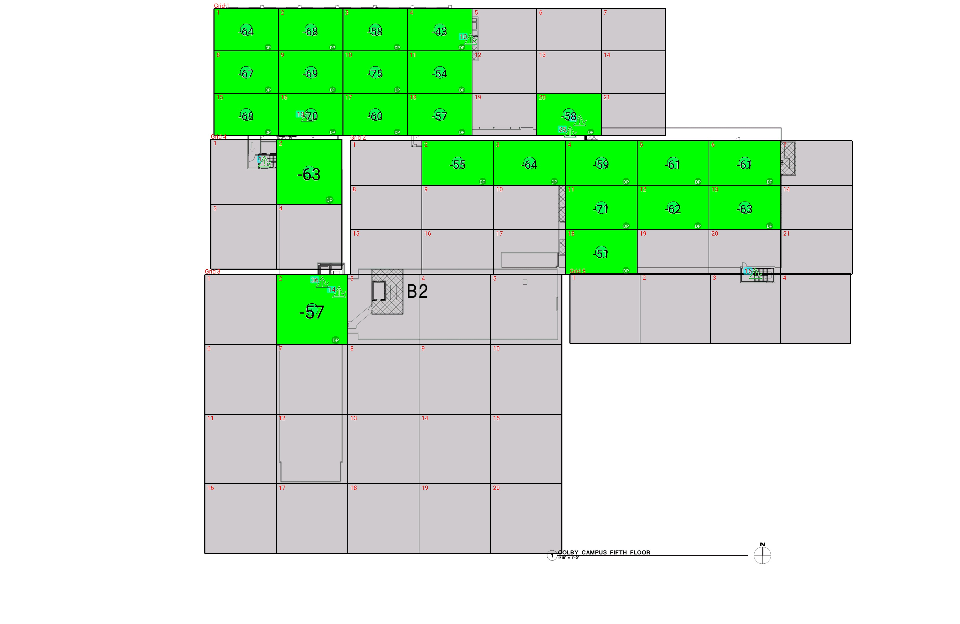

| **Grid** | **# of Areas** | **Area Size (sq. ft)** | **Area Width**  **(ft)** | **Area Height**  **(ft)** | **Ignore Area Color** | **Comments** |
| --- | --- | --- | --- | --- | --- | --- |
| 1 | 21 | 257.46 | 17.34 | 14.85 | Black |  |
| 2 | 21 | 301.44 | 19.29 | 15.63 | Black |  |
| 3 | 20 | 469.72 | 19.18 | 24.49 | Black |  |
| 4 | 4 | 400.28 | 17.61 | 22.73 | Black |  |
| 5 | 4 | 460.49 | 18.87 | 24.41 | Black |  |

**Floor: A1.5**

**Channel: 463550**

| **Critical Point Report** | | | | | | | |
| --- | --- | --- | --- | --- | --- | --- | --- |
| **Critical Point** | **DL**  **Power**  **(dBm)** | **DL**  **DAQ** | **UL**  **Power**  **(dBm)** | **UL**  **DAQ** | **Result** | **DL**  **Loss**  **(dB)** | **Comment** |
| 1 | -55.77 |  |  |  | **Pass** |  |  |
| 10 | -42.61 |  |  |  | **Pass** |  |  |
| 11 | -72.85 |  |  |  | **Pass** |  |  |
| 13 | -63.48 |  |  |  | **Pass** |  |  |
| 14 | -53.46 |  |  |  | **Pass** |  |  |
| 16 | -50.08 |  |  |  | **Pass** |  |  |
| 35 | -56.71 |  |  |  | **Pass** |  |  |
| 36 | -60.04 |  |  |  | **Pass** |  |  |

| **Area Report** | | | | | | | | |
| --- | --- | --- | --- | --- | --- | --- | --- | --- |
| **Grid** | **Area** | **DL**  **Power**  **(dBm)** | **DL**  **DAQ** | **UL**  **Power**  **(dBm)** | **UL**  **DAQ** | **Result** | **DL**  **Loss**  **(dB)** | **Comment** |
| 1 | 1 | -63.65 |  |  |  | **Pass** |  |  |
| 1 | 2 | -67.94 |  |  |  | **Pass** |  |  |
| 1 | 3 | -57.48 |  |  |  | **Pass** |  |  |
| 1 | 4 | -42.61 |  |  |  | **Pass** |  |  |
| 1 | 5 | NT | NT | NT | NT | **NT** |  |  |
| 1 | 6 | NT | NT | NT | NT | **NT** |  |  |
| 1 | 7 | NT | NT | NT | NT | **NT** |  |  |
| 1 | 8 | -66.73 |  |  |  | **Pass** |  |  |
| 1 | 9 | -68.68 |  |  |  | **Pass** |  |  |
| 1 | 10 | -74.30 |  |  |  | **Pass** |  |  |
| 1 | 11 | -53.61 |  |  |  | **Pass** |  |  |
| 1 | 12 | NT | NT | NT | NT | **NT** |  |  |
| 1 | 13 | NT | NT | NT | NT | **NT** |  |  |
| 1 | 14 | NT | NT | NT | NT | **NT** |  |  |
| 1 | 15 | -67.70 |  |  |  | **Pass** |  |  |
| 1 | 16 | -69.49 |  |  |  | **Pass** |  |  |
| 1 | 17 | -59.01 |  |  |  | **Pass** |  |  |
| 1 | 18 | -56.58 |  |  |  | **Pass** |  |  |
| 1 | 19 | NT | NT | NT | NT | **NT** |  |  |
| 1 | 20 | -57.77 |  |  |  | **Pass** |  |  |
| 1 | 21 | NT | NT | NT | NT | **NT** |  |  |
| 2 | 1 | NT | NT | NT | NT | **NT** |  |  |
| 2 | 2 | -54.40 |  |  |  | **Pass** |  |  |
| 2 | 3 | -63.24 |  |  |  | **Pass** |  |  |
| 2 | 4 | -58.07 |  |  |  | **Pass** |  |  |
| 2 | 5 | -60.48 |  |  |  | **Pass** |  |  |
| 2 | 6 | -60.28 |  |  |  | **Pass** |  |  |
| 2 | 7 | NT | NT | NT | NT | **NT** |  |  |
| 2 | 8 | NT | NT | NT | NT | **NT** |  |  |
| 2 | 9 | NT | NT | NT | NT | **NT** |  |  |
| 2 | 10 | NT | NT | NT | NT | **NT** |  |  |
| 2 | 11 | -70.21 |  |  |  | **Pass** |  |  |
| 2 | 12 | -61.60 |  |  |  | **Pass** |  |  |
| 2 | 13 | -62.92 |  |  |  | **Pass** |  |  |
| 2 | 14 | NT | NT | NT | NT | **NT** |  |  |
| 2 | 15 | NT | NT | NT | NT | **NT** |  |  |
| 2 | 16 | NT | NT | NT | NT | **NT** |  |  |
| 2 | 17 | NT | NT | NT | NT | **NT** |  |  |
| 2 | 18 | -50.95 |  |  |  | **Pass** |  |  |
| 2 | 19 | NT | NT | NT | NT | **NT** |  |  |
| 2 | 20 | NT | NT | NT | NT | **NT** |  |  |
| 2 | 21 | NT | NT | NT | NT | **NT** |  |  |
| 3 | 1 | NT | NT | NT | NT | **NT** |  |  |
| 3 | 2 | -56.82 |  |  |  | **Pass** |  |  |
| 3 | 3 | NT | NT | NT | NT | **NT** |  |  |
| 3 | 4 | NT | NT | NT | NT | **NT** |  |  |
| 3 | 5 | NT | NT | NT | NT | **NT** |  |  |
| 3 | 6 | NT | NT | NT | NT | **NT** |  |  |
| 3 | 7 | NT | NT | NT | NT | **NT** |  |  |
| 3 | 8 | NT | NT | NT | NT | **NT** |  |  |
| 3 | 9 | NT | NT | NT | NT | **NT** |  |  |
| 3 | 10 | NT | NT | NT | NT | **NT** |  |  |
| 3 | 11 | NT | NT | NT | NT | **NT** |  |  |
| 3 | 12 | NT | NT | NT | NT | **NT** |  |  |
| 3 | 13 | NT | NT | NT | NT | **NT** |  |  |
| 3 | 14 | NT | NT | NT | NT | **NT** |  |  |
| 3 | 15 | NT | NT | NT | NT | **NT** |  |  |
| 3 | 16 | NT | NT | NT | NT | **NT** |  |  |
| 3 | 17 | NT | NT | NT | NT | **NT** |  |  |
| 3 | 18 | NT | NT | NT | NT | **NT** |  |  |
| 3 | 19 | NT | NT | NT | NT | **NT** |  |  |
| 3 | 20 | NT | NT | NT | NT | **NT** |  |  |
| 4 | 1 | NT | NT | NT | NT | **NT** |  |  |
| 4 | 2 | -62.40 |  |  |  | **Pass** |  |  |
| 4 | 3 | NT | NT | NT | NT | **NT** |  |  |
| 4 | 4 | NT | NT | NT | NT | **NT** |  |  |
| 5 | 1 | NT | NT | NT | NT | **NT** |  |  |
| 5 | 2 | NT | NT | NT | NT | **NT** |  |  |
| 5 | 3 | NT | NT | NT | NT | **NT** |  |  |
| 5 | 4 | NT | NT | NT | NT | **NT** |  |  |

**Floor: A1.6**

**Channel: 463550**

**Result: Pass**

| **Freq (MHz)** | **Tech** | **Band** | **Ant Gain** | **Cable Loss** | **Ph.** | **Type** | **Mod** | **NAC** | **Area Points passed (%)** | **Critical Points passed (%)** |
| --- | --- | --- | --- | --- | --- | --- | --- | --- | --- | --- |
| 463.55000 | P25 | PRMCE | 0.00 | 0.00 |  |  |  |  | 15/15 (100%) | 5/5 (100%) |

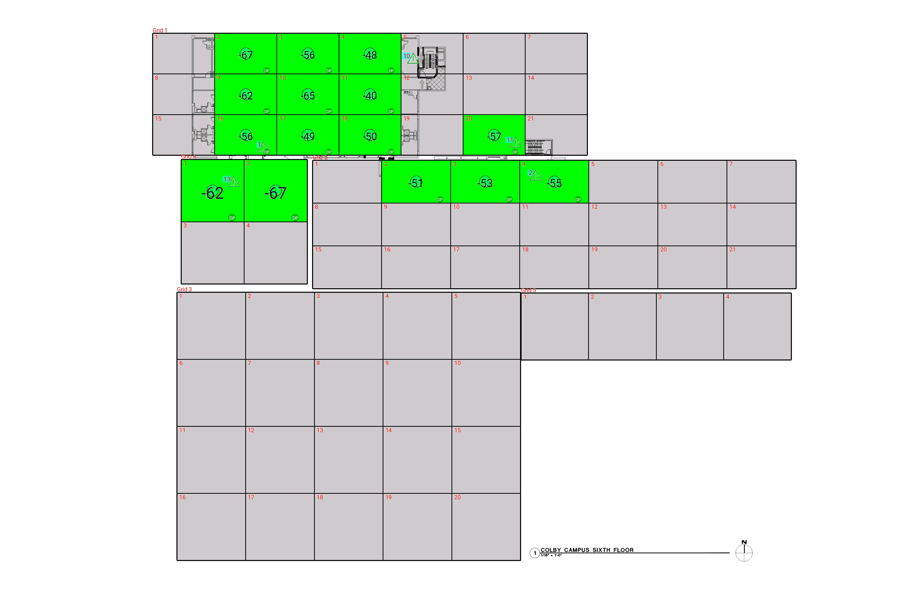

| **Grid** | **# of Areas** | **Area Size (sq. ft)** | **Area Width**  **(ft)** | **Area Height**  **(ft)** | **Ignore Area Color** | **Comments** |
| --- | --- | --- | --- | --- | --- | --- |
| 1 | 21 | 257.46 | 17.34 | 14.85 | Black |  |
| 2 | 21 | 301.44 | 19.29 | 15.63 | Black |  |
| 3 | 20 | 469.72 | 19.18 | 24.49 | Black |  |
| 4 | 4 | 400.28 | 17.61 | 22.73 | Black |  |
| 5 | 4 | 460.49 | 18.87 | 24.41 | Black |  |

**Floor: A1.6**

**Channel: 463550**

| **Critical Point Report** | | | | | | | |
| --- | --- | --- | --- | --- | --- | --- | --- |
| **Critical Point** | **DL**  **Power**  **(dBm)** | **DL**  **DAQ** | **UL**  **Power**  **(dBm)** | **UL**  **DAQ** | **Result** | **DL**  **Loss**  **(dB)** | **Comment** |
| 1 | -57.27 |  |  |  | **Pass** |  |  |
| 2 | -60.07 |  |  |  | **Pass** |  |  |
| 10 | -44.35 |  |  |  | **Pass** |  |  |
| 11 | -57.16 |  |  |  | **Pass** |  |  |
| 13 | -56.34 |  |  |  | **Pass** |  |  |

| **Area Report** | | | | | | | | |
| --- | --- | --- | --- | --- | --- | --- | --- | --- |
| **Grid** | **Area** | **DL**  **Power**  **(dBm)** | **DL**  **DAQ** | **UL**  **Power**  **(dBm)** | **UL**  **DAQ** | **Result** | **DL**  **Loss**  **(dB)** | **Comment** |
| 1 | 1 | NT | NT | NT | NT | **NT** |  |  |
| 1 | 2 | -66.24 |  |  |  | **Pass** |  |  |
| 1 | 3 | -55.92 |  |  |  | **Pass** |  |  |
| 1 | 4 | -47.54 |  |  |  | **Pass** |  |  |
| 1 | 5 | NT | NT | NT | NT | **NT** |  |  |
| 1 | 6 | NT | NT | NT | NT | **NT** |  |  |
| 1 | 7 | NT | NT | NT | NT | **NT** |  |  |
| 1 | 8 | NT | NT | NT | NT | **NT** |  |  |
| 1 | 9 | -61.76 |  |  |  | **Pass** |  |  |
| 1 | 10 | -64.10 |  |  |  | **Pass** |  |  |
| 1 | 11 | -39.85 |  |  |  | **Pass** |  |  |
| 1 | 12 | NT | NT | NT | NT | **NT** |  |  |
| 1 | 13 | NT | NT | NT | NT | **NT** |  |  |
| 1 | 14 | NT | NT | NT | NT | **NT** |  |  |
| 1 | 15 | NT | NT | NT | NT | **NT** |  |  |
| 1 | 16 | -55.49 |  |  |  | **Pass** |  |  |
| 1 | 17 | -48.15 |  |  |  | **Pass** |  |  |
| 1 | 18 | -49.03 |  |  |  | **Pass** |  |  |
| 1 | 19 | NT | NT | NT | NT | **NT** |  |  |
| 1 | 20 | -56.67 |  |  |  | **Pass** |  |  |
| 1 | 21 | NT | NT | NT | NT | **NT** |  |  |
| 2 | 1 | NT | NT | NT | NT | **NT** |  |  |
| 2 | 2 | -50.73 |  |  |  | **Pass** |  |  |
| 2 | 3 | -52.79 |  |  |  | **Pass** |  |  |
| 2 | 4 | -54.04 |  |  |  | **Pass** |  |  |
| 2 | 5 | NT | NT | NT | NT | **NT** |  |  |
| 2 | 6 | NT | NT | NT | NT | **NT** |  |  |
| 2 | 7 | NT | NT | NT | NT | **NT** |  |  |
| 2 | 8 | NT | NT | NT | NT | **NT** |  |  |
| 2 | 9 | NT | NT | NT | NT | **NT** |  |  |
| 2 | 10 | NT | NT | NT | NT | **NT** |  |  |
| 2 | 11 | NT | NT | NT | NT | **NT** |  |  |
| 2 | 12 | NT | NT | NT | NT | **NT** |  |  |
| 2 | 13 | NT | NT | NT | NT | **NT** |  |  |
| 2 | 14 | NT | NT | NT | NT | **NT** |  |  |
| 2 | 15 | NT | NT | NT | NT | **NT** |  |  |
| 2 | 16 | NT | NT | NT | NT | **NT** |  |  |
| 2 | 17 | NT | NT | NT | NT | **NT** |  |  |
| 2 | 18 | NT | NT | NT | NT | **NT** |  |  |
| 2 | 19 | NT | NT | NT | NT | **NT** |  |  |
| 2 | 20 | NT | NT | NT | NT | **NT** |  |  |
| 2 | 21 | NT | NT | NT | NT | **NT** |  |  |
| 3 | 1 | NT | NT | NT | NT | **NT** |  |  |
| 3 | 2 | NT | NT | NT | NT | **NT** |  |  |
| 3 | 3 | NT | NT | NT | NT | **NT** |  |  |
| 3 | 4 | NT | NT | NT | NT | **NT** |  |  |
| 3 | 5 | NT | NT | NT | NT | **NT** |  |  |
| 3 | 6 | NT | NT | NT | NT | **NT** |  |  |
| 3 | 7 | NT | NT | NT | NT | **NT** |  |  |
| 3 | 8 | NT | NT | NT | NT | **NT** |  |  |
| 3 | 9 | NT | NT | NT | NT | **NT** |  |  |
| 3 | 10 | NT | NT | NT | NT | **NT** |  |  |
| 3 | 11 | NT | NT | NT | NT | **NT** |  |  |
| 3 | 12 | NT | NT | NT | NT | **NT** |  |  |
| 3 | 13 | NT | NT | NT | NT | **NT** |  |  |
| 3 | 14 | NT | NT | NT | NT | **NT** |  |  |
| 3 | 15 | NT | NT | NT | NT | **NT** |  |  |
| 3 | 16 | NT | NT | NT | NT | **NT** |  |  |
| 3 | 17 | NT | NT | NT | NT | **NT** |  |  |
| 3 | 18 | NT | NT | NT | NT | **NT** |  |  |
| 3 | 19 | NT | NT | NT | NT | **NT** |  |  |
| 3 | 20 | NT | NT | NT | NT | **NT** |  |  |
| 4 | 1 | -61.97 |  |  |  | **Pass** |  |  |
| 4 | 2 | -66.98 |  |  |  | **Pass** |  |  |
| 4 | 3 | NT | NT | NT | NT | **NT** |  |  |
| 4 | 4 | NT | NT | NT | NT | **NT** |  |  |
| 5 | 1 | NT | NT | NT | NT | **NT** |  |  |
| 5 | 2 | NT | NT | NT | NT | **NT** |  |  |
| 5 | 3 | NT | NT | NT | NT | **NT** |  |  |
| 5 | 4 | NT | NT | NT | NT | **NT** |  |  |

**Floor: A1.7**

**Channel: 463550**

**Result: Fail**

| **Freq (MHz)** | **Tech** | **Band** | **Ant Gain** | **Cable Loss** | **Ph.** | **Type** | **Mod** | **NAC** | **Area Points passed (%)** | **Critical Points passed (%)** |
| --- | --- | --- | --- | --- | --- | --- | --- | --- | --- | --- |
| 463.55000 | P25 | PRMCE | 0.00 | 0.00 |  |  |  |  | 13/15 (86%) | 5/5 (100%) |

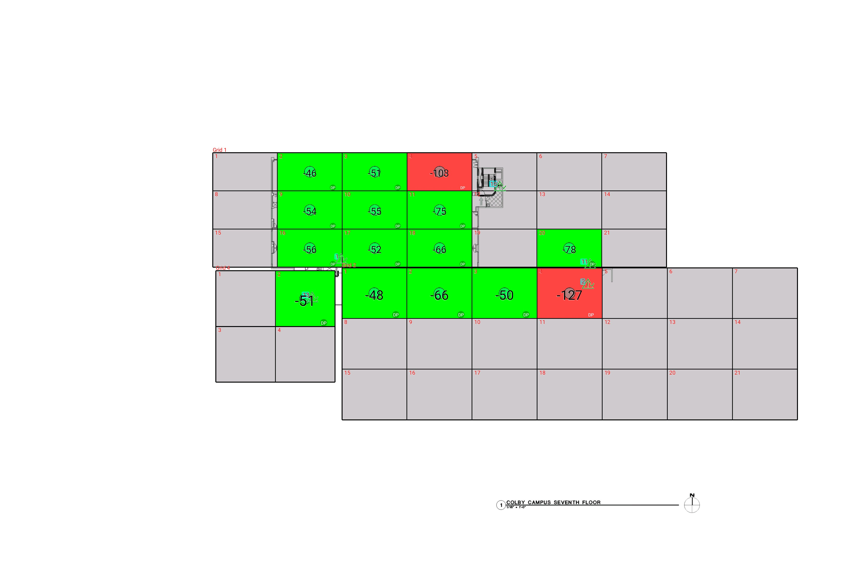

| **Grid** | **# of Areas** | **Area Size (sq. ft)** | **Area Width**  **(ft)** | **Area Height**  **(ft)** | **Ignore Area Color** | **Comments** |
| --- | --- | --- | --- | --- | --- | --- |
| 1 | 21 | 286.18 | 19.28 | 14.85 | Black |  |
| 2 | 21 | 380.74 | 19.34 | 19.69 | Black |  |
| 4 | 4 | 383.52 | 17.69 | 21.68 | Black |  |

**Floor: A1.7**

**Channel: 463550**

| **Critical Point Report** | | | | | | | |
| --- | --- | --- | --- | --- | --- | --- | --- |
| **Critical Point** | **DL**  **Power**  **(dBm)** | **DL**  **DAQ** | **UL**  **Power**  **(dBm)** | **UL**  **DAQ** | **Result** | **DL**  **Loss**  **(dB)** | **Comment** |
| 1 | -49.07 |  |  |  | **Pass** |  |  |
| 2 | -50.77 |  |  |  | **Pass** |  |  |
| 10 | -57.63 |  |  |  | **Pass** |  |  |
| 11 | -41.80 |  |  |  | **Pass** |  |  |
| 13 | -66.55 |  |  |  | **Pass** |  |  |

| **Area Report** | | | | | | | | |
| --- | --- | --- | --- | --- | --- | --- | --- | --- |
| **Grid** | **Area** | **DL**  **Power**  **(dBm)** | **DL**  **DAQ** | **UL**  **Power**  **(dBm)** | **UL**  **DAQ** | **Result** | **DL**  **Loss**  **(dB)** | **Comment** |
| 1 | 1 | NT | NT | NT | NT | **NT** |  |  |
| 1 | 2 | -45.59 |  |  |  | **Pass** |  |  |
| 1 | 3 | -50.13 |  |  |  | **Pass** |  |  |
| 1 | 4 | -102.60 |  |  |  | **Fail** |  |  |
| 1 | 5 | NT | NT | NT | NT | **NT** |  |  |
| 1 | 6 | NT | NT | NT | NT | **NT** |  |  |
| 1 | 7 | NT | NT | NT | NT | **NT** |  |  |
| 1 | 8 | NT | NT | NT | NT | **NT** |  |  |
| 1 | 9 | -53.41 |  |  |  | **Pass** |  |  |
| 1 | 10 | -54.40 |  |  |  | **Pass** |  |  |
| 1 | 11 | -74.54 |  |  |  | **Pass** |  |  |
| 1 | 12 | NT | NT | NT | NT | **NT** |  |  |
| 1 | 13 | NT | NT | NT | NT | **NT** |  |  |
| 1 | 14 | NT | NT | NT | NT | **NT** |  |  |
| 1 | 15 | NT | NT | NT | NT | **NT** |  |  |
| 1 | 16 | -55.69 |  |  |  | **Pass** |  |  |
| 1 | 17 | -51.50 |  |  |  | **Pass** |  |  |
| 1 | 18 | -65.12 |  |  |  | **Pass** |  |  |
| 1 | 19 | NT | NT | NT | NT | **NT** |  |  |
| 1 | 20 | -77.80 |  |  |  | **Pass** |  |  |
| 1 | 21 | NT | NT | NT | NT | **NT** |  |  |
| 2 | 1 | -47.21 |  |  |  | **Pass** |  |  |
| 2 | 2 | -65.15 |  |  |  | **Pass** |  |  |
| 2 | 3 | -49.98 |  |  |  | **Pass** |  |  |
| 2 | 4 | -126.18 |  |  |  | **Fail** |  |  |
| 2 | 5 | NT | NT | NT | NT | **NT** |  |  |
| 2 | 6 | NT | NT | NT | NT | **NT** |  |  |
| 2 | 7 | NT | NT | NT | NT | **NT** |  |  |
| 2 | 8 | NT | NT | NT | NT | **NT** |  |  |
| 2 | 9 | NT | NT | NT | NT | **NT** |  |  |
| 2 | 10 | NT | NT | NT | NT | **NT** |  |  |
| 2 | 11 | NT | NT | NT | NT | **NT** |  |  |
| 2 | 12 | NT | NT | NT | NT | **NT** |  |  |
| 2 | 13 | NT | NT | NT | NT | **NT** |  |  |
| 2 | 14 | NT | NT | NT | NT | **NT** |  |  |
| 2 | 15 | NT | NT | NT | NT | **NT** |  |  |
| 2 | 16 | NT | NT | NT | NT | **NT** |  |  |
| 2 | 17 | NT | NT | NT | NT | **NT** |  |  |
| 2 | 18 | NT | NT | NT | NT | **NT** |  |  |
| 2 | 19 | NT | NT | NT | NT | **NT** |  |  |
| 2 | 20 | NT | NT | NT | NT | **NT** |  |  |
| 2 | 21 | NT | NT | NT | NT | **NT** |  |  |
| 4 | 1 | NT | NT | NT | NT | **NT** |  |  |
| 4 | 2 | -50.79 |  |  |  | **Pass** |  |  |
| 4 | 3 | NT | NT | NT | NT | **NT** |  |  |
| 4 | 4 | NT | NT | NT | NT | **NT** |  |  |

**Floor: A1.8**

**Channel: 463550**

**Result: Pass**

| **Freq (MHz)** | **Tech** | **Band** | **Ant Gain** | **Cable Loss** | **Ph.** | **Type** | **Mod** | **NAC** | **Area Points passed (%)** | **Critical Points passed (%)** |
| --- | --- | --- | --- | --- | --- | --- | --- | --- | --- | --- |
| 463.55000 | P25 | PRMCE | 0.00 | 0.00 |  |  |  |  | 14/14 (100%) | 5/5 (100%) |

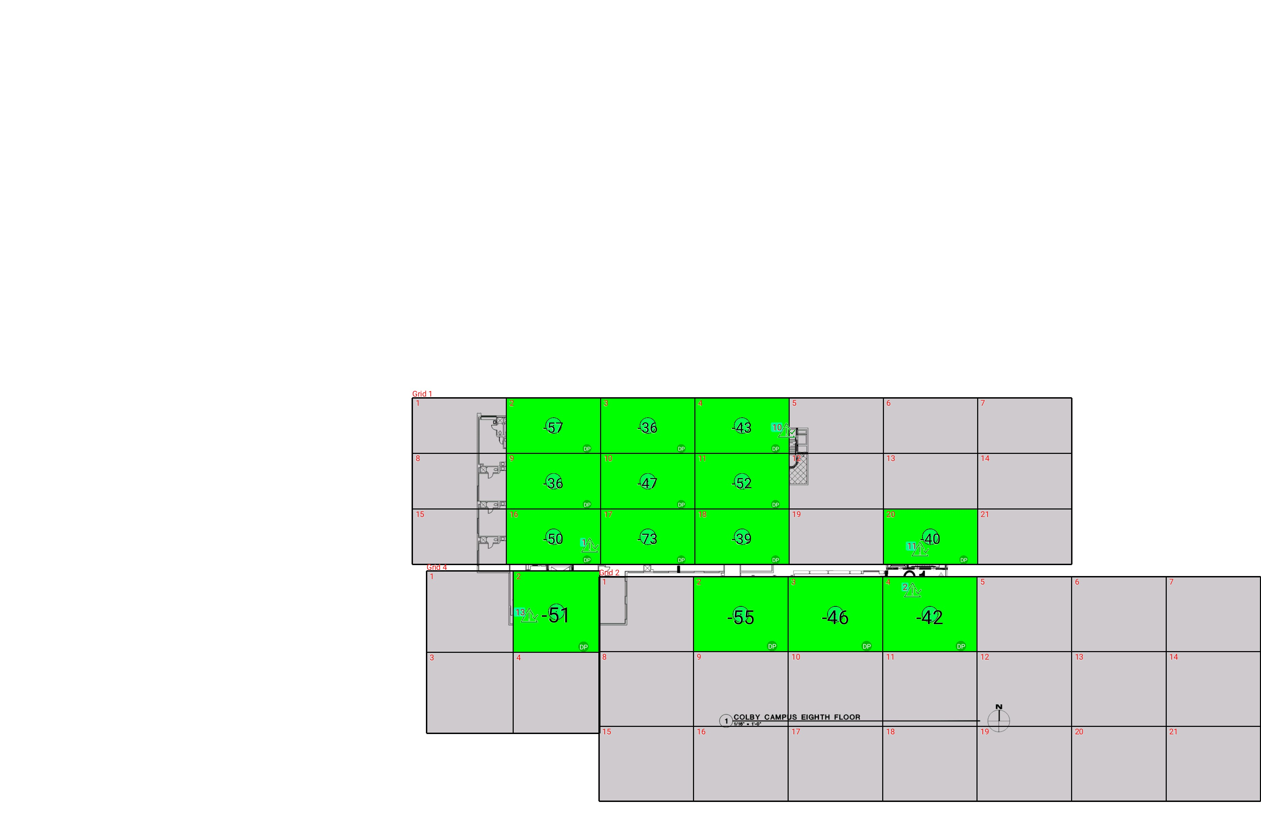

| **Grid** | **# of Areas** | **Area Size (sq. ft)** | **Area Width**  **(ft)** | **Area Height**  **(ft)** | **Ignore Area Color** | **Comments** |
| --- | --- | --- | --- | --- | --- | --- |
| 1 | 21 | 286.18 | 19.28 | 14.85 | Black |  |
| 2 | 21 | 387.02 | 19.34 | 20.01 | Black |  |
| 4 | 4 | 383.52 | 17.69 | 21.68 | Black |  |

**Floor: A1.8**

**Channel: 463550**

| **Critical Point Report** | | | | | | | |
| --- | --- | --- | --- | --- | --- | --- | --- |
| **Critical Point** | **DL**  **Power**  **(dBm)** | **DL**  **DAQ** | **UL**  **Power**  **(dBm)** | **UL**  **DAQ** | **Result** | **DL**  **Loss**  **(dB)** | **Comment** |
| 1 | -44.96 |  |  |  | **Pass** |  |  |
| 2 | -58.48 |  |  |  | **Pass** |  |  |
| 10 | -40.30 |  |  |  | **Pass** |  |  |
| 11 | -54.07 |  |  |  | **Pass** |  |  |
| 13 | -46.33 |  |  |  | **Pass** |  |  |

| **Area Report** | | | | | | | | |
| --- | --- | --- | --- | --- | --- | --- | --- | --- |
| **Grid** | **Area** | **DL**  **Power**  **(dBm)** | **DL**  **DAQ** | **UL**  **Power**  **(dBm)** | **UL**  **DAQ** | **Result** | **DL**  **Loss**  **(dB)** | **Comment** |
| 1 | 1 | NT | NT | NT | NT | **NT** |  |  |
| 1 | 2 | -56.27 |  |  |  | **Pass** |  |  |
| 1 | 3 | -35.32 |  |  |  | **Pass** |  |  |
| 1 | 4 | -42.63 |  |  |  | **Pass** |  |  |
| 1 | 5 | NT | NT | NT | NT | **NT** |  |  |
| 1 | 6 | NT | NT | NT | NT | **NT** |  |  |
| 1 | 7 | NT | NT | NT | NT | **NT** |  |  |
| 1 | 8 | NT | NT | NT | NT | **NT** |  |  |
| 1 | 9 | -35.01 |  |  |  | **Pass** |  |  |
| 1 | 10 | -46.32 |  |  |  | **Pass** |  |  |
| 1 | 11 | -51.04 |  |  |  | **Pass** |  |  |
| 1 | 12 | NT | NT | NT | NT | **NT** |  |  |
| 1 | 13 | NT | NT | NT | NT | **NT** |  |  |
| 1 | 14 | NT | NT | NT | NT | **NT** |  |  |
| 1 | 15 | NT | NT | NT | NT | **NT** |  |  |
| 1 | 16 | -49.54 |  |  |  | **Pass** |  |  |
| 1 | 17 | -72.01 |  |  |  | **Pass** |  |  |
| 1 | 18 | -38.19 |  |  |  | **Pass** |  |  |
| 1 | 19 | NT | NT | NT | NT | **NT** |  |  |
| 1 | 20 | -39.96 |  |  |  | **Pass** |  |  |
| 1 | 21 | NT | NT | NT | NT | **NT** |  |  |
| 2 | 1 | NT | NT | NT | NT | **NT** |  |  |
| 2 | 2 | -54.09 |  |  |  | **Pass** |  |  |
| 2 | 3 | -45.80 |  |  |  | **Pass** |  |  |
| 2 | 4 | -41.38 |  |  |  | **Pass** |  |  |
| 2 | 5 | NT | NT | NT | NT | **NT** |  |  |
| 2 | 6 | NT | NT | NT | NT | **NT** |  |  |
| 2 | 7 | NT | NT | NT | NT | **NT** |  |  |
| 2 | 8 | NT | NT | NT | NT | **NT** |  |  |
| 2 | 9 | NT | NT | NT | NT | **NT** |  |  |
| 2 | 10 | NT | NT | NT | NT | **NT** |  |  |
| 2 | 11 | NT | NT | NT | NT | **NT** |  |  |
| 2 | 12 | NT | NT | NT | NT | **NT** |  |  |
| 2 | 13 | NT | NT | NT | NT | **NT** |  |  |
| 2 | 14 | NT | NT | NT | NT | **NT** |  |  |
| 2 | 15 | NT | NT | NT | NT | **NT** |  |  |
| 2 | 16 | NT | NT | NT | NT | **NT** |  |  |
| 2 | 17 | NT | NT | NT | NT | **NT** |  |  |
| 2 | 18 | NT | NT | NT | NT | **NT** |  |  |
| 2 | 19 | NT | NT | NT | NT | **NT** |  |  |
| 2 | 20 | NT | NT | NT | NT | **NT** |  |  |
| 2 | 21 | NT | NT | NT | NT | **NT** |  |  |
| 4 | 1 | NT | NT | NT | NT | **NT** |  |  |
| 4 | 2 | -50.37 |  |  |  | **Pass** |  |  |
| 4 | 3 | NT | NT | NT | NT | **NT** |  |  |
| 4 | 4 | NT | NT | NT | NT | **NT** |  |  |

**Floor: A4.B**

**Channel: 463550**

**Result: Fail (Adjacent)**

| **Freq (MHz)** | **Tech** | **Band** | **Ant Gain** | **Cable Loss** | **Ph.** | **Type** | **Mod** | **NAC** | **Area Points passed (%)** | **Critical Points passed (%)** |
| --- | --- | --- | --- | --- | --- | --- | --- | --- | --- | --- |
| 463.55000 | P25 | PRMCE | 0.00 | 0.00 |  |  |  |  | 1/40 (2%) | 5/9 (55%) |

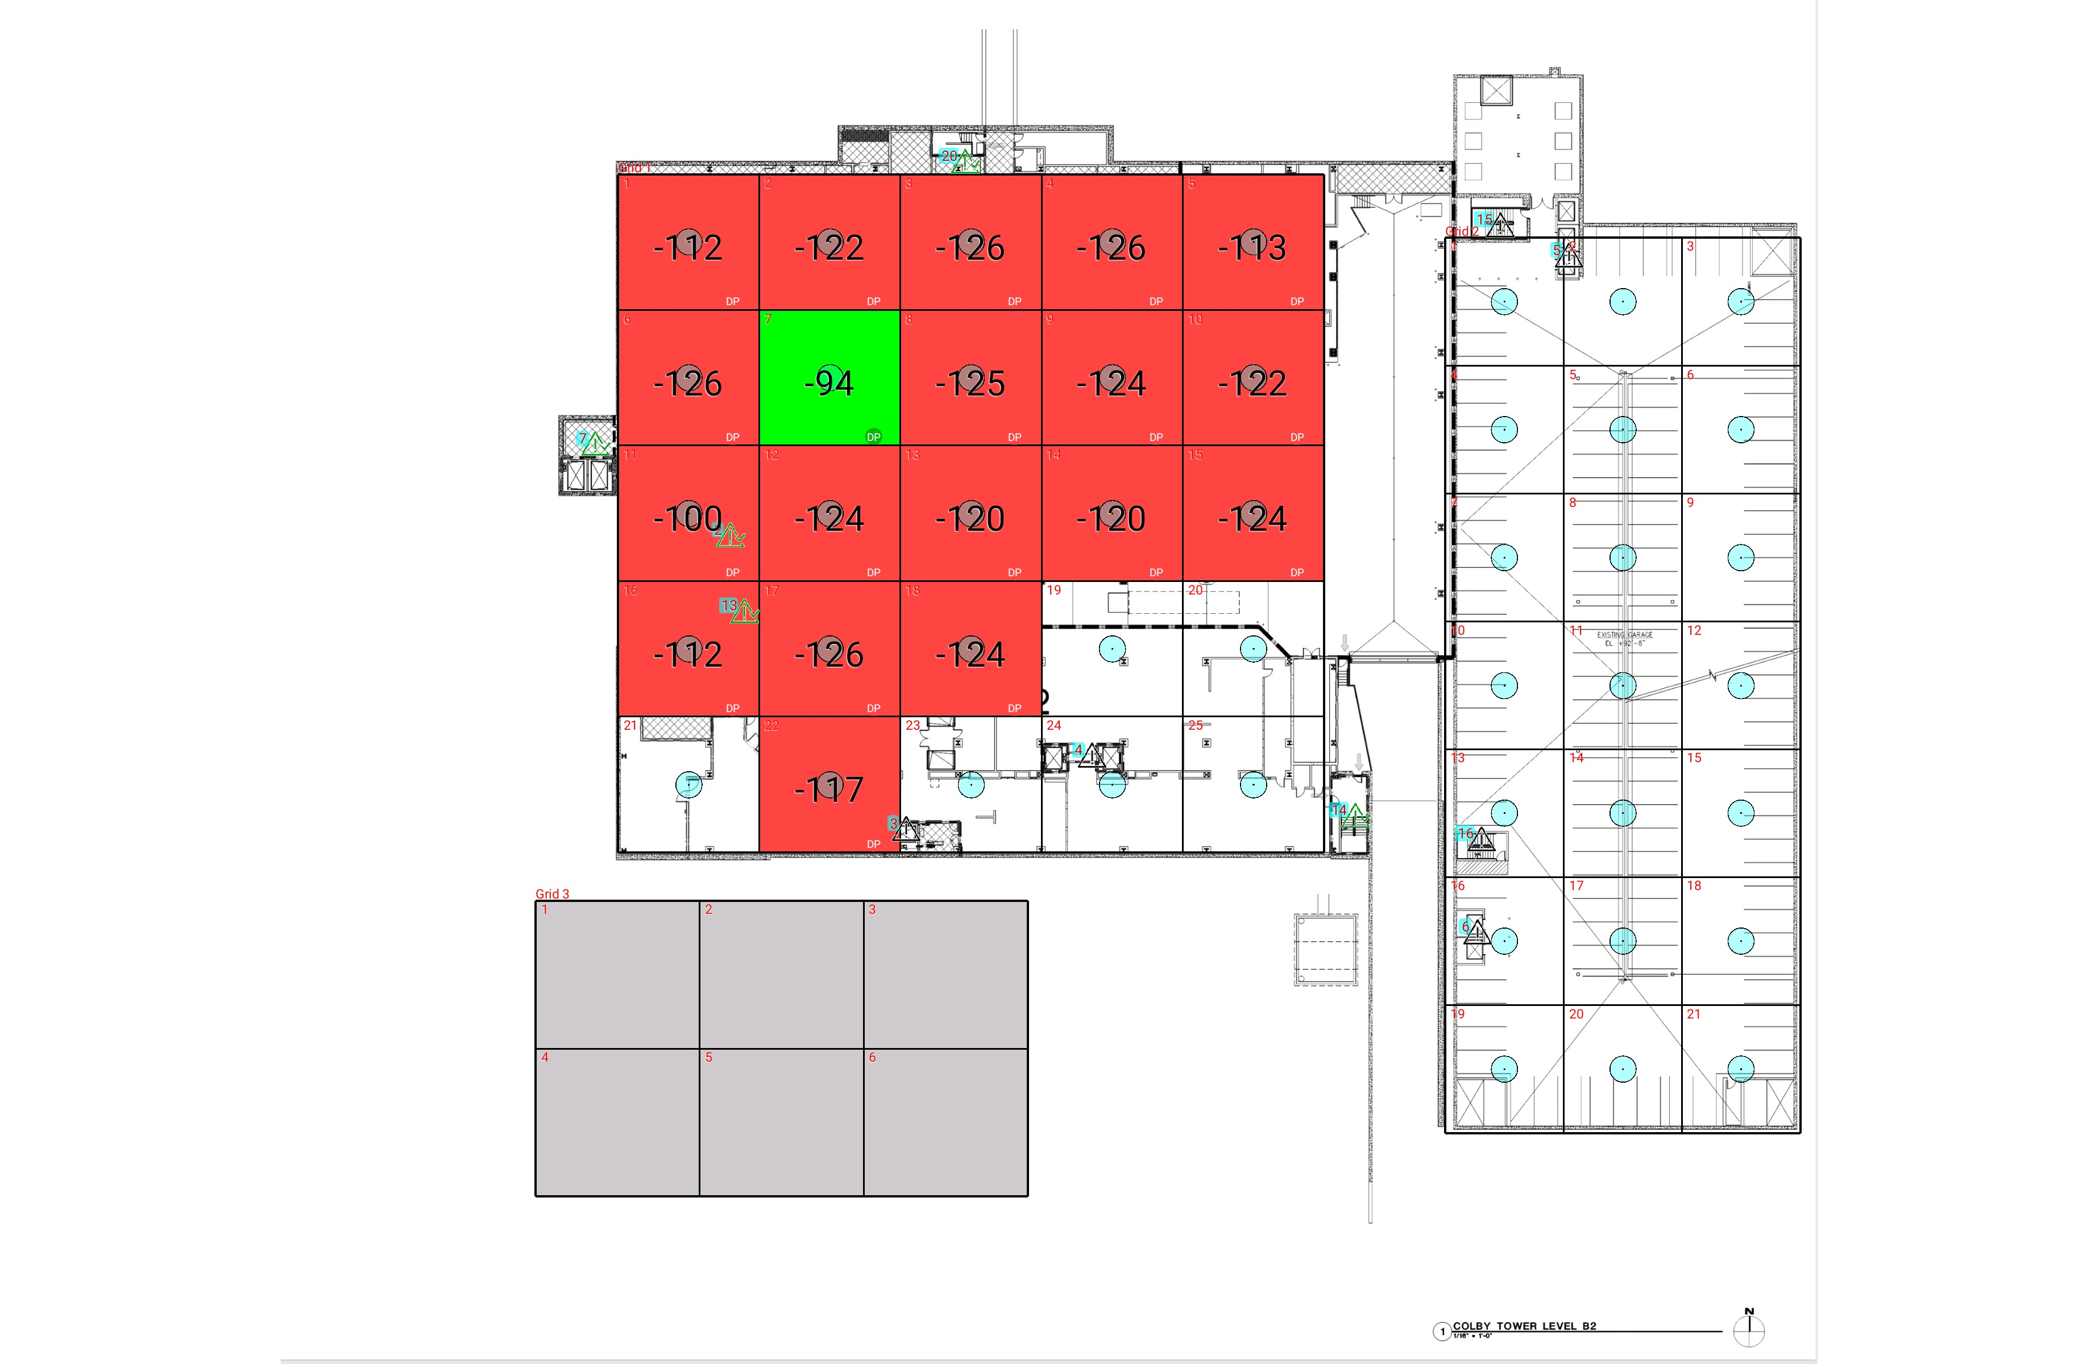

| **Grid** | **# of Areas** | **Area Size (sq. ft)** | **Area Width**  **(ft)** | **Area Height**  **(ft)** | **Ignore Area Color** | **Comments** |
| --- | --- | --- | --- | --- | --- | --- |
| 1 | 25 | 377.71 | 17.35 | 21.77 | Black |  |
| 2 | 21 | 298.85 | 14.56 | 20.53 | Black |  |
| 3 | 6 | 478.76 | 20.17 | 23.74 | Black |  |

**Floor: A4.B**

**Channel: 463550**

| **Critical Point Report** | | | | | | | |
| --- | --- | --- | --- | --- | --- | --- | --- |
| **Critical Point** | **DL**  **Power**  **(dBm)** | **DL**  **DAQ** | **UL**  **Power**  **(dBm)** | **UL**  **DAQ** | **Result** | **DL**  **Loss**  **(dB)** | **Comment** |
| 2 | -111.06 |  |  |  | **Pass** |  |  |
| 3 |  |  |  |  |  |  |  |
| 4 |  |  |  |  |  |  |  |
| 5 |  |  |  |  |  |  |  |
| 6 |  |  |  |  |  |  |  |
| 7 | -117.12 |  |  |  | **Pass** |  |  |
| 13 | -101.49 |  |  |  | **Pass** |  |  |
| 14 | -123.73 |  |  |  | **Pass** |  |  |
| 15 |  |  |  |  |  |  |  |
| 16 |  |  |  |  |  |  |  |
| 20 | -108.65 |  |  |  | **Pass** |  |  |

| **Area Report** | | | | | | | | |
| --- | --- | --- | --- | --- | --- | --- | --- | --- |
| **Grid** | **Area** | **DL**  **Power**  **(dBm)** | **DL**  **DAQ** | **UL**  **Power**  **(dBm)** | **UL**  **DAQ** | **Result** | **DL**  **Loss**  **(dB)** | **Comment** |
| 1 | 1 | -111.99 |  |  |  | **Fail** |  |  |
| 1 | 2 | -121.17 |  |  |  | **Fail** |  |  |
| 1 | 3 | -125.46 |  |  |  | **Fail** |  |  |
| 1 | 4 | -125.74 |  |  |  | **Fail** |  |  |
| 1 | 5 | -112.58 |  |  |  | **Fail** |  |  |
| 1 | 6 | -125.35 |  |  |  | **Fail** |  |  |
| 1 | 7 | -93.90 |  |  |  | **Pass** |  |  |
| 1 | 8 | -124.82 |  |  |  | **Fail** |  |  |
| 1 | 9 | -123.28 |  |  |  | **Fail** |  |  |
| 1 | 10 | -121.71 |  |  |  | **Fail** |  |  |
| 1 | 11 | -99.63 |  |  |  | **Fail** |  |  |
| 1 | 12 | -123.30 |  |  |  | **Fail** |  |  |
| 1 | 13 | -119.06 |  |  |  | **Fail** |  |  |
| 1 | 14 | -119.69 |  |  |  | **Fail** |  |  |
| 1 | 15 | -123.91 |  |  |  | **Fail** |  |  |
| 1 | 16 | -111.35 |  |  |  | **Fail** |  |  |
| 1 | 17 | -125.30 |  |  |  | **Fail** |  |  |
| 1 | 18 | -123.35 |  |  |  | **Fail** |  |  |
| 1 | 22 | -116.37 |  |  |  | **Fail** |  |  |
| 3 | 1 | NT | NT | NT | NT | **NT** |  |  |
| 3 | 2 | NT | NT | NT | NT | **NT** |  |  |
| 3 | 3 | NT | NT | NT | NT | **NT** |  |  |
| 3 | 4 | NT | NT | NT | NT | **NT** |  |  |
| 3 | 5 | NT | NT | NT | NT | **NT** |  |  |
| 3 | 6 | NT | NT | NT | NT | **NT** |  |  |

**Floor: A4.G**

**Channel: 463550**

**Result: Fail (Adjacent)**

| **Freq (MHz)** | **Tech** | **Band** | **Ant Gain** | **Cable Loss** | **Ph.** | **Type** | **Mod** | **NAC** | **Area Points passed (%)** | **Critical Points passed (%)** |
| --- | --- | --- | --- | --- | --- | --- | --- | --- | --- | --- |
| 463.55000 | P25 | PRMCE | 0.00 | 0.00 |  |  |  |  | 2/46 (4%) | 7/11 (63%) |

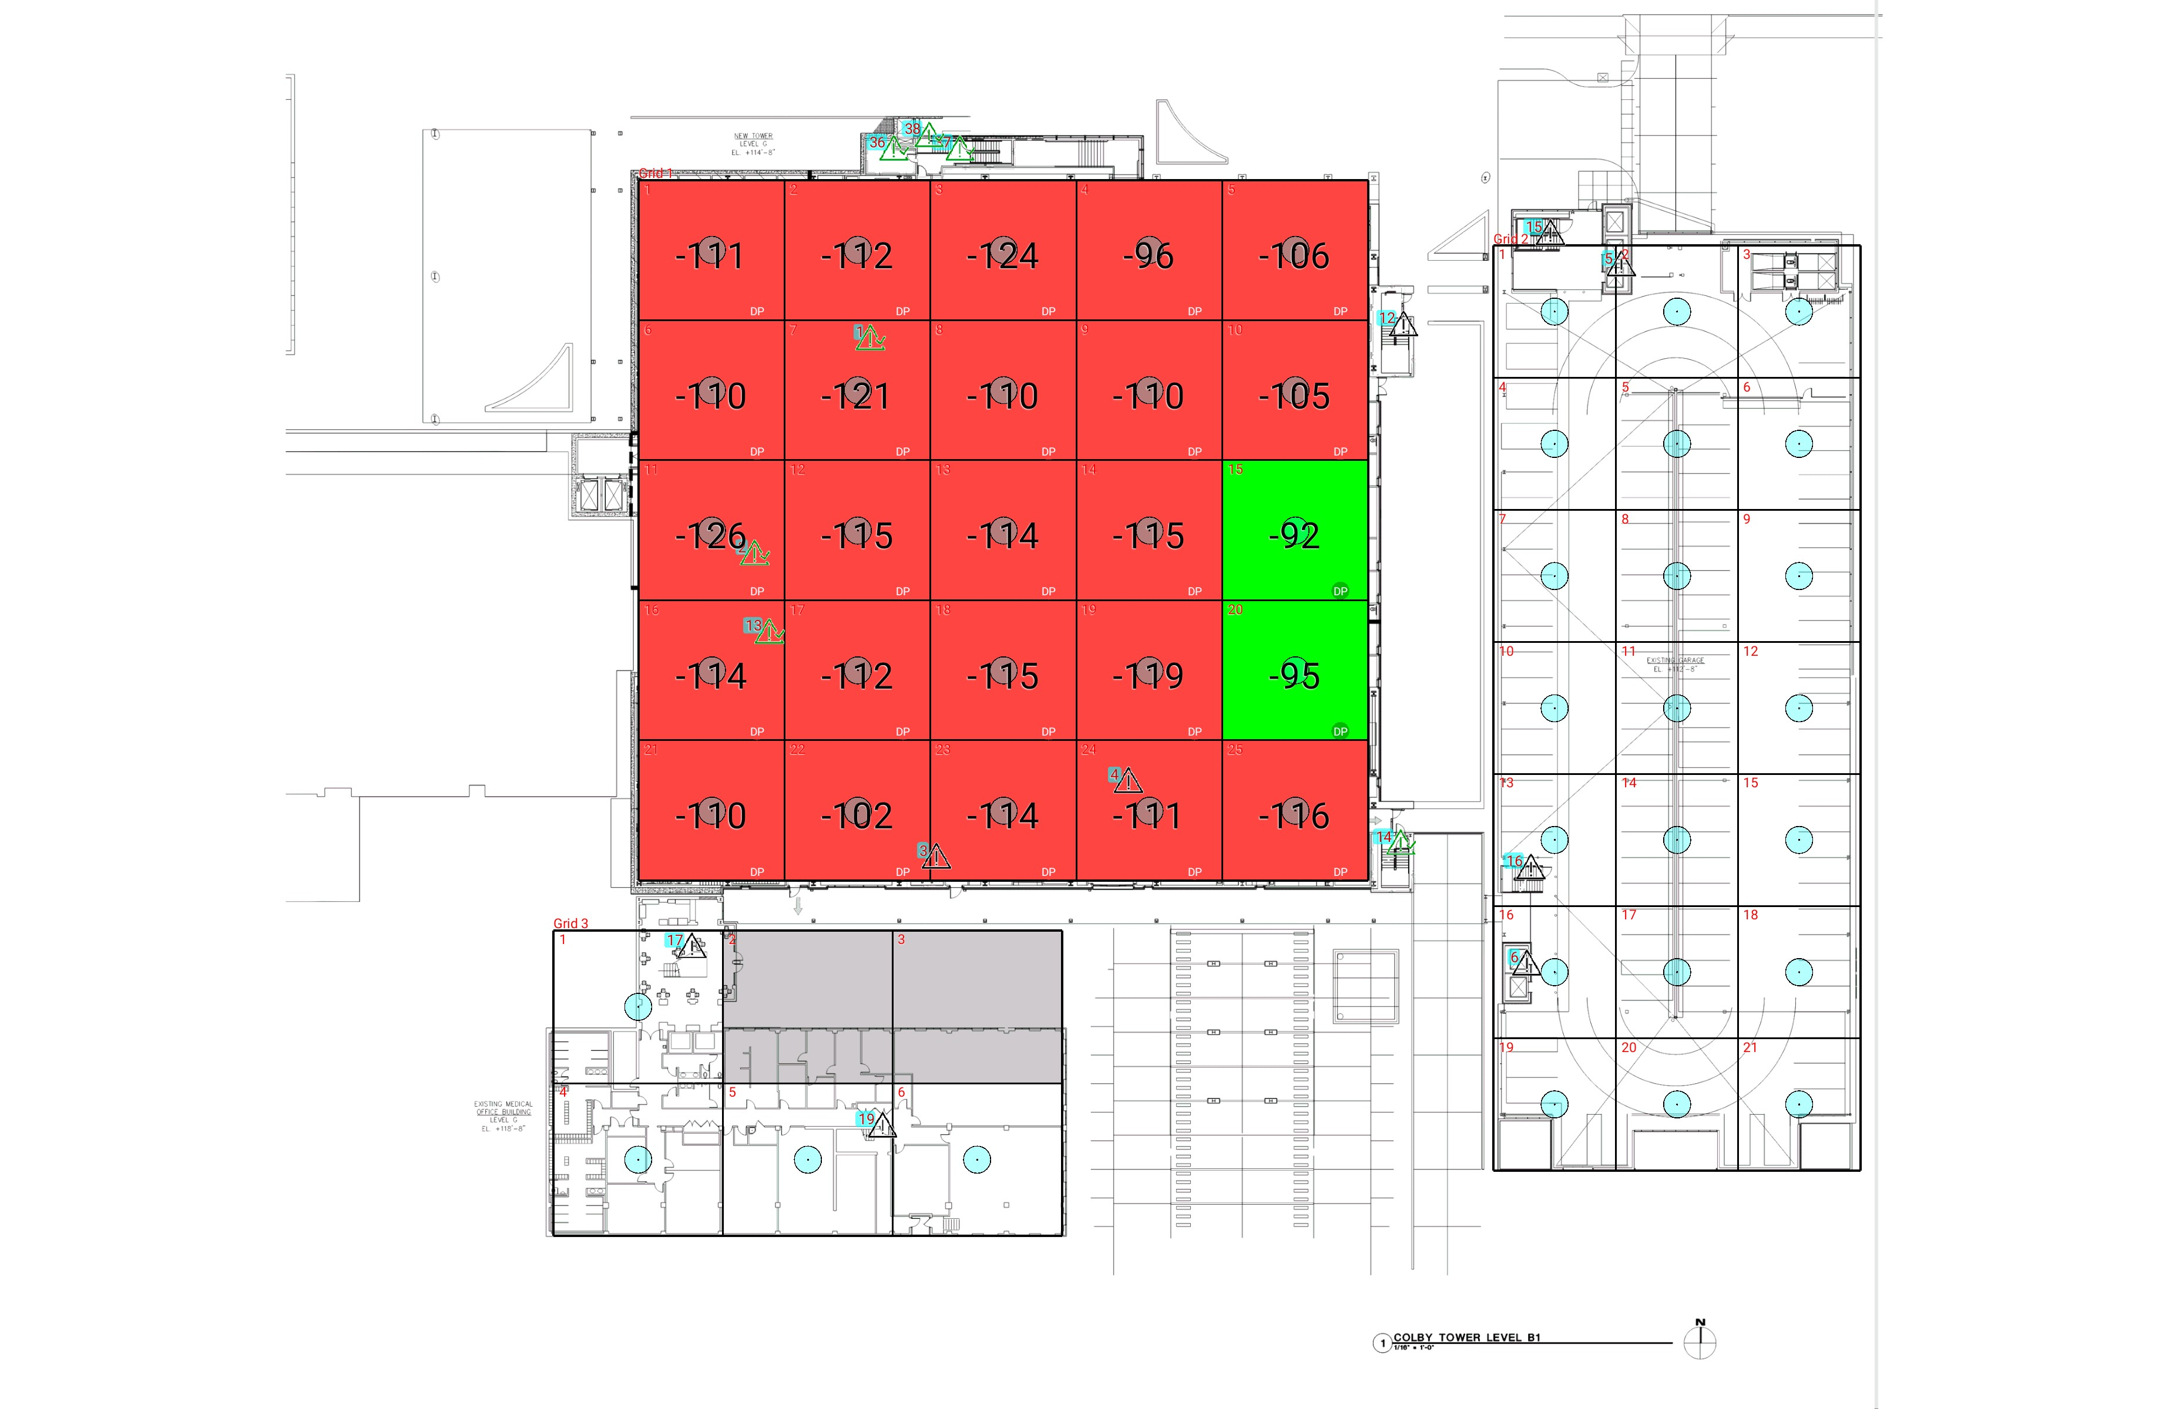

| **Grid** | **# of Areas** | **Area Size (sq. ft)** | **Area Width**  **(ft)** | **Area Height**  **(ft)** | **Ignore Area Color** | **Comments** |
| --- | --- | --- | --- | --- | --- | --- |
| 1 | 25 | 377.71 | 17.35 | 21.77 | Black |  |
| 2 | 21 | 298.85 | 14.56 | 20.53 | Black |  |
| 3 | 6 | 478.76 | 20.17 | 23.74 | Black |  |

**Floor: A4.G**

**Channel: 463550**

| **Critical Point Report** | | | | | | | |
| --- | --- | --- | --- | --- | --- | --- | --- |
| **Critical Point** | **DL**  **Power**  **(dBm)** | **DL**  **DAQ** | **UL**  **Power**  **(dBm)** | **UL**  **DAQ** | **Result** | **DL**  **Loss**  **(dB)** | **Comment** |
| 1 | -107.62 |  |  |  | **Pass** |  |  |
| 2 | -123.35 |  |  |  | **Pass** |  |  |
| 3 |  |  |  |  |  |  |  |
| 4 |  |  |  |  |  |  |  |
| 5 |  |  |  |  |  |  |  |
| 6 |  |  |  |  |  |  |  |
| 12 |  |  |  |  |  |  |  |
| 13 | -108.98 |  |  |  | **Pass** |  |  |
| 14 | -109.55 |  |  |  | **Pass** |  |  |
| 15 |  |  |  |  |  |  |  |
| 16 |  |  |  |  |  |  |  |
| 17 |  |  |  |  |  |  |  |
| 19 |  |  |  |  |  |  |  |
| 36 | -71.25 |  |  |  | **Pass** |  |  |
| 37 | -119.05 |  |  |  | **Pass** |  |  |
| 38 | -91.94 |  |  |  | **Pass** |  |  |

| **Area Report** | | | | | | | | |
| --- | --- | --- | --- | --- | --- | --- | --- | --- |
| **Grid** | **Area** | **DL**  **Power**  **(dBm)** | **DL**  **DAQ** | **UL**  **Power**  **(dBm)** | **UL**  **DAQ** | **Result** | **DL**  **Loss**  **(dB)** | **Comment** |
| 1 | 1 | -110.42 |  |  |  | **Fail** |  |  |
| 1 | 2 | -111.68 |  |  |  | **Fail** |  |  |
| 1 | 3 | -123.20 |  |  |  | **Fail** |  |  |
| 1 | 4 | -95.79 |  |  |  | **Fail** |  |  |
| 1 | 5 | -105.67 |  |  |  | **Fail** |  |  |
| 1 | 6 | -109.69 |  |  |  | **Fail** |  |  |
| 1 | 7 | -120.12 |  |  |  | **Fail** |  |  |
| 1 | 8 | -109.35 |  |  |  | **Fail** |  |  |
| 1 | 9 | -109.63 |  |  |  | **Fail** |  |  |
| 1 | 10 | -104.26 |  |  |  | **Fail** |  |  |
| 1 | 11 | -125.78 |  |  |  | **Fail** |  |  |
| 1 | 12 | -114.13 |  |  |  | **Fail** |  |  |
| 1 | 13 | -113.56 |  |  |  | **Fail** |  |  |
| 1 | 14 | -114.56 |  |  |  | **Fail** |  |  |
| 1 | 15 | -91.73 |  |  |  | **Pass** |  |  |
| 1 | 16 | -113.60 |  |  |  | **Fail** |  |  |
| 1 | 17 | -111.56 |  |  |  | **Fail** |  |  |
| 1 | 18 | -114.76 |  |  |  | **Fail** |  |  |
| 1 | 19 | -118.44 |  |  |  | **Fail** |  |  |
| 1 | 20 | -94.81 |  |  |  | **Pass** |  |  |
| 1 | 21 | -109.75 |  |  |  | **Fail** |  | uhf to aaron no response |
| 1 | 22 | -101.07 |  |  |  | **Fail** |  |  |
| 1 | 23 | -113.06 |  |  |  | **Fail** |  |  |
| 1 | 24 | -110.58 |  |  |  | **Fail** |  |  |
| 1 | 25 | -115.61 |  |  |  | **Fail** |  |  |
| 3 | 2 | NT | NT | NT | NT | **NT** |  |  |
| 3 | 3 | NT | NT | NT | NT | **NT** |  |  |

**Floor: A4.1**

**Channel: 463550**

**Result: Fail (Adjacent)**

| **Freq (MHz)** | **Tech** | **Band** | **Ant Gain** | **Cable Loss** | **Ph.** | **Type** | **Mod** | **NAC** | **Area Points passed (%)** | **Critical Points passed (%)** |
| --- | --- | --- | --- | --- | --- | --- | --- | --- | --- | --- |
| 463.55000 | P25 | PRMCE | 0.00 | 0.00 |  |  |  |  | 4/49 (8%) | 11/14 (78%) |

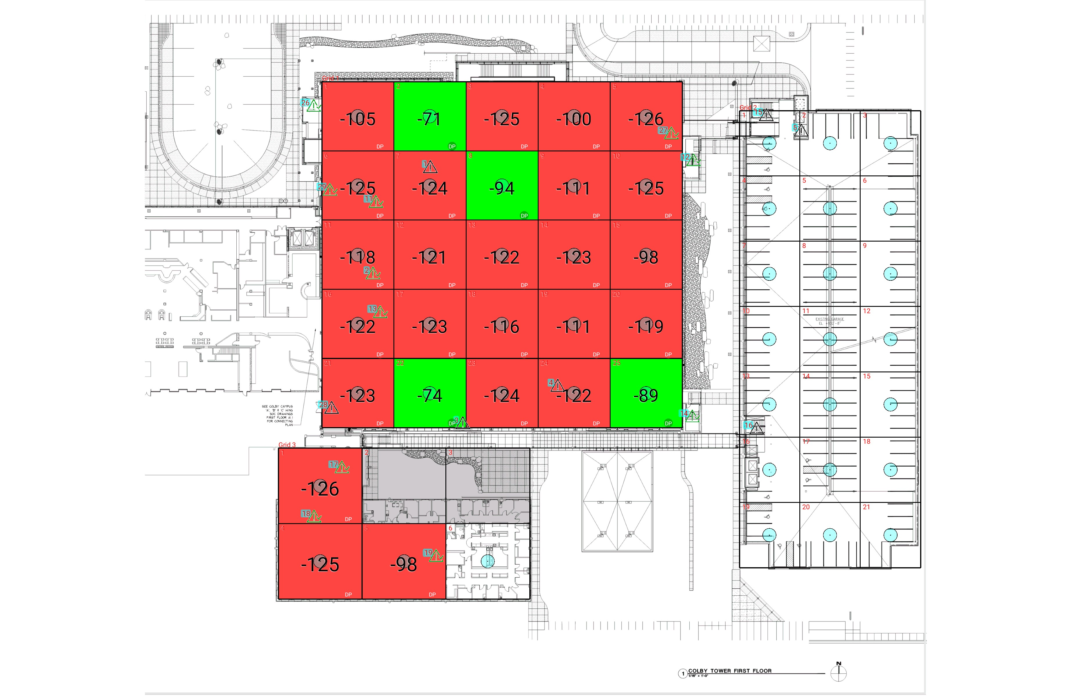

| **Grid** | **# of Areas** | **Area Size (sq. ft)** | **Area Width**  **(ft)** | **Area Height**  **(ft)** | **Ignore Area Color** | **Comments** |
| --- | --- | --- | --- | --- | --- | --- |
| 1 | 25 | 377.71 | 17.35 | 21.77 | Black |  |
| 2 | 21 | 298.85 | 14.56 | 20.53 | Black |  |
| 3 | 6 | 478.76 | 20.17 | 23.74 | Black |  |

**Floor: A4.1**

**Channel: 463550**

| **Critical Point Report** | | | | | | | |
| --- | --- | --- | --- | --- | --- | --- | --- |
| **Critical Point** | **DL**  **Power**  **(dBm)** | **DL**  **DAQ** | **UL**  **Power**  **(dBm)** | **UL**  **DAQ** | **Result** | **DL**  **Loss**  **(dB)** | **Comment** |
| 1 |  |  |  |  |  |  |  |
| 2 | -97.40 |  |  |  | **Pass** |  |  |
| 3 |  |  |  |  |  |  |  |
| 4 |  |  |  |  |  |  |  |
| 5 |  |  |  |  |  |  |  |
| 11 | -105.91 |  |  |  | **Pass** |  |  |
| 12 | -125.42 |  |  |  | **Pass** |  |  |
| 13 | -124.46 |  |  |  | **Pass** |  |  |
| 14 | -125.03 |  |  |  | **Pass** |  |  |
| 15 |  |  |  |  |  |  |  |
| 16 |  |  |  |  |  |  |  |
| 17 | -101.96 |  |  |  | **Pass** |  |  |
| 18 | -125.77 |  |  |  | **Pass** |  |  |
| 19 | -124.55 |  |  |  | **Pass** |  |  |
| 26 | -125.87 |  |  |  | **Pass** |  |  |
| 27 | -125.52 |  |  |  | **Pass** |  |  |
| 28 |  |  |  |  |  |  |  |
| 29 | -66.33 |  |  |  | **Pass** |  |  |

| **Area Report** | | | | | | | | |
| --- | --- | --- | --- | --- | --- | --- | --- | --- |
| **Grid** | **Area** | **DL**  **Power**  **(dBm)** | **DL**  **DAQ** | **UL**  **Power**  **(dBm)** | **UL**  **DAQ** | **Result** | **DL**  **Loss**  **(dB)** | **Comment** |
| 1 | 1 | -104.66 |  |  |  | **Fail** |  |  |
| 1 | 2 | -70.54 |  |  |  | **Pass** |  |  |
| 1 | 3 | -124.89 |  |  |  | **Fail** |  |  |
| 1 | 4 | -99.60 |  |  |  | **Fail** |  |  |
| 1 | 5 | -125.21 |  |  |  | **Fail** |  |  |
| 1 | 6 | -124.37 |  |  |  | **Fail** |  |  |
| 1 | 7 | -123.15 |  |  |  | **Fail** |  |  |
| 1 | 8 | -93.72 |  |  |  | **Pass** |  |  |
| 1 | 9 | -110.56 |  |  |  | **Fail** |  |  |
| 1 | 10 | -124.30 |  |  |  | **Fail** |  |  |
| 1 | 11 | -117.11 |  |  |  | **Fail** |  |  |
| 1 | 12 | -120.75 |  |  |  | **Fail** |  |  |
| 1 | 13 | -121.78 |  |  |  | **Fail** |  |  |
| 1 | 14 | -122.16 |  |  |  | **Fail** |  |  |
| 1 | 15 | -97.48 |  |  |  | **Fail** |  |  |
| 1 | 16 | -121.70 |  |  |  | **Fail** |  |  |
| 1 | 17 | -122.96 |  |  |  | **Fail** |  |  |
| 1 | 18 | -115.17 |  |  |  | **Fail** |  | dead uhf |
| 1 | 19 | -110.54 |  |  |  | **Fail** |  |  |
| 1 | 20 | -118.34 |  |  |  | **Fail** |  |  |
| 1 | 21 | -122.59 |  |  |  | **Fail** |  |  |
| 1 | 22 | -73.30 |  |  |  | **Pass** |  |  |
| 1 | 23 | -123.14 |  |  |  | **Fail** |  |  |
| 1 | 24 | -121.80 |  |  |  | **Fail** |  |  |
| 1 | 25 | -88.46 |  |  |  | **Pass** |  |  |
| 3 | 1 | -125.29 |  |  |  | **Fail** |  |  |
| 3 | 2 | NT | NT | NT | NT | **NT** |  |  |
| 3 | 3 | NT | NT | NT | NT | **NT** |  |  |
| 3 | 4 | -124.91 |  |  |  | **Fail** |  |  |
| 3 | 5 | -97.61 |  |  |  | **Fail** |  |  |

**Floor: A4.2**

**Channel: 463550**

**Result: Fail (Adjacent)**

| **Freq (MHz)** | **Tech** | **Band** | **Ant Gain** | **Cable Loss** | **Ph.** | **Type** | **Mod** | **NAC** | **Area Points passed (%)** | **Critical Points passed (%)** |
| --- | --- | --- | --- | --- | --- | --- | --- | --- | --- | --- |
| 463.55000 | P25 | PRMCE | 0.00 | 0.00 |  |  |  |  | 13/35 (37%) | 8/12 (66%) |

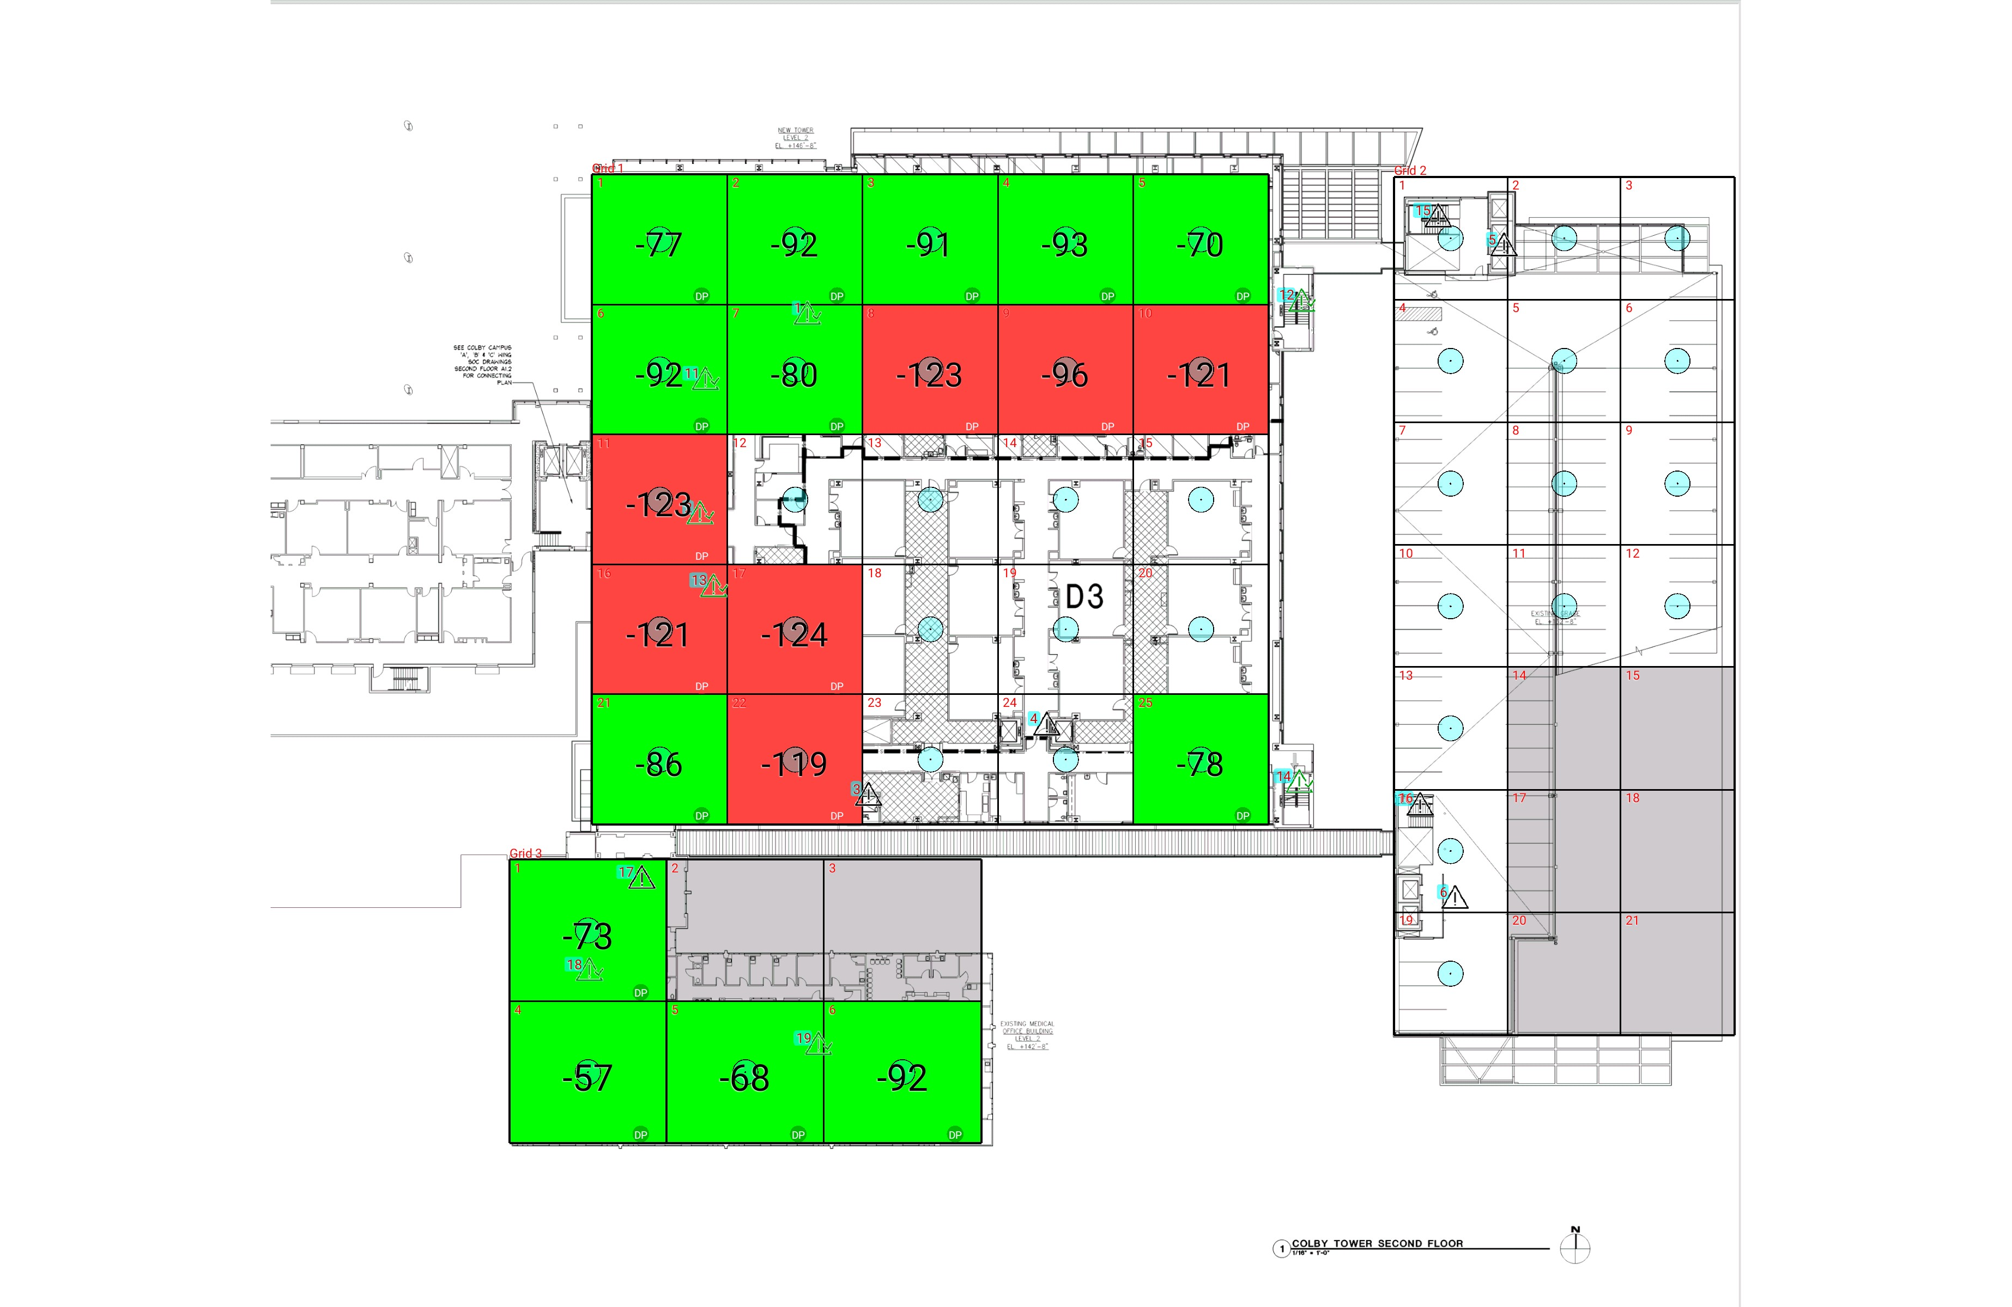

| **Grid** | **# of Areas** | **Area Size (sq. ft)** | **Area Width**  **(ft)** | **Area Height**  **(ft)** | **Ignore Area Color** | **Comments** |
| --- | --- | --- | --- | --- | --- | --- |
| 1 | 25 | 377.71 | 17.35 | 21.77 | Black |  |
| 2 | 21 | 298.85 | 14.56 | 20.53 | Black |  |
| 3 | 6 | 478.76 | 20.17 | 23.74 | Black |  |

**Floor: A4.2**

**Channel: 463550**

| **Critical Point Report** | | | | | | | |
| --- | --- | --- | --- | --- | --- | --- | --- |
| **Critical Point** | **DL**  **Power**  **(dBm)** | **DL**  **DAQ** | **UL**  **Power**  **(dBm)** | **UL**  **DAQ** | **Result** | **DL**  **Loss**  **(dB)** | **Comment** |
| 1 | -122.91 |  |  |  | **Pass** |  |  |
| 2 | -112.88 |  |  |  | **Pass** |  |  |
| 3 |  |  |  |  |  |  |  |
| 4 |  |  |  |  |  |  |  |
| 5 |  |  |  |  |  |  |  |
| 6 |  |  |  |  |  |  |  |
| 11 | -122.81 |  |  |  | **Pass** |  |  |
| 12 | -111.56 |  |  |  | **Pass** |  |  |
| 13 | -98.32 |  |  |  | **Pass** |  |  |
| 14 | -117.93 |  |  |  | **Pass** |  |  |
| 15 |  |  |  |  |  |  |  |
| 16 |  |  |  |  |  |  |  |
| 17 |  |  |  |  |  |  |  |
| 18 | -126.18 |  |  |  | **Pass** |  |  |
| 19 | -113.23 |  |  |  | **Pass** |  |  |

| **Area Report** | | | | | | | | |
| --- | --- | --- | --- | --- | --- | --- | --- | --- |
| **Grid** | **Area** | **DL**  **Power**  **(dBm)** | **DL**  **DAQ** | **UL**  **Power**  **(dBm)** | **UL**  **DAQ** | **Result** | **DL**  **Loss**  **(dB)** | **Comment** |
| 1 | 1 | -76.66 |  |  |  | **Pass** |  |  |
| 1 | 2 | -91.13 |  |  |  | **Pass** |  |  |
| 1 | 3 | -90.86 |  |  |  | **Pass** |  |  |
| 1 | 4 | -92.60 |  |  |  | **Pass** |  |  |
| 1 | 5 | -69.22 |  |  |  | **Pass** |  |  |
| 1 | 6 | -91.44 |  |  |  | **Pass** |  |  |
| 1 | 7 | -79.66 |  |  |  | **Pass** |  |  |
| 1 | 8 | -122.51 |  |  |  | **Fail** |  |  |
| 1 | 9 | -95.98 |  |  |  | **Fail** |  |  |
| 1 | 10 | -120.22 |  |  |  | **Fail** |  |  |
| 1 | 11 | -122.40 |  |  |  | **Fail** |  |  |
| 1 | 16 | -120.60 |  |  |  | **Fail** |  |  |
| 1 | 17 | -123.39 |  |  |  | **Fail** |  |  |
| 1 | 21 | -85.85 |  |  |  | **Pass** |  |  |
| 1 | 22 | -118.27 |  |  |  | **Fail** |  |  |
| 1 | 25 | -77.49 |  |  |  | **Pass** |  |  |
| 2 | 14 | NT | NT | NT | NT | **NT** |  |  |
| 2 | 15 | NT | NT | NT | NT | **NT** |  |  |
| 2 | 17 | NT | NT | NT | NT | **NT** |  |  |
| 2 | 18 | NT | NT | NT | NT | **NT** |  |  |
| 2 | 20 | NT | NT | NT | NT | **NT** |  |  |
| 2 | 21 | NT | NT | NT | NT | **NT** |  |  |
| 3 | 1 | -72.13 |  |  |  | **Pass** |  |  |
| 3 | 2 | NT | NT | NT | NT | **NT** |  |  |
| 3 | 3 | NT | NT | NT | NT | **NT** |  |  |
| 3 | 4 | -56.52 |  |  |  | **Pass** |  |  |
| 3 | 5 | -67.43 |  |  |  | **Pass** |  |  |
| 3 | 6 | -91.74 |  |  |  | **Pass** |  |  |

**Floor: A4.3**

**Channel: 463550**

**Result: Fail (Adjacent)**

| **Freq (MHz)** | **Tech** | **Band** | **Ant Gain** | **Cable Loss** | **Ph.** | **Type** | **Mod** | **NAC** | **Area Points passed (%)** | **Critical Points passed (%)** |
| --- | --- | --- | --- | --- | --- | --- | --- | --- | --- | --- |
| 463.55000 | P25 | PRMCE | 0.00 | 0.00 |  |  |  |  | 5/20 (25%) | 8/8 (100%) |

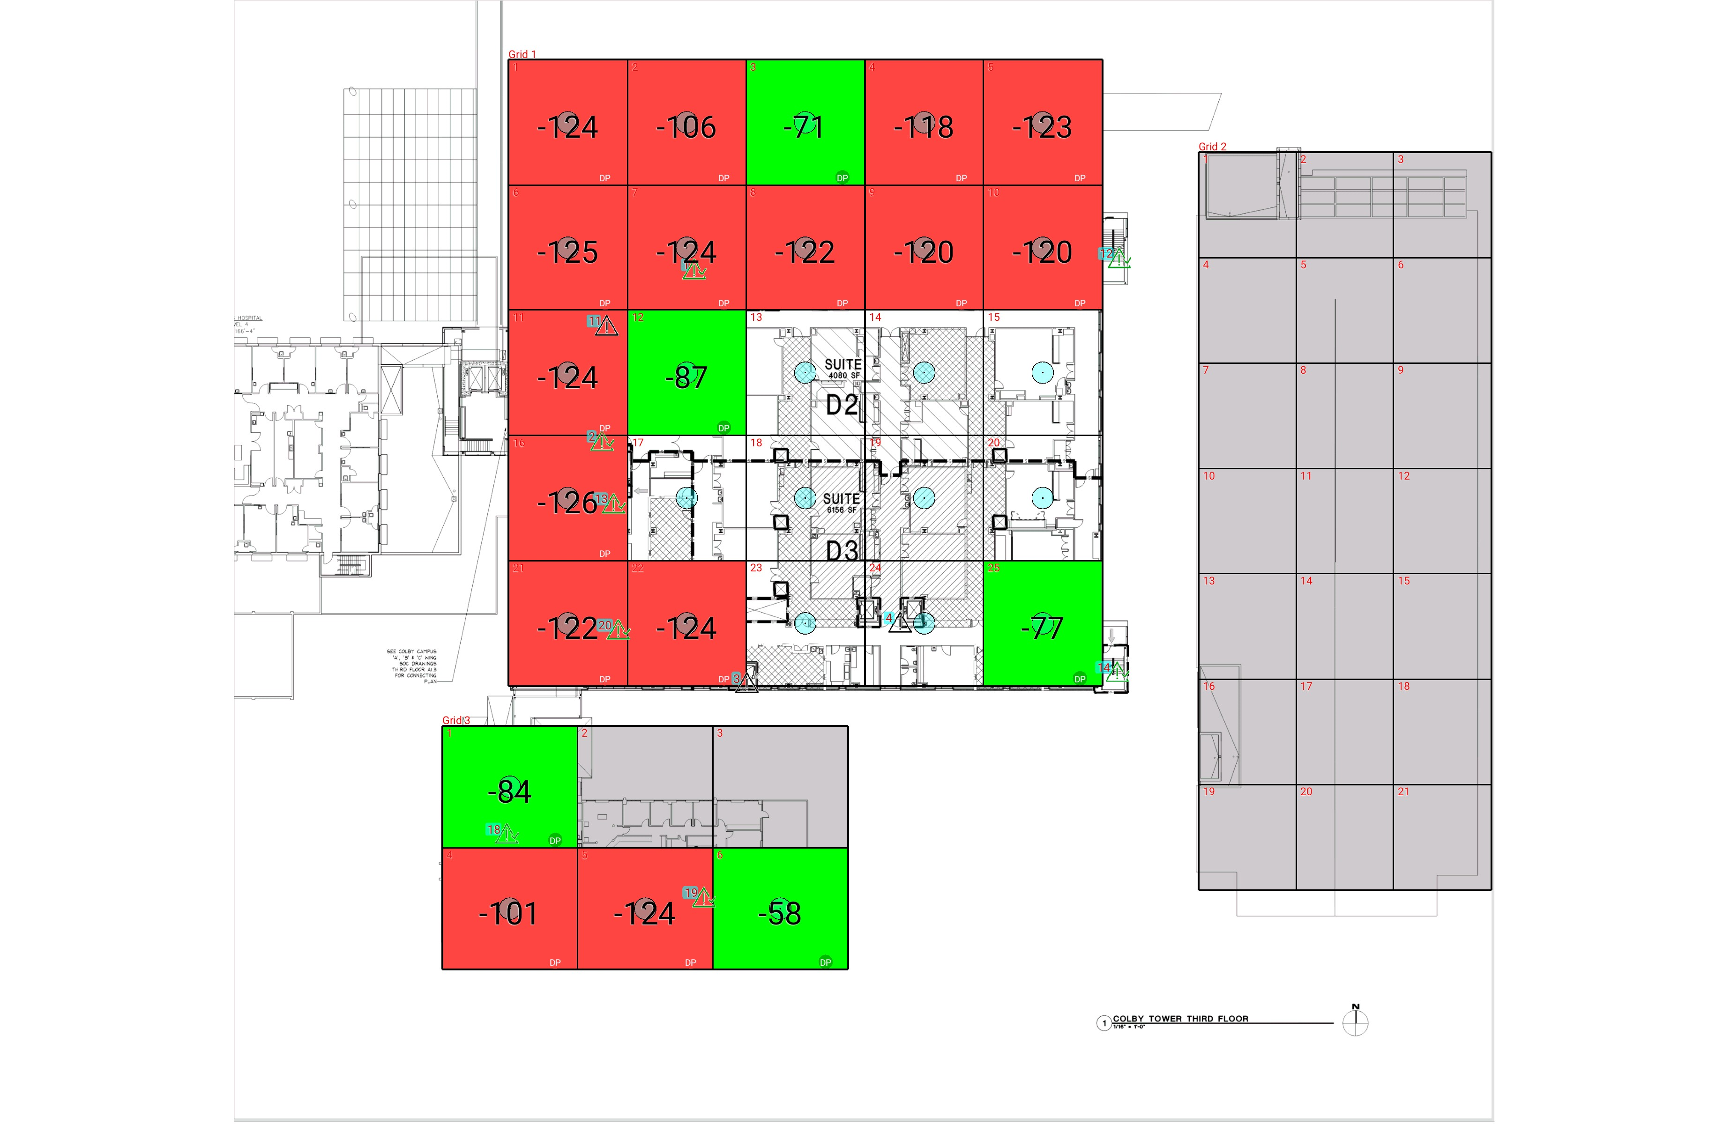

| **Grid** | **# of Areas** | **Area Size (sq. ft)** | **Area Width**  **(ft)** | **Area Height**  **(ft)** | **Ignore Area Color** | **Comments** |
| --- | --- | --- | --- | --- | --- | --- |
| 1 | 25 | 431.80 | 17.70 | 24.39 | Black |  |
| 2 | 21 | 298.85 | 14.56 | 20.53 | Black |  |
| 3 | 6 | 478.76 | 20.17 | 23.74 | Black |  |

**Floor: A4.3**

**Channel: 463550**

| **Critical Point Report** | | | | | | | |
| --- | --- | --- | --- | --- | --- | --- | --- |
| **Critical Point** | **DL**  **Power**  **(dBm)** | **DL**  **DAQ** | **UL**  **Power**  **(dBm)** | **UL**  **DAQ** | **Result** | **DL**  **Loss**  **(dB)** | **Comment** |
| 1 | -105.39 |  |  |  | **Pass** |  |  |
| 2 | -125.07 |  |  |  | **Pass** |  |  |
| 3 |  |  |  |  |  |  |  |
| 4 |  |  |  |  |  |  |  |
| 11 |  |  |  |  |  |  |  |
| 12 | -93.88 |  |  |  | **Pass** |  |  |
| 13 | -78.63 |  |  |  | **Pass** |  |  |
| 14 | -99.64 |  |  |  | **Pass** |  |  |
| 18 | -125.14 |  |  |  | **Pass** |  |  |
| 19 | -72.28 |  |  |  | **Pass** |  |  |
| 20 | -78.86 |  |  |  | **Pass** |  |  |

| **Area Report** | | | | | | | | |
| --- | --- | --- | --- | --- | --- | --- | --- | --- |
| **Grid** | **Area** | **DL**  **Power**  **(dBm)** | **DL**  **DAQ** | **UL**  **Power**  **(dBm)** | **UL**  **DAQ** | **Result** | **DL**  **Loss**  **(dB)** | **Comment** |
| 1 | 1 | -123.78 |  |  |  | **Fail** |  |  |
| 1 | 2 | -105.38 |  |  |  | **Fail** |  |  |
| 1 | 3 | -70.86 |  |  |  | **Pass** |  |  |
| 1 | 4 | -117.49 |  |  |  | **Fail** |  |  |
| 1 | 5 | -122.64 |  |  |  | **Fail** |  |  |
| 1 | 6 | -124.85 |  |  |  | **Fail** |  |  |
| 1 | 7 | -123.29 |  |  |  | **Fail** |  |  |
| 1 | 8 | -121.23 |  |  |  | **Fail** |  |  |
| 1 | 9 | -119.55 |  |  |  | **Fail** |  |  |
| 1 | 10 | -119.81 |  |  |  | **Fail** |  |  |
| 1 | 11 | -123.86 |  |  |  | **Fail** |  |  |
| 1 | 12 | -86.77 |  |  |  | **Pass** |  |  |
| 1 | 16 | -125.14 |  |  |  | **Fail** |  |  |
| 1 | 21 | -121.14 |  |  |  | **Fail** |  |  |
| 1 | 22 | -123.78 |  |  |  | **Fail** |  |  |
| 1 | 25 | -76.52 |  |  |  | **Pass** |  |  |
| 2 | 1 | NT | NT | NT | NT | **NT** |  |  |
| 2 | 2 | NT | NT | NT | NT | **NT** |  |  |
| 2 | 3 | NT | NT | NT | NT | **NT** |  |  |
| 2 | 4 | NT | NT | NT | NT | **NT** |  |  |
| 2 | 5 | NT | NT | NT | NT | **NT** |  |  |
| 2 | 6 | NT | NT | NT | NT | **NT** |  |  |
| 2 | 7 | NT | NT | NT | NT | **NT** |  |  |
| 2 | 8 | NT | NT | NT | NT | **NT** |  |  |
| 2 | 9 | NT | NT | NT | NT | **NT** |  |  |
| 2 | 10 | NT | NT | NT | NT | **NT** |  |  |
| 2 | 11 | NT | NT | NT | NT | **NT** |  |  |
| 2 | 12 | NT | NT | NT | NT | **NT** |  |  |
| 2 | 13 | NT | NT | NT | NT | **NT** |  |  |
| 2 | 14 | NT | NT | NT | NT | **NT** |  |  |
| 2 | 15 | NT | NT | NT | NT | **NT** |  |  |
| 2 | 16 | NT | NT | NT | NT | **NT** |  |  |
| 2 | 17 | NT | NT | NT | NT | **NT** |  |  |
| 2 | 18 | NT | NT | NT | NT | **NT** |  |  |
| 2 | 19 | NT | NT | NT | NT | **NT** |  |  |
| 2 | 20 | NT | NT | NT | NT | **NT** |  |  |
| 2 | 21 | NT | NT | NT | NT | **NT** |  |  |
| 3 | 1 | -83.74 |  |  |  | **Pass** |  |  |
| 3 | 2 | NT | NT | NT | NT | **NT** |  |  |
| 3 | 3 | NT | NT | NT | NT | **NT** |  |  |
| 3 | 4 | -100.12 |  |  |  | **Fail** |  |  |
| 3 | 5 | -123.35 |  |  |  | **Fail** |  |  |
| 3 | 6 | -57.86 |  |  |  | **Pass** |  |  |

**Floor: A4.4**

**Channel: 463550**

**Result: Fail (Adjacent)**

| **Freq (MHz)** | **Tech** | **Band** | **Ant Gain** | **Cable Loss** | **Ph.** | **Type** | **Mod** | **NAC** | **Area Points passed (%)** | **Critical Points passed (%)** |
| --- | --- | --- | --- | --- | --- | --- | --- | --- | --- | --- |
| 463.55000 | P25 | PRMCE | 0.00 | 0.00 |  |  |  |  | 7/14 (50%) | 4/4 (100%) |

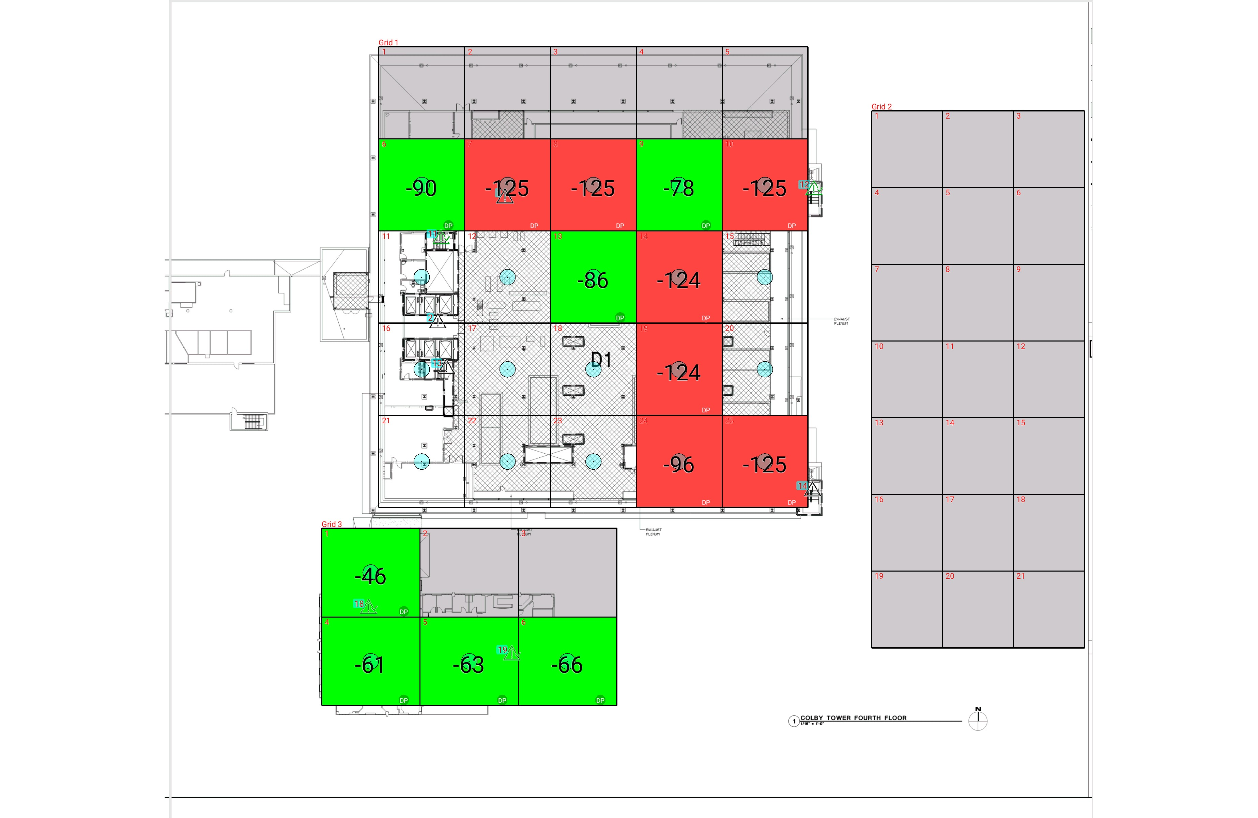

| **Grid** | **# of Areas** | **Area Size (sq. ft)** | **Area Width**  **(ft)** | **Area Height**  **(ft)** | **Ignore Area Color** | **Comments** |
| --- | --- | --- | --- | --- | --- | --- |
| 1 | 25 | 434.17 | 17.60 | 24.67 | Black |  |
| 2 | 21 | 298.85 | 14.56 | 20.53 | Black |  |
| 3 | 6 | 478.76 | 20.17 | 23.74 | Black |  |

**Floor: A4.4**

**Channel: 463550**

| **Critical Point Report** | | | | | | | |
| --- | --- | --- | --- | --- | --- | --- | --- |
| **Critical Point** | **DL**  **Power**  **(dBm)** | **DL**  **DAQ** | **UL**  **Power**  **(dBm)** | **UL**  **DAQ** | **Result** | **DL**  **Loss**  **(dB)** | **Comment** |
| 1 |  |  |  |  |  |  |  |
| 2 |  |  |  |  |  |  |  |
| 11 | -125.74 |  |  |  | **Pass** |  |  |
| 12 | -116.20 |  |  |  | **Pass** |  |  |
| 13 |  |  |  |  |  |  |  |
| 14 |  |  |  |  |  |  |  |
| 18 | -126.35 |  |  |  | **Pass** |  |  |
| 19 | -113.50 |  |  |  | **Pass** |  |  |

| **Area Report** | | | | | | | | |
| --- | --- | --- | --- | --- | --- | --- | --- | --- |
| **Grid** | **Area** | **DL**  **Power**  **(dBm)** | **DL**  **DAQ** | **UL**  **Power**  **(dBm)** | **UL**  **DAQ** | **Result** | **DL**  **Loss**  **(dB)** | **Comment** |
| 1 | 1 | NT | NT | NT | NT | **NT** |  |  |
| 1 | 2 | NT | NT | NT | NT | **NT** |  |  |
| 1 | 3 | NT | NT | NT | NT | **NT** |  |  |
| 1 | 4 | NT | NT | NT | NT | **NT** |  |  |
| 1 | 5 | NT | NT | NT | NT | **NT** |  |  |
| 1 | 6 | -89.87 |  |  |  | **Pass** |  |  |
| 1 | 7 | -124.04 |  |  |  | **Fail** |  |  |
| 1 | 8 | -124.51 |  |  |  | **Fail** |  |  |
| 1 | 9 | -77.77 |  |  |  | **Pass** |  |  |
| 1 | 10 | -124.80 |  |  |  | **Fail** |  |  |
| 1 | 13 | -85.91 |  |  |  | **Pass** |  |  |
| 1 | 14 | -123.84 |  |  |  | **Fail** |  |  |
| 1 | 19 | -123.63 |  |  |  | **Fail** |  |  |
| 1 | 24 | -95.58 |  |  |  | **Fail** |  |  |
| 1 | 25 | -124.88 |  |  |  | **Fail** |  |  |
| 2 | 1 | NT | NT | NT | NT | **NT** |  |  |
| 2 | 2 | NT | NT | NT | NT | **NT** |  |  |
| 2 | 3 | NT | NT | NT | NT | **NT** |  |  |
| 2 | 4 | NT | NT | NT | NT | **NT** |  |  |
| 2 | 5 | NT | NT | NT | NT | **NT** |  |  |
| 2 | 6 | NT | NT | NT | NT | **NT** |  |  |
| 2 | 7 | NT | NT | NT | NT | **NT** |  |  |
| 2 | 8 | NT | NT | NT | NT | **NT** |  |  |
| 2 | 9 | NT | NT | NT | NT | **NT** |  |  |
| 2 | 10 | NT | NT | NT | NT | **NT** |  |  |
| 2 | 11 | NT | NT | NT | NT | **NT** |  |  |
| 2 | 12 | NT | NT | NT | NT | **NT** |  |  |
| 2 | 13 | NT | NT | NT | NT | **NT** |  |  |
| 2 | 14 | NT | NT | NT | NT | **NT** |  |  |
| 2 | 15 | NT | NT | NT | NT | **NT** |  |  |
| 2 | 16 | NT | NT | NT | NT | **NT** |  |  |
| 2 | 17 | NT | NT | NT | NT | **NT** |  |  |
| 2 | 18 | NT | NT | NT | NT | **NT** |  |  |
| 2 | 19 | NT | NT | NT | NT | **NT** |  |  |
| 2 | 20 | NT | NT | NT | NT | **NT** |  |  |
| 2 | 21 | NT | NT | NT | NT | **NT** |  |  |
| 3 | 1 | -45.21 |  |  |  | **Pass** |  |  |
| 3 | 2 | NT | NT | NT | NT | **NT** |  |  |
| 3 | 3 | NT | NT | NT | NT | **NT** |  |  |
| 3 | 4 | -60.09 |  |  |  | **Pass** |  |  |
| 3 | 5 | -62.83 |  |  |  | **Pass** |  |  |
| 3 | 6 | -65.17 |  |  |  | **Pass** |  |  |

**Floor: A4.5**

**Channel: 463550**

**Result: Fail (Adjacent)**

| **Freq (MHz)** | **Tech** | **Band** | **Ant Gain** | **Cable Loss** | **Ph.** | **Type** | **Mod** | **NAC** | **Area Points passed (%)** | **Critical Points passed (%)** |
| --- | --- | --- | --- | --- | --- | --- | --- | --- | --- | --- |
| 463.55000 | P25 | PRMCE | 0.00 | 0.00 |  |  |  |  | 2/14 (14%) | 5/5 (100%) |

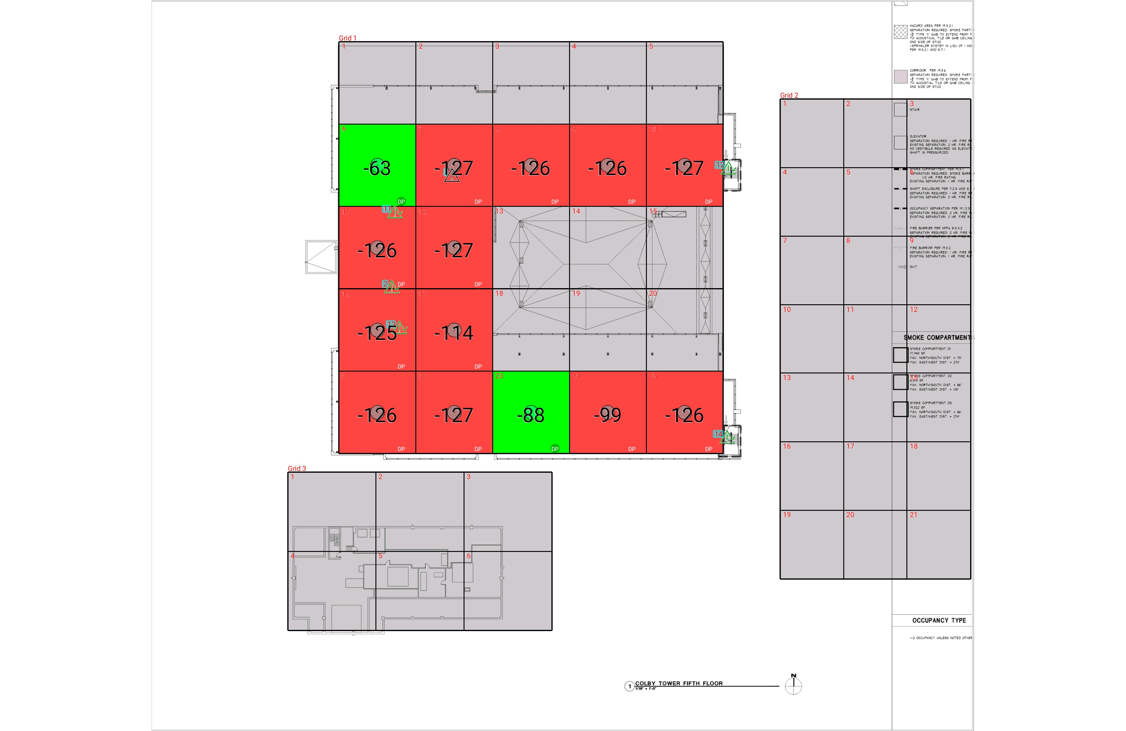

| **Grid** | **# of Areas** | **Area Size (sq. ft)** | **Area Width**  **(ft)** | **Area Height**  **(ft)** | **Ignore Area Color** | **Comments** |
| --- | --- | --- | --- | --- | --- | --- |
| 1 | 25 | 434.17 | 17.60 | 24.67 | Black |  |
| 2 | 21 | 298.85 | 14.56 | 20.53 | Black |  |
| 3 | 6 | 478.76 | 20.17 | 23.74 | Black |  |

**Floor: A4.5**

**Channel: 463550**

| **Critical Point Report** | | | | | | | |
| --- | --- | --- | --- | --- | --- | --- | --- |
| **Critical Point** | **DL**  **Power**  **(dBm)** | **DL**  **DAQ** | **UL**  **Power**  **(dBm)** | **UL**  **DAQ** | **Result** | **DL**  **Loss**  **(dB)** | **Comment** |
| 1 |  |  |  |  |  |  |  |
| 2 | -125.24 |  |  |  | **Pass** |  |  |
| 11 | -89.35 |  |  |  | **Pass** |  |  |
| 12 | -118.33 |  |  |  | **Pass** |  |  |
| 13 | -112.12 |  |  |  | **Pass** |  |  |
| 14 | -98.81 |  |  |  | **Pass** |  |  |

| **Area Report** | | | | | | | | |
| --- | --- | --- | --- | --- | --- | --- | --- | --- |
| **Grid** | **Area** | **DL**  **Power**  **(dBm)** | **DL**  **DAQ** | **UL**  **Power**  **(dBm)** | **UL**  **DAQ** | **Result** | **DL**  **Loss**  **(dB)** | **Comment** |
| 1 | 1 | NT | NT | NT | NT | **NT** |  |  |
| 1 | 2 | NT | NT | NT | NT | **NT** |  |  |
| 1 | 3 | NT | NT | NT | NT | **NT** |  |  |
| 1 | 4 | NT | NT | NT | NT | **NT** |  |  |
| 1 | 5 | NT | NT | NT | NT | **NT** |  |  |
| 1 | 6 | -62.81 |  |  |  | **Pass** |  |  |
| 1 | 7 | -126.26 |  |  |  | **Fail** |  |  |
| 1 | 8 | -125.92 |  |  |  | **Fail** |  |  |
| 1 | 9 | -125.57 |  |  |  | **Fail** |  |  |
| 1 | 10 | -126.25 |  |  |  | **Fail** |  |  |
| 1 | 11 | -125.76 |  |  |  | **Fail** |  |  |
| 1 | 12 | -126.10 |  |  |  | **Fail** |  |  |
| 1 | 13 | NT | NT | NT | NT | **NT** |  |  |
| 1 | 14 | NT | NT | NT | NT | **NT** |  |  |
| 1 | 15 | NT | NT | NT | NT | **NT** |  |  |
| 1 | 16 | -124.86 |  |  |  | **Fail** |  |  |
| 1 | 17 | -113.93 |  |  |  | **Fail** |  |  |
| 1 | 18 | NT | NT | NT | NT | **NT** |  |  |
| 1 | 19 | NT | NT | NT | NT | **NT** |  |  |
| 1 | 20 | NT | NT | NT | NT | **NT** |  |  |
| 1 | 21 | -125.04 |  |  |  | **Fail** |  |  |
| 1 | 22 | -126.14 |  |  |  | **Fail** |  |  |
| 1 | 23 | -87.04 |  |  |  | **Pass** |  |  |
| 1 | 24 | -98.26 |  |  |  | **Fail** |  |  |
| 1 | 25 | -125.90 |  |  |  | **Fail** |  |  |
| 2 | 1 | NT | NT | NT | NT | **NT** |  |  |
| 2 | 2 | NT | NT | NT | NT | **NT** |  |  |
| 2 | 3 | NT | NT | NT | NT | **NT** |  |  |
| 2 | 4 | NT | NT | NT | NT | **NT** |  |  |
| 2 | 5 | NT | NT | NT | NT | **NT** |  |  |
| 2 | 6 | NT | NT | NT | NT | **NT** |  |  |
| 2 | 7 | NT | NT | NT | NT | **NT** |  |  |
| 2 | 8 | NT | NT | NT | NT | **NT** |  |  |
| 2 | 9 | NT | NT | NT | NT | **NT** |  |  |
| 2 | 10 | NT | NT | NT | NT | **NT** |  |  |
| 2 | 11 | NT | NT | NT | NT | **NT** |  |  |
| 2 | 12 | NT | NT | NT | NT | **NT** |  |  |
| 2 | 13 | NT | NT | NT | NT | **NT** |  |  |
| 2 | 14 | NT | NT | NT | NT | **NT** |  |  |
| 2 | 15 | NT | NT | NT | NT | **NT** |  |  |
| 2 | 16 | NT | NT | NT | NT | **NT** |  |  |
| 2 | 17 | NT | NT | NT | NT | **NT** |  |  |
| 2 | 18 | NT | NT | NT | NT | **NT** |  |  |
| 2 | 19 | NT | NT | NT | NT | **NT** |  |  |
| 2 | 20 | NT | NT | NT | NT | **NT** |  |  |
| 2 | 21 | NT | NT | NT | NT | **NT** |  |  |
| 3 | 1 | NT | NT | NT | NT | **NT** |  |  |
| 3 | 2 | NT | NT | NT | NT | **NT** |  |  |
| 3 | 3 | NT | NT | NT | NT | **NT** |  |  |
| 3 | 4 | NT | NT | NT | NT | **NT** |  |  |
| 3 | 5 | NT | NT | NT | NT | **NT** |  |  |
| 3 | 6 | NT | NT | NT | NT | **NT** |  |  |

**Floor: A4.6**

**Channel: 463550**

**Result: Fail (Adjacent)**

| **Freq (MHz)** | **Tech** | **Band** | **Ant Gain** | **Cable Loss** | **Ph.** | **Type** | **Mod** | **NAC** | **Area Points passed (%)** | **Critical Points passed (%)** |
| --- | --- | --- | --- | --- | --- | --- | --- | --- | --- | --- |
| 463.55000 | P25 | PRMCE | 0.00 | 0.00 |  |  |  |  | 4/12 (33%) | 5/5 (100%) |

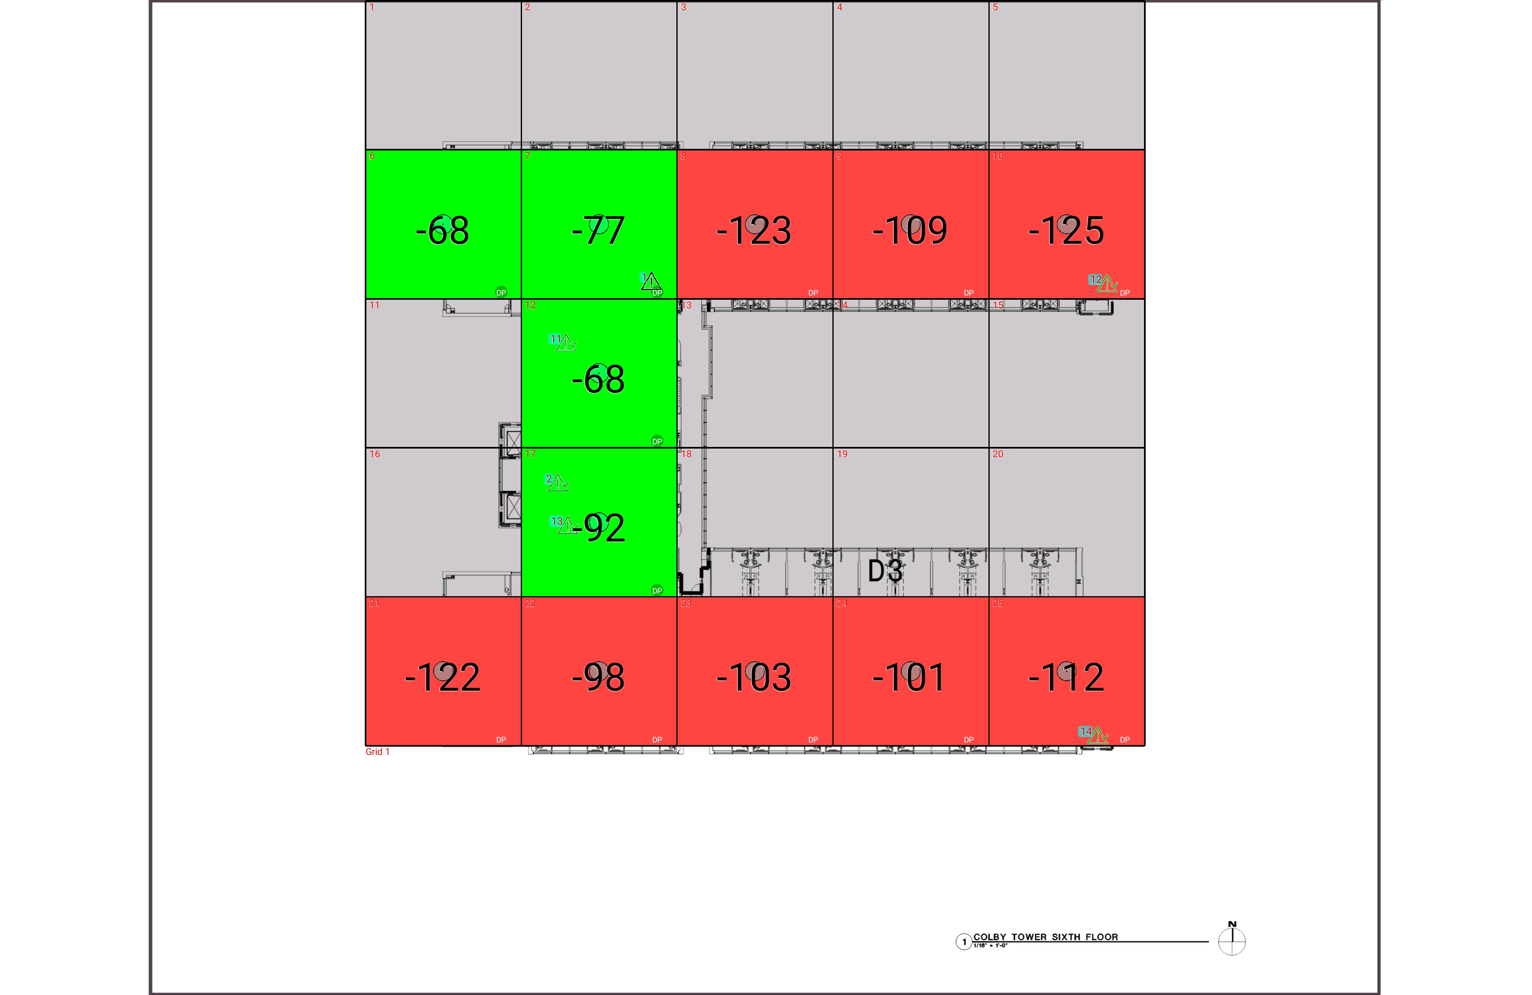

| **Grid** | **# of Areas** | **Area Size (sq. ft)** | **Area Width**  **(ft)** | **Area Height**  **(ft)** | **Ignore Area Color** | **Comments** |
| --- | --- | --- | --- | --- | --- | --- |
| 1 | 25 | 860.38 | 26.25 | 32.77 | Black |  |

**Floor: A4.6**

**Channel: 463550**

| **Critical Point Report** | | | | | | | |
| --- | --- | --- | --- | --- | --- | --- | --- |
| **Critical Point** | **DL**  **Power**  **(dBm)** | **DL**  **DAQ** | **UL**  **Power**  **(dBm)** | **UL**  **DAQ** | **Result** | **DL**  **Loss**  **(dB)** | **Comment** |
| 1 |  |  |  |  |  |  |  |
| 2 | -73.84 |  |  |  | **Pass** |  |  |
| 11 | -125.16 |  |  |  | **Pass** |  |  |
| 12 | -118.09 |  |  |  | **Pass** |  |  |
| 13 | -80.40 |  |  |  | **Pass** |  |  |
| 14 | -122.96 |  |  |  | **Pass** |  |  |

| **Area Report** | | | | | | | | |
| --- | --- | --- | --- | --- | --- | --- | --- | --- |
| **Grid** | **Area** | **DL**  **Power**  **(dBm)** | **DL**  **DAQ** | **UL**  **Power**  **(dBm)** | **UL**  **DAQ** | **Result** | **DL**  **Loss**  **(dB)** | **Comment** |
| 1 | 1 | NT | NT | NT | NT | **NT** |  |  |
| 1 | 2 | NT | NT | NT | NT | **NT** |  |  |
| 1 | 3 | NT | NT | NT | NT | **NT** |  |  |
| 1 | 4 | NT | NT | NT | NT | **NT** |  |  |
| 1 | 5 | NT | NT | NT | NT | **NT** |  |  |
| 1 | 6 | -67.52 |  |  |  | **Pass** |  |  |
| 1 | 7 | -76.57 |  |  |  | **Pass** |  |  |
| 1 | 8 | -122.55 |  |  |  | **Fail** |  |  |
| 1 | 9 | -108.78 |  |  |  | **Fail** |  |  |
| 1 | 10 | -124.29 |  |  |  | **Fail** |  |  |
| 1 | 11 | NT | NT | NT | NT | **NT** |  |  |
| 1 | 12 | -67.32 |  |  |  | **Pass** |  |  |
| 1 | 13 | NT | NT | NT | NT | **NT** |  |  |
| 1 | 14 | NT | NT | NT | NT | **NT** |  |  |
| 1 | 15 | NT | NT | NT | NT | **NT** |  |  |
| 1 | 16 | NT | NT | NT | NT | **NT** |  |  |
| 1 | 17 | -91.85 |  |  |  | **Pass** |  |  |
| 1 | 18 | NT | NT | NT | NT | **NT** |  |  |
| 1 | 19 | NT | NT | NT | NT | **NT** |  |  |
| 1 | 20 | NT | NT | NT | NT | **NT** |  |  |
| 1 | 21 | -121.41 |  |  |  | **Fail** |  |  |
| 1 | 22 | -97.76 |  |  |  | **Fail** |  |  |
| 1 | 23 | -102.83 |  |  |  | **Fail** |  |  |
| 1 | 24 | -100.83 |  |  |  | **Fail** |  |  |
| 1 | 25 | -111.22 |  |  |  | **Fail** |  |  |

**Floor: A4.7**

**Channel: 463550**

**Result: Fail (Adjacent)**

| **Freq (MHz)** | **Tech** | **Band** | **Ant Gain** | **Cable Loss** | **Ph.** | **Type** | **Mod** | **NAC** | **Area Points passed (%)** | **Critical Points passed (%)** |
| --- | --- | --- | --- | --- | --- | --- | --- | --- | --- | --- |
| 463.55000 | P25 | PRMCE | 0.00 | 0.00 |  |  |  |  | 3/12 (25%) | 5/5 (100%) |

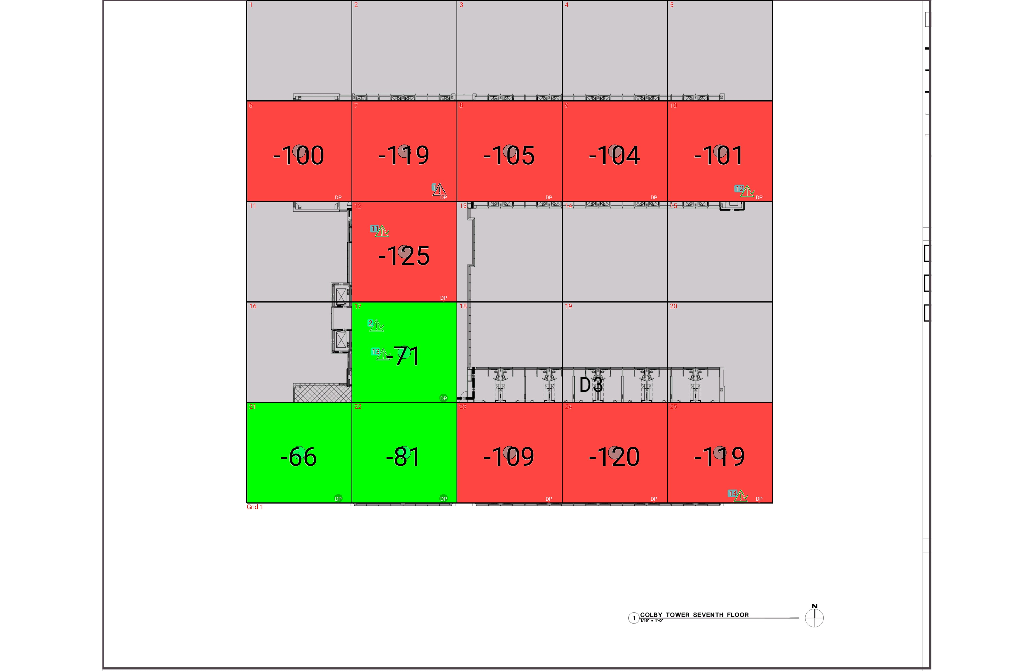

| **Grid** | **# of Areas** | **Area Size (sq. ft)** | **Area Width**  **(ft)** | **Area Height**  **(ft)** | **Ignore Area Color** | **Comments** |
| --- | --- | --- | --- | --- | --- | --- |
| 1 | 25 | 860.38 | 26.25 | 32.77 | Black |  |

**Floor: A4.7**

**Channel: 463550**

| **Critical Point Report** | | | | | | | |
| --- | --- | --- | --- | --- | --- | --- | --- |
| **Critical Point** | **DL**  **Power**  **(dBm)** | **DL**  **DAQ** | **UL**  **Power**  **(dBm)** | **UL**  **DAQ** | **Result** | **DL**  **Loss**  **(dB)** | **Comment** |
| 1 |  |  |  |  |  |  |  |
| 2 | -91.88 |  |  |  | **Pass** |  |  |
| 11 | -125.39 |  |  |  | **Pass** |  |  |
| 12 | -104.75 |  |  |  | **Pass** |  |  |
| 13 | -90.30 |  |  |  | **Pass** |  |  |
| 14 | -112.66 |  |  |  | **Pass** |  |  |

| **Area Report** | | | | | | | | |
| --- | --- | --- | --- | --- | --- | --- | --- | --- |
| **Grid** | **Area** | **DL**  **Power**  **(dBm)** | **DL**  **DAQ** | **UL**  **Power**  **(dBm)** | **UL**  **DAQ** | **Result** | **DL**  **Loss**  **(dB)** | **Comment** |
| 1 | 1 | NT | NT | NT | NT | **NT** |  |  |
| 1 | 2 | NT | NT | NT | NT | **NT** |  |  |
| 1 | 3 | NT | NT | NT | NT | **NT** |  |  |
| 1 | 4 | NT | NT | NT | NT | **NT** |  |  |
| 1 | 5 | NT | NT | NT | NT | **NT** |  |  |
| 1 | 6 | -99.63 |  |  |  | **Fail** |  |  |
| 1 | 7 | -118.93 |  |  |  | **Fail** |  |  |
| 1 | 8 | -104.50 |  |  |  | **Fail** |  |  |
| 1 | 9 | -103.35 |  |  |  | **Fail** |  |  |
| 1 | 10 | -100.22 |  |  |  | **Fail** |  |  |
| 1 | 11 | NT | NT | NT | NT | **NT** |  |  |
| 1 | 12 | -124.77 |  |  |  | **Fail** |  |  |
| 1 | 13 | NT | NT | NT | NT | **NT** |  |  |
| 1 | 14 | NT | NT | NT | NT | **NT** |  |  |
| 1 | 15 | NT | NT | NT | NT | **NT** |  |  |
| 1 | 16 | NT | NT | NT | NT | **NT** |  |  |
| 1 | 17 | -70.64 |  |  |  | **Pass** |  |  |
| 1 | 18 | NT | NT | NT | NT | **NT** |  |  |
| 1 | 19 | NT | NT | NT | NT | **NT** |  |  |
| 1 | 20 | NT | NT | NT | NT | **NT** |  |  |
| 1 | 21 | -65.83 |  |  |  | **Pass** |  |  |
| 1 | 22 | -80.81 |  |  |  | **Pass** |  |  |
| 1 | 23 | -108.76 |  |  |  | **Fail** |  |  |
| 1 | 24 | -119.66 |  |  |  | **Fail** |  |  |
| 1 | 25 | -118.91 |  |  |  | **Fail** |  |  |

**Floor: A4.8**

**Channel: 463550**

**Result: Fail (Adjacent)**

| **Freq (MHz)** | **Tech** | **Band** | **Ant Gain** | **Cable Loss** | **Ph.** | **Type** | **Mod** | **NAC** | **Area Points passed (%)** | **Critical Points passed (%)** |
| --- | --- | --- | --- | --- | --- | --- | --- | --- | --- | --- |
| 463.55000 | P25 | PRMCE | 0.00 | 0.00 |  |  |  |  | 3/12 (25%) | 5/5 (100%) |

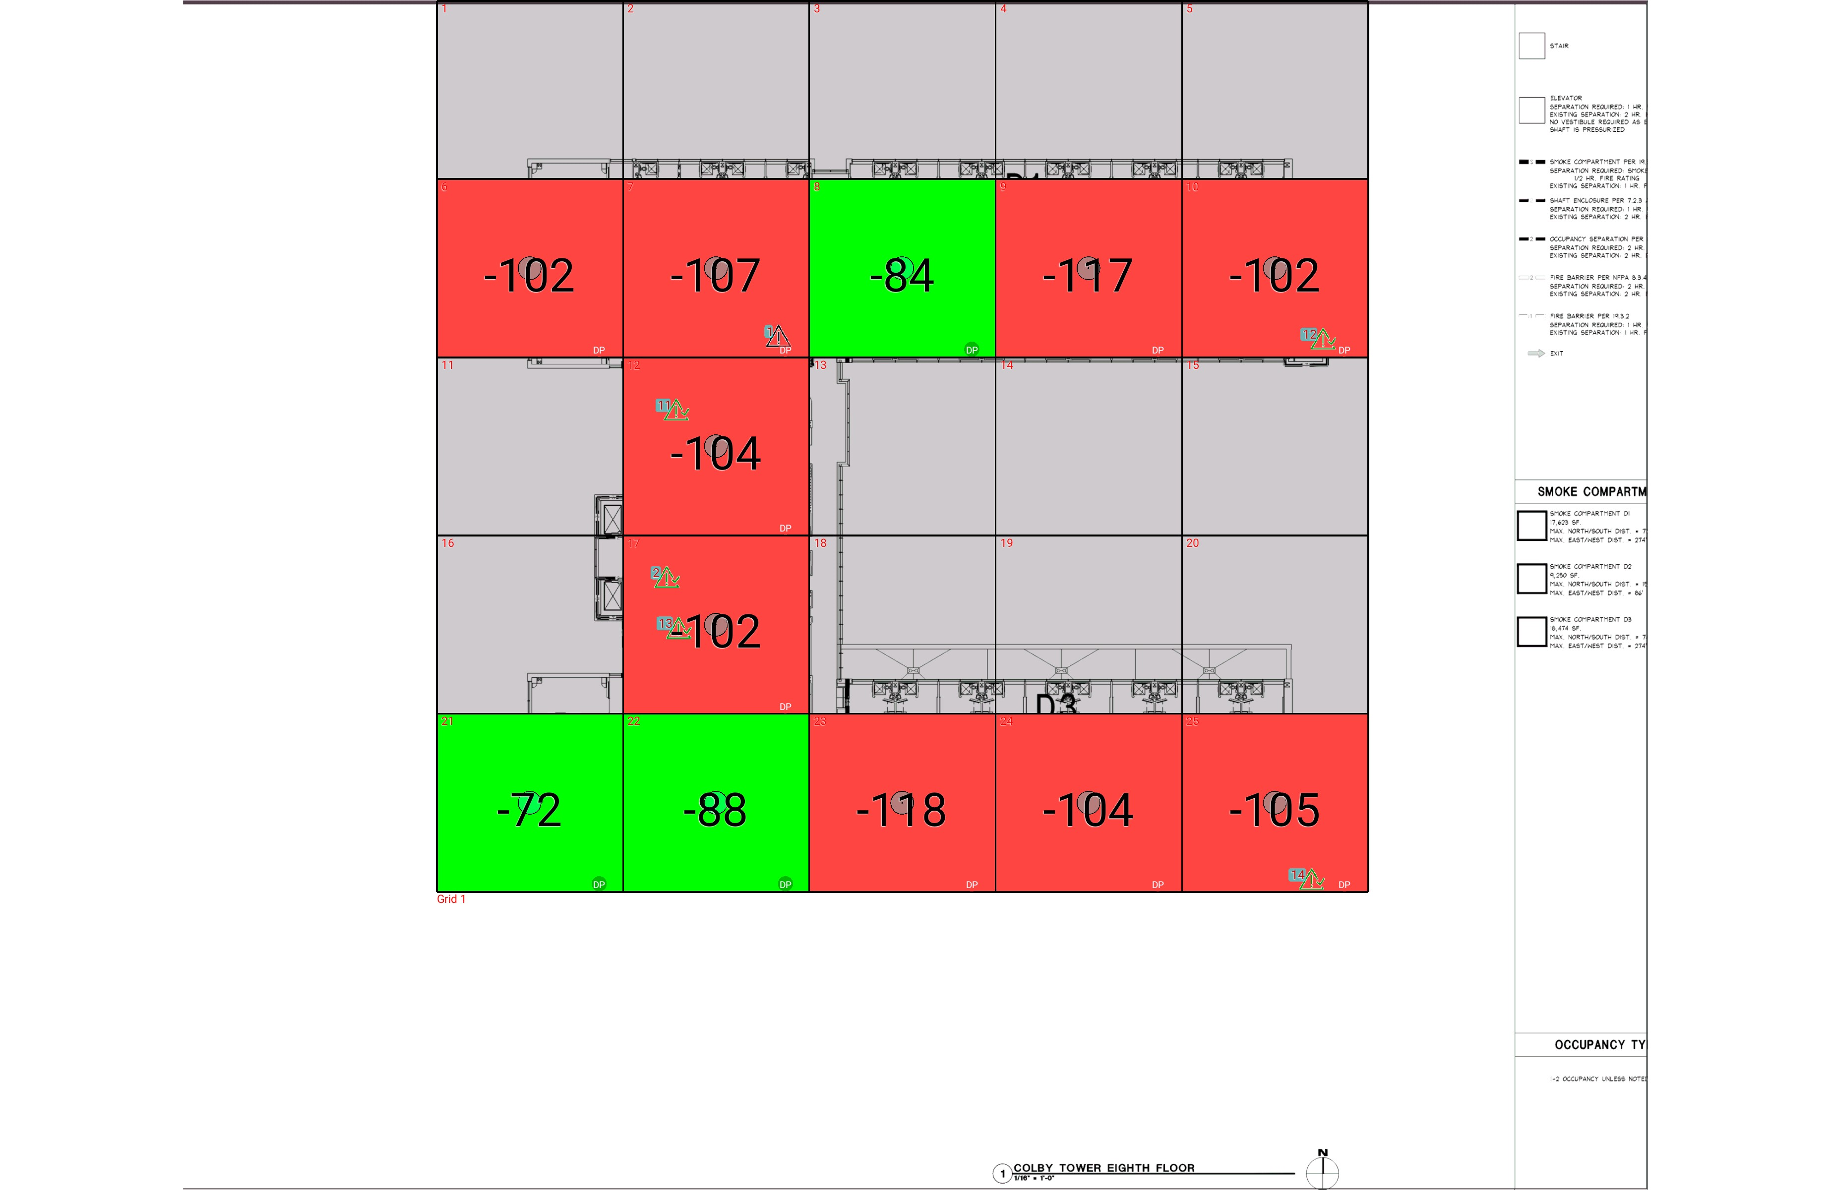

| **Grid** | **# of Areas** | **Area Size (sq. ft)** | **Area Width**  **(ft)** | **Area Height**  **(ft)** | **Ignore Area Color** | **Comments** |
| --- | --- | --- | --- | --- | --- | --- |
| 1 | 25 | 860.38 | 26.25 | 32.77 | Black |  |

**Floor: A4.8**

**Channel: 463550**

| **Critical Point Report** | | | | | | | |
| --- | --- | --- | --- | --- | --- | --- | --- |
| **Critical Point** | **DL**  **Power**  **(dBm)** | **DL**  **DAQ** | **UL**  **Power**  **(dBm)** | **UL**  **DAQ** | **Result** | **DL**  **Loss**  **(dB)** | **Comment** |
| 1 |  |  |  |  |  |  |  |
| 2 | -125.65 |  |  |  | **Pass** |  |  |
| 11 | -104.24 |  |  |  | **Pass** |  |  |
| 12 | -103.10 |  |  |  | **Pass** |  |  |
| 13 | -99.90 |  |  |  | **Pass** |  |  |
| 14 | -118.39 |  |  |  | **Pass** |  |  |

| **Area Report** | | | | | | | | |
| --- | --- | --- | --- | --- | --- | --- | --- | --- |
| **Grid** | **Area** | **DL**  **Power**  **(dBm)** | **DL**  **DAQ** | **UL**  **Power**  **(dBm)** | **UL**  **DAQ** | **Result** | **DL**  **Loss**  **(dB)** | **Comment** |
| 1 | 1 | NT | NT | NT | NT | **NT** |  |  |
| 1 | 2 | NT | NT | NT | NT | **NT** |  |  |
| 1 | 3 | NT | NT | NT | NT | **NT** |  |  |
| 1 | 4 | NT | NT | NT | NT | **NT** |  |  |
| 1 | 5 | NT | NT | NT | NT | **NT** |  |  |
| 1 | 6 | -101.39 |  |  |  | **Fail** |  |  |
| 1 | 7 | -106.55 |  |  |  | **Fail** |  |  |
| 1 | 8 | -83.53 |  |  |  | **Pass** |  |  |
| 1 | 9 | -116.18 |  |  |  | **Fail** |  |  |
| 1 | 10 | -101.81 |  |  |  | **Fail** |  |  |
| 1 | 11 | NT | NT | NT | NT | **NT** |  |  |
| 1 | 12 | -103.63 |  |  |  | **Fail** |  |  |
| 1 | 13 | NT | NT | NT | NT | **NT** |  |  |
| 1 | 14 | NT | NT | NT | NT | **NT** |  |  |
| 1 | 15 | NT | NT | NT | NT | **NT** |  |  |
| 1 | 16 | NT | NT | NT | NT | **NT** |  |  |
| 1 | 17 | -101.69 |  |  |  | **Fail** |  |  |
| 1 | 18 | NT | NT | NT | NT | **NT** |  |  |
| 1 | 19 | NT | NT | NT | NT | **NT** |  |  |
| 1 | 20 | NT | NT | NT | NT | **NT** |  |  |
| 1 | 21 | -71.47 |  |  |  | **Pass** |  |  |
| 1 | 22 | -87.89 |  |  |  | **Pass** |  |  |
| 1 | 23 | -117.25 |  |  |  | **Fail** |  |  |
| 1 | 24 | -103.75 |  |  |  | **Fail** |  |  |
| 1 | 25 | -104.84 |  |  |  | **Fail** |  |  |

**Floor: A4.9**

**Channel: 463550**

**Result: Fail (Adjacent)**

| **Freq (MHz)** | **Tech** | **Band** | **Ant Gain** | **Cable Loss** | **Ph.** | **Type** | **Mod** | **NAC** | **Area Points passed (%)** | **Critical Points passed (%)** |
| --- | --- | --- | --- | --- | --- | --- | --- | --- | --- | --- |
| 463.55000 | P25 | PRMCE | 0.00 | 0.00 |  |  |  |  | 1/12 (8%) | 5/5 (100%) |

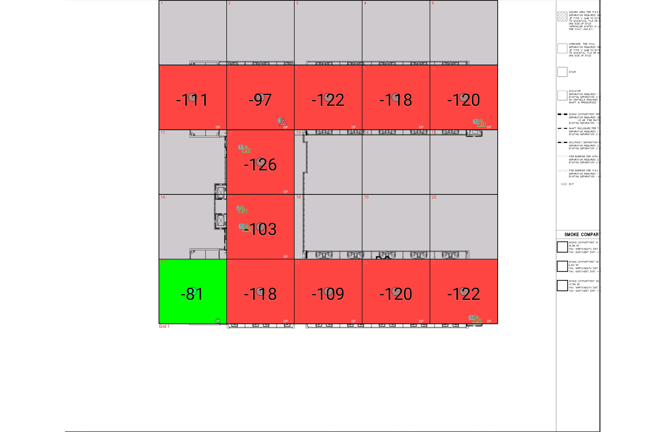

| **Grid** | **# of Areas** | **Area Size (sq. ft)** | **Area Width**  **(ft)** | **Area Height**  **(ft)** | **Ignore Area Color** | **Comments** |
| --- | --- | --- | --- | --- | --- | --- |
| 1 | 25 | 860.38 | 26.25 | 32.77 | Black |  |

**Floor: A4.9**

**Channel: 463550**

| **Critical Point Report** | | | | | | | |
| --- | --- | --- | --- | --- | --- | --- | --- |
| **Critical Point** | **DL**  **Power**  **(dBm)** | **DL**  **DAQ** | **UL**  **Power**  **(dBm)** | **UL**  **DAQ** | **Result** | **DL**  **Loss**  **(dB)** | **Comment** |
| 1 |  |  |  |  |  |  |  |
| 2 | -117.19 |  |  |  | **Pass** |  |  |
| 11 | -125.91 |  |  |  | **Pass** |  |  |
| 12 | -123.39 |  |  |  | **Pass** |  |  |
| 13 | -108.33 |  |  |  | **Pass** |  |  |
| 14 | -116.94 |  |  |  | **Pass** |  |  |

| **Area Report** | | | | | | | | |
| --- | --- | --- | --- | --- | --- | --- | --- | --- |
| **Grid** | **Area** | **DL**  **Power**  **(dBm)** | **DL**  **DAQ** | **UL**  **Power**  **(dBm)** | **UL**  **DAQ** | **Result** | **DL**  **Loss**  **(dB)** | **Comment** |
| 1 | 1 | NT | NT | NT | NT | **NT** |  |  |
| 1 | 2 | NT | NT | NT | NT | **NT** |  |  |
| 1 | 3 | NT | NT | NT | NT | **NT** |  |  |
| 1 | 4 | NT | NT | NT | NT | **NT** |  |  |
| 1 | 5 | NT | NT | NT | NT | **NT** |  |  |
| 1 | 6 | -110.72 |  |  |  | **Fail** |  |  |
| 1 | 7 | -96.66 |  |  |  | **Fail** |  |  |
| 1 | 8 | -121.06 |  |  |  | **Fail** |  |  |
| 1 | 9 | -117.66 |  |  |  | **Fail** |  |  |
| 1 | 10 | -119.93 |  |  |  | **Fail** |  |  |
| 1 | 11 | NT | NT | NT | NT | **NT** |  |  |
| 1 | 12 | -125.16 |  |  |  | **Fail** |  |  |
| 1 | 13 | NT | NT | NT | NT | **NT** |  |  |
| 1 | 14 | NT | NT | NT | NT | **NT** |  |  |
| 1 | 15 | NT | NT | NT | NT | **NT** |  |  |
| 1 | 16 | NT | NT | NT | NT | **NT** |  |  |
| 1 | 17 | -102.32 |  |  |  | **Fail** |  |  |
| 1 | 18 | NT | NT | NT | NT | **NT** |  |  |
| 1 | 19 | NT | NT | NT | NT | **NT** |  |  |
| 1 | 20 | NT | NT | NT | NT | **NT** |  |  |
| 1 | 21 | -81.00 |  |  |  | **Pass** |  |  |
| 1 | 22 | -118.00 |  |  |  | **Fail** |  |  |
| 1 | 23 | -108.45 |  |  |  | **Fail** |  |  |
| 1 | 24 | -119.48 |  |  |  | **Fail** |  |  |
| 1 | 25 | -121.49 |  |  |  | **Fail** |  |  |

**Floor: A4.10**

**Channel: 463550**

**Result: Fail (Adjacent)**

| **Freq (MHz)** | **Tech** | **Band** | **Ant Gain** | **Cable Loss** | **Ph.** | **Type** | **Mod** | **NAC** | **Area Points passed (%)** | **Critical Points passed (%)** |
| --- | --- | --- | --- | --- | --- | --- | --- | --- | --- | --- |
| 463.55000 | P25 | PRMCE | 0.00 | 0.00 |  |  |  |  | 5/12 (41%) | 5/5 (100%) |

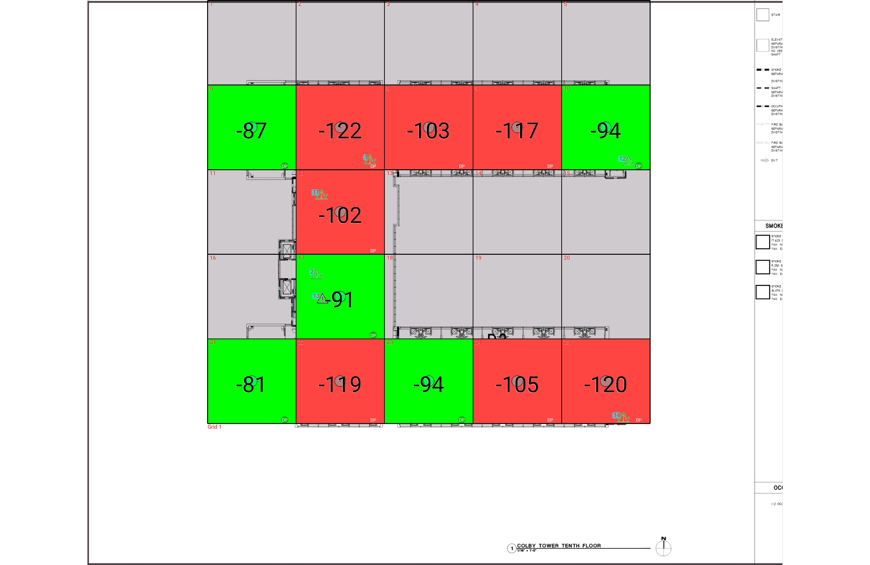

| **Grid** | **# of Areas** | **Area Size (sq. ft)** | **Area Width**  **(ft)** | **Area Height**  **(ft)** | **Ignore Area Color** | **Comments** |
| --- | --- | --- | --- | --- | --- | --- |
| 1 | 25 | 860.38 | 26.25 | 32.77 | Black |  |

**Floor: A4.10**

**Channel: 463550**

| **Critical Point Report** | | | | | | | |
| --- | --- | --- | --- | --- | --- | --- | --- |
| **Critical Point** | **DL**  **Power**  **(dBm)** | **DL**  **DAQ** | **UL**  **Power**  **(dBm)** | **UL**  **DAQ** | **Result** | **DL**  **Loss**  **(dB)** | **Comment** |
| 1 | -100.76 |  |  |  | **Pass** |  |  |
| 2 | -125.30 |  |  |  | **Pass** |  |  |
| 11 | -109.69 |  |  |  | **Pass** |  |  |
| 12 | -124.01 |  |  |  | **Pass** |  |  |
| 13 |  |  |  |  |  |  |  |
| 14 | -105.59 |  |  |  | **Pass** |  |  |

| **Area Report** | | | | | | | | |
| --- | --- | --- | --- | --- | --- | --- | --- | --- |
| **Grid** | **Area** | **DL**  **Power**  **(dBm)** | **DL**  **DAQ** | **UL**  **Power**  **(dBm)** | **UL**  **DAQ** | **Result** | **DL**  **Loss**  **(dB)** | **Comment** |
| 1 | 1 | NT | NT | NT | NT | **NT** |  |  |
| 1 | 2 | NT | NT | NT | NT | **NT** |  |  |
| 1 | 3 | NT | NT | NT | NT | **NT** |  |  |
| 1 | 4 | NT | NT | NT | NT | **NT** |  |  |
| 1 | 5 | NT | NT | NT | NT | **NT** |  |  |
| 1 | 6 | -86.26 |  |  |  | **Pass** |  |  |
| 1 | 7 | -121.52 |  |  |  | **Fail** |  |  |
| 1 | 8 | -102.12 |  |  |  | **Fail** |  |  |
| 1 | 9 | -116.93 |  |  |  | **Fail** |  |  |
| 1 | 10 | -93.05 |  |  |  | **Pass** |  |  |
| 1 | 11 | NT | NT | NT | NT | **NT** |  |  |
| 1 | 12 | -101.43 |  |  |  | **Fail** |  |  |
| 1 | 13 | NT | NT | NT | NT | **NT** |  |  |
| 1 | 14 | NT | NT | NT | NT | **NT** |  |  |
| 1 | 15 | NT | NT | NT | NT | **NT** |  |  |
| 1 | 16 | NT | NT | NT | NT | **NT** |  |  |
| 1 | 17 | -90.25 |  |  |  | **Pass** |  |  |
| 1 | 18 | NT | NT | NT | NT | **NT** |  |  |
| 1 | 19 | NT | NT | NT | NT | **NT** |  |  |
| 1 | 20 | NT | NT | NT | NT | **NT** |  |  |
| 1 | 21 | -80.72 |  |  |  | **Pass** |  |  |
| 1 | 22 | -118.48 |  |  |  | **Fail** |  |  |
| 1 | 23 | -93.10 |  |  |  | **Pass** |  |  |
| 1 | 24 | -104.61 |  |  |  | **Fail** |  |  |
| 1 | 25 | -119.13 |  |  |  | **Fail** |  |  |

**Floor: A.4R**

**Channel: 463550**

**Result: Pass**

| **Freq (MHz)** | **Tech** | **Band** | **Ant Gain** | **Cable Loss** | **Ph.** | **Type** | **Mod** | **NAC** | **Area Points passed (%)** | **Critical Points passed (%)** |
| --- | --- | --- | --- | --- | --- | --- | --- | --- | --- | --- |
| 463.55000 | P25 | PRMCE | 0.00 | 0.00 |  |  |  |  | 0/0 (0%) | 2/2 (100%) |

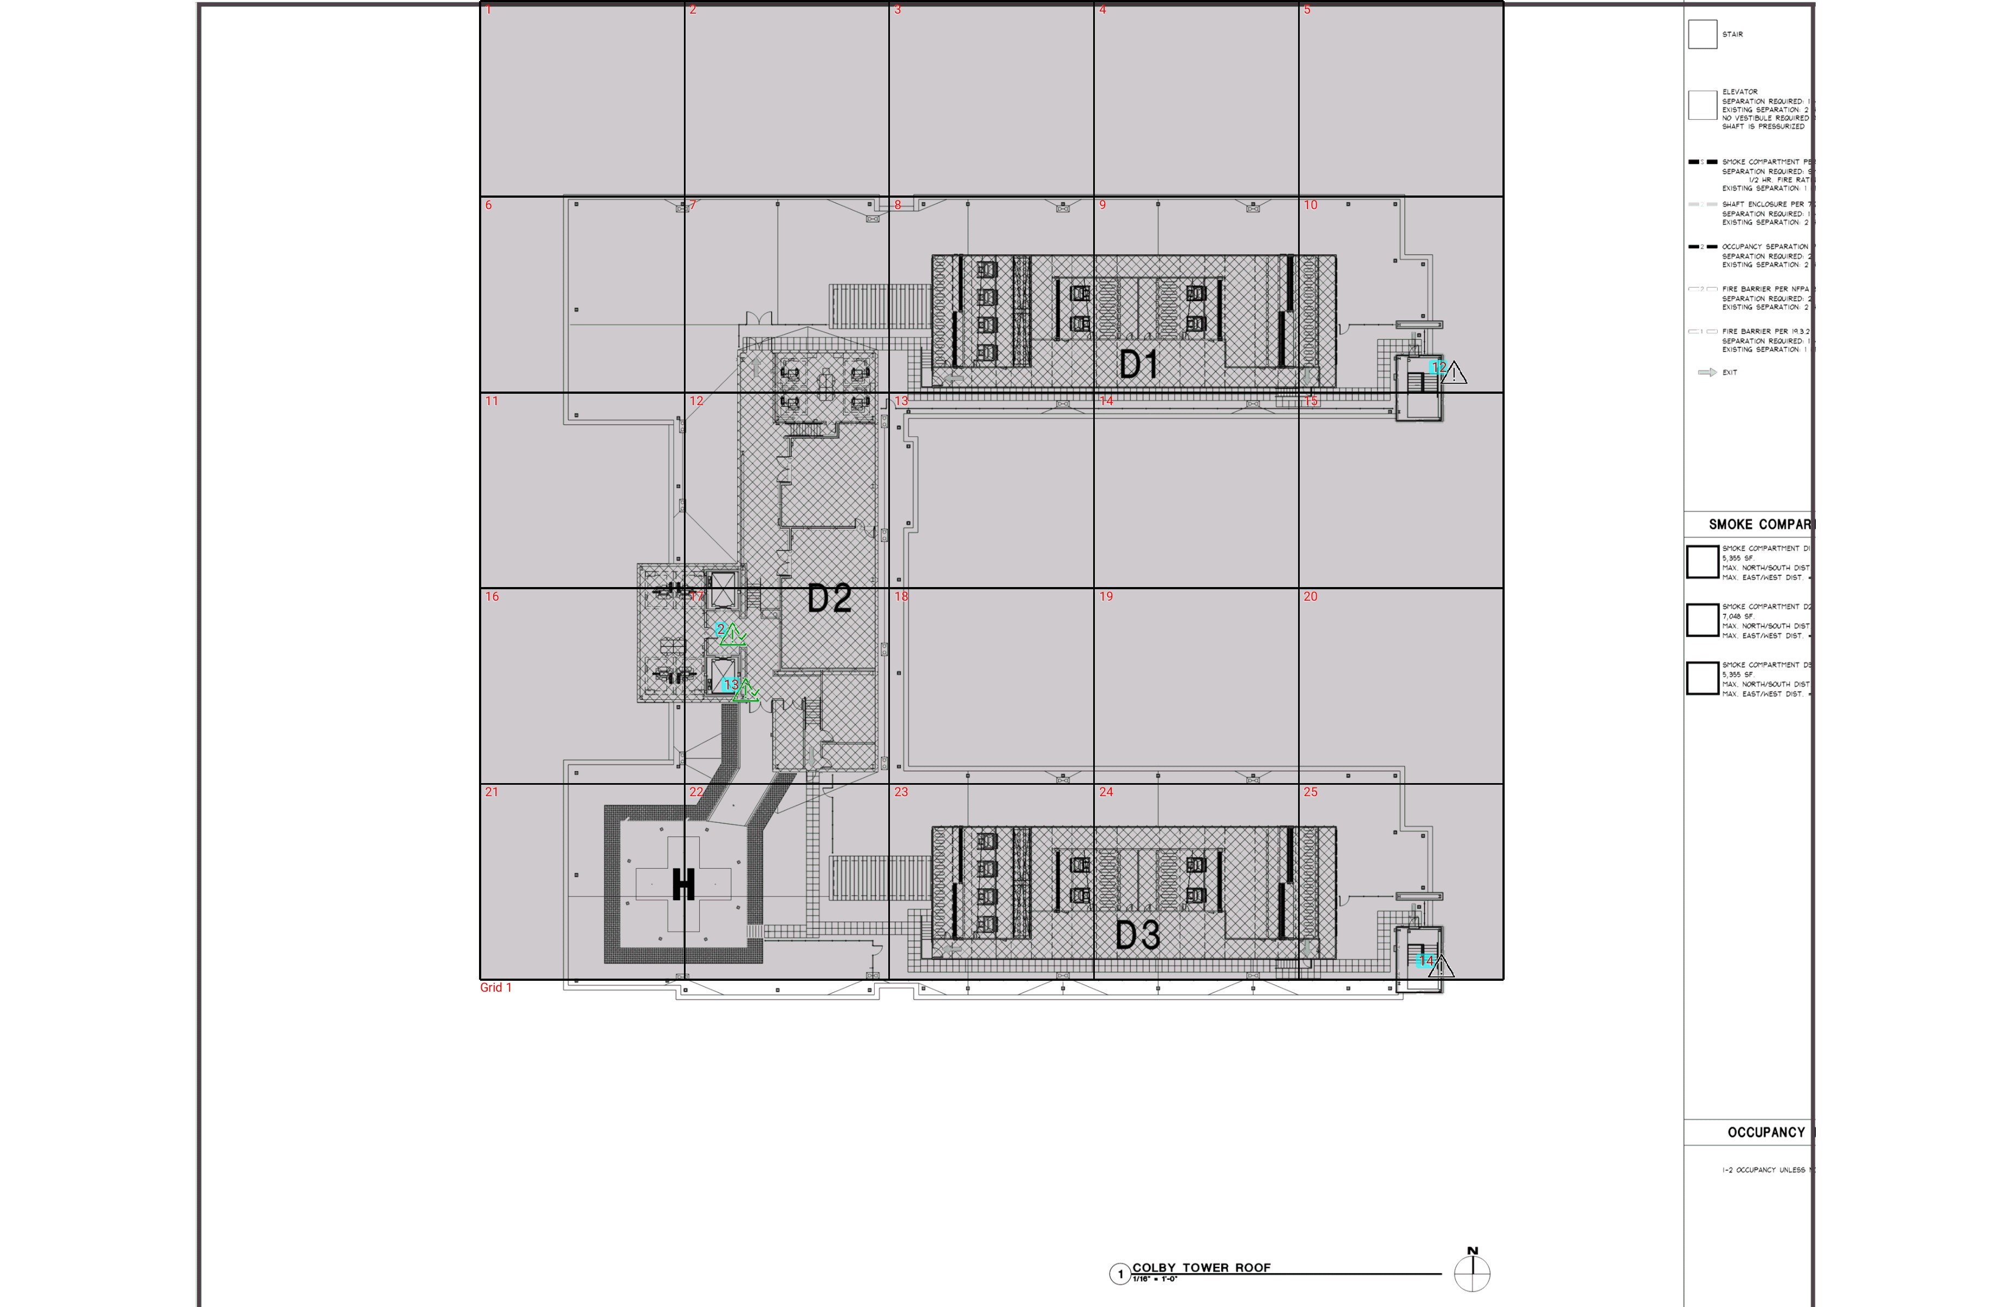

| **Grid** | **# of Areas** | **Area Size (sq. ft)** | **Area Width**  **(ft)** | **Area Height**  **(ft)** | **Ignore Area Color** | **Comments** |
| --- | --- | --- | --- | --- | --- | --- |
| 1 | 25 | 860.38 | 26.25 | 32.77 | Black |  |

**Floor: A.4R**

**Channel: 463550**

| **Critical Point Report** | | | | | | | |
| --- | --- | --- | --- | --- | --- | --- | --- |
| **Critical Point** | **DL**  **Power**  **(dBm)** | **DL**  **DAQ** | **UL**  **Power**  **(dBm)** | **UL**  **DAQ** | **Result** | **DL**  **Loss**  **(dB)** | **Comment** |
| 2 | -99.50 |  |  |  | **Pass** |  |  |
| 12 |  |  |  |  |  |  |  |
| 13 | -69.53 |  |  |  | **Pass** |  |  |
| 14 |  |  |  |  |  |  |  |

| **Area Report** | | | | | | | | |
| --- | --- | --- | --- | --- | --- | --- | --- | --- |
| **Grid** | **Area** | **DL**  **Power**  **(dBm)** | **DL**  **DAQ** | **UL**  **Power**  **(dBm)** | **UL**  **DAQ** | **Result** | **DL**  **Loss**  **(dB)** | **Comment** |
| 1 | 1 | NT | NT | NT | NT | **NT** |  |  |
| 1 | 2 | NT | NT | NT | NT | **NT** |  |  |
| 1 | 3 | NT | NT | NT | NT | **NT** |  |  |
| 1 | 4 | NT | NT | NT | NT | **NT** |  |  |
| 1 | 5 | NT | NT | NT | NT | **NT** |  |  |
| 1 | 6 | NT | NT | NT | NT | **NT** |  |  |
| 1 | 7 | NT | NT | NT | NT | **NT** |  |  |
| 1 | 8 | NT | NT | NT | NT | **NT** |  |  |
| 1 | 9 | NT | NT | NT | NT | **NT** |  |  |
| 1 | 10 | NT | NT | NT | NT | **NT** |  |  |
| 1 | 11 | NT | NT | NT | NT | **NT** |  |  |
| 1 | 12 | NT | NT | NT | NT | **NT** |  |  |
| 1 | 13 | NT | NT | NT | NT | **NT** |  |  |
| 1 | 14 | NT | NT | NT | NT | **NT** |  |  |
| 1 | 15 | NT | NT | NT | NT | **NT** |  |  |
| 1 | 16 | NT | NT | NT | NT | **NT** |  |  |
| 1 | 17 | NT | NT | NT | NT | **NT** |  |  |
| 1 | 18 | NT | NT | NT | NT | **NT** |  |  |
| 1 | 19 | NT | NT | NT | NT | **NT** |  |  |
| 1 | 20 | NT | NT | NT | NT | **NT** |  |  |
| 1 | 21 | NT | NT | NT | NT | **NT** |  |  |
| 1 | 22 | NT | NT | NT | NT | **NT** |  |  |
| 1 | 23 | NT | NT | NT | NT | **NT** |  |  |
| 1 | 24 | NT | NT | NT | NT | **NT** |  |  |
| 1 | 25 | NT | NT | NT | NT | **NT** |  |  |

**Additional Info**